DESIRED OUTCOMES
All people enjoy civil and political rights. Mechanisms to regulate and arbitrate people’s rights in respect of each other are trustworthy.
Civil and Political Rights
INTRODUCTION
The enjoyment of civil and political rights is crucial to people’s ability to participate in society, make choices about their lives, and live with dignity.
Civil and political rights fall into two broad categories. The first requires that people are protected from interference or abuse of power by others. The second requires that society is organised in a way that enables all people to develop to their full potential.⁵⁹
Rights are defined in various international treaties and in domestic legislation. The New Zealand Bill of Rights Act 1990 sets out many rights New Zealanders enjoy. These include rights to life and security, voting rights, and rights to freedom of expression, peaceful assembly, association, thought, conscience, religion and belief. They also include rights to freedom from discrimination, and various rights relating to justice and criminal procedures. Other laws, such as the Privacy Act 1993, also provide protection for specific rights. The relationship between Mäori and the Crown is guided by the Treaty of Waitangi.
New Zealand has also signed six core United Nations treaties, covering civil and political rights; economic, social and cultural rights; the elimination of racial discrimination and discrimination against women; the rights of children; and protection against torture and other cruel, inhuman or degrading treatment.
Civil and political rights are important for wellbeing in many ways. At a fundamental level, they protect people’s lives and their physical wellbeing (for example, by recognising rights to freedom from torture and arbitrary arrest).
Wellbeing depends on people having a sense of choice or control over their lives, and on being reasonably able to do things they value, all of which are impossible without the exercise of the many rights referred to above.⁶⁰ People’s ability to take part in society, and their senses of belonging and identity also depend on the exercise of these rights.
INDICATORS New Zealand is internationally recognised as having an excellent human rights record.⁶¹ The court system is independent and courts can enforce the rights affirmed in the New Zealand Bill of Rights Act, although there is no power to strike down legislation inconsistent with the Act. Other institutions exist to protect people from government power (examples include the Privacy Commissioner and the Ombudsmen) or to prevent and deal with instances of discrimination (such as the Human Rights Commission and Human Rights Review Tribunal). New Zealand regularly reports to the United Nations on its record in protecting rights.
However, direct measurement of civil and political rights is not a simple matter.
This chapter uses four indicators to provide some picture of how New Zealand's formal commitments to civil and political rights are reflected in reality. They are: voter turnout at general elections, the proportion of women represented in elected government positions, perceived discrimination, and perceptions of public integrity.
A key right in any democracy is the right to vote. The inclusion of voter turnout figures provides an indication of the confidence voters have in, and the importance of, the nation's political institutions. High voluntary voter turnout rates are an indication people see these institutions as relevant and meaningful to them, and they believe their individual vote is important.
An effective and relevant political system should broadly reflect the society it represents. The second indicator measures the proportion of women in elected positions in government.
Measuring the extent to which New Zealanders actually experience discrimination is problematic. Some research has suggested that for every 100 people who are discriminated against, only one will make a complaint.⁶² Perceived discrimination is a subjective measure of people’s views about the level of discrimination against different groups in New Zealand society.
Corruption undermines the democratic process and the rule of law. It is difficult to measure levels of corruption by reference to the number of prosecutions or court cases as this will to some extent be driven by the efficient functioning of the justice system. The fourth indicator, absence of corruption, is the level of perceived corruption among politicians and public officials.
Voter turnout
DEFINITION
General elections: The proportion of the estimated voting age population (aged 18 and over) who cast a valid vote in general elections. Local authority elections: The proportion of all enrolled electors (both resident and ratepayer) who cast a vote in contested local authority elections.

RELEVANCE Voter turnout rates are a measure of political participation. They can be seen as an indicator of the extent to which citizens are a part of the political process, and an indicator of the level of trust in political institutions.

CURRENT LEVEL 1. General elections
Voter turnout of the eligible population was 72.5 percent in 2002. Voter participation in general elections declined sharply from 89 percent in 1984 to 78 percent in 1990, increased slightly to 81 percent in 1996, then declined again to a new low in 2002.
Figure CP1.1 Proportion of voting age population who cast votes, 1984-2002
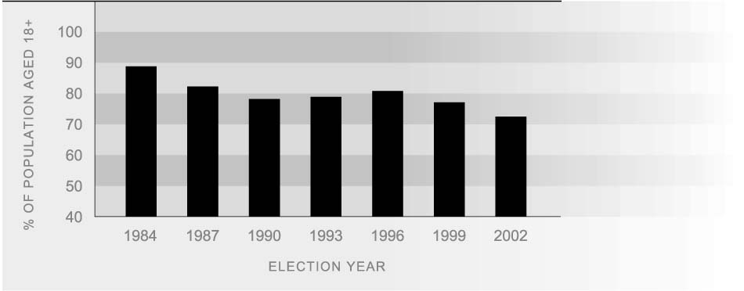Source: Electoral Commission (2002) p174. 1984 figure calculated by Ministry of Social Development

COMPARISONS Because of the nature of the secret ballot, information on differences in participation
BETWEEN GROUPS rates among various sectors of the New Zealand population is not directly available. Nevertheless, results from several New Zealand Election Surveys over a number of years associate a number of social, demographic, and occupational characteristics with impacts on the voter turnout rate. Non-voters are more likely to be people on lower incomes, younger people, and members of Mäori or Pacific ethnic groups. There are few differences in voting turnout rates between men and women.⁶³
REGIONAL There are few discernible differences in voting turnout rates between rural and urban
DIFFERENCES voters, although non-voting tends to be lowest in provincial cities.

INTERNATIONAL New Zealand’s voter turnout rate in 2002 was 72.5 percent, compared to an OECD
COMPARISON median over 1997 to 2002 of 71 percent.⁶⁴ This placed New Zealand 15th out of 30 OECD countries. Greece had the best voter turnout at 89 percent. Voter turnout was higher in Australia (sixth, 82 percent) than New Zealand, but lower in Canada (26th, 55 percent), the United Kingdom (23rd, 58 percent) and the United States (29th, 47 percent).

CURRENT LEVEL 2. Local authority elections AND TRENDS There are 252 elected local authorities in New Zealand: 12 regional councils, 21 district health boards (established 1 January 2001), 15 city councils, 59 district councils and 146 community boards. There was a major restructuring of local government in 1989. Voter turnout in the 2001 local authority elections was the lowest since 1989 for all except regional councils, which had the second lowest since then.

Table CP1.1 Voter turnout (%) in local authority elections, 1989-2001
 | 1989 | 1992 | 1995 | 1998 | 2001
Regional councils | 56 | 52 | 48 | 53 | 49
District health boards |  |  |  |  | 50
Territorial authorities
City councils | 52 | 48 | 49 | 51 | 45
City mayors | 50 | 48 | 49 | 51 | 45
District councils | 67 | 61 | 59 | 61 | 57
District mayors | 67 | 61 | 59 | 59 | 56
Community boards | 54 | 49 | 50 | 50 | 46
Source: Department of Internal Affairs (2003), Table 7.1
Note: There was no election held for Rodney District in 2001
Local authority voter turnout is generally highest for district councils, with their more rural population base, for smaller city councils and those in the South Island. Councils of these types all had a majority turnout in 2001, while among large city councils and North Island city councils, fewer than half of eligible electors voted. Voter turnout ranged from 65 percent for district councils in the South Island, to 43 percent for city councils in the North Island.
In large regional councils, there was an upward trend in voter turnout between 1995 and 2001. However, the average turnout was still higher among small regional councils. Similarly, voter turnout was highest on average among the smaller district health boards.
Representation of women in government
DEFINITION
The proportion of elected members of parliament and local government bodies who are women.

RELEVANCE The representation of women in government can be seen as an indicator of political representation more generally. Representative political institutions engage a wide range of communities in the political process, draw on the talents and skills of the broadest group of people, and provide checks and balances on the use of political power.

CURRENT LEVEL 1. General elections AND TRENDS As a result of the 2002 general election, women hold 34 of the 120 seats in Parliament, or 28 percent. Under the first-past-the-post electoral system, women’s representation in parliament increased from 13 percent in 1984 to 21 percent in 1993. In the first mixed- member-proportional election held in 1996, this rose sharply to 29 percent. There was a further small rise to 31 percent in 1999, followed by a decline to 28 percent in 2002.
In 1996, women made up a far higher proportion of list MPs than electorate MPs (46 percent, compared to just 15 percent of electorate MPs). However, by 2002, the female proportions were similar in both categories.
The majority of women elected to parliament in 2002 were electorate MPs (56 percent). The proportion of women MPs who were electorate MPs has increased from 29 percent in 1996 and 43 percent in 1999.
Figure CP2.1 Women as a proportion of elected members pf parliament, 1984-2002
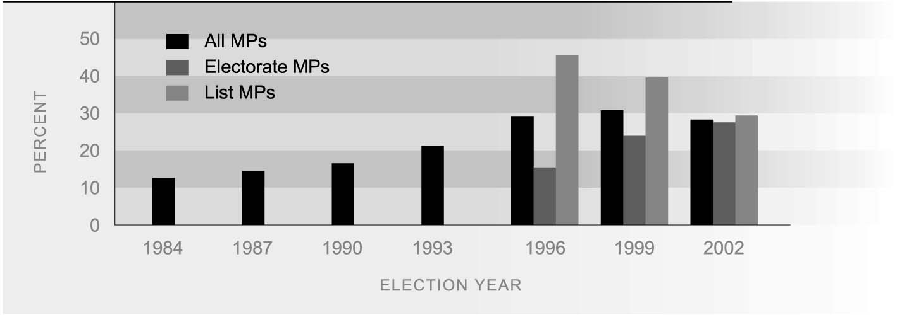
Source: Electoral Commission (2002) p176

INTERNATIONAL In 2003, the percentage of women in New Zealand’s parliament was 28 percent,
COMPARISON compared to an OECD median of 20 percent.⁶⁵ New Zealand was ranked 11th best out of 30 OECD nations, with Sweden ranking first place with 45 percent. Other countries with higher representation of women include Denmark and Finland (38 percent), the Netherlands (37 percent), and Norway (36 percent). Australia (25 percent), Canada (21 percent), the United Kingdom (18 percent) and the United States (14 percent) all have lower percentages of women represented in parliament than New Zealand.
CURRENT LEVEL 2. Local government elections
AND TRENDS
In the 2001 local government elections, 615 women were elected to local authorities and they made up 31 percent of elected members. The representation of women among those elected increased from 25 percent in 1989 to 32 percent in 1998, then fell slightly to 31 percent in 2001. In the 1980s, women were more highly represented in local government than in national government but the difference has narrowed over time.
Women candidates were more likely than male candidates to be elected in each election year from 1989 to 1998, but this was reversed in 2001, when 40 percent of women candidates were elected, compared to 43 percent of men.
In 2001, women’s representation was highest on district health boards (44 percent), followed by city councils (39 percent) and community boards (31 percent). City councils were the only local authorities to see an increased share of women elected in 2001.
The number of women elected to city council mayoral positions has remained steady at four (out of 15) for most election years since 1989. In contrast, the number of women mayors in district councils increased rapidly from six (out of 59) in 1989 to 15 in 1998, then fell sharply to eight in 2001.
Table CP2.1 Proportion (%) of members who were women, by type of local body, 1989-2001
 | 1989 | 1992 | 1995 | 1998 | 2001
Regional councils | 22 | 25 | 29 | 28 | 26
District health boards |  |  |  |  | 44
City councils | 35 | 35 | 33 | 36 | 39
District councils | 19 | 23 | 26 | 27 | 25
Community boards | 29 | 32 | 33 | 35 | 31
Source: Department of Internal Affairs (2003), Table 5.4
Table CP2.2 Women mayors, 1989-2001
 | 1989 | 1992 | 1995 | 1998 | 2001
City councils | 4/14 | 4/15 | 3/15 | 4/15 | 4/15
District councils | 6/59 | 9/59 | 12/59 | 15/59 | 8/58*
Source: Department of Internal Affairs (2003), Table 5.5
Note: There was no election in Rodney District in 2001
Perceived discrimination
DEFINITION
The proportion of people aged 18 and over who perceived selected groups as being the targets of some or a great deal of discrimination.

RELEVANCE Surveys on perceived discrimination towards groups of people provide one indication of the level and type of discrimination in New Zealand. They do not measure actual levels of discrimination and therefore it is not possible to conclude whether actual levels of discrimination have increased or decreased.

CURRENT LEVELS In January 2004, more than three-quarters of respondents from the Human Rights
AND TRENDS Commission Survey 2004 (78 percent) thought that Asian people were subject to a great deal or some discrimination, the highest proportion for any group. This was followed by recent immigrants (72 percent) and refugees (70 percent). Perceived discrimination against these groups has increased since December 2001, from 73 percent for Asians, and from 68 percent for recent immigrants and refugees.
Table CP3.1 Proportion (%) of survey respondents who perceived selected groups as being subject to a great deal or some discrimination, December 2000-January 2004
Group | Dec 2000 | Dec 2001 | Jan 2003 | Jan 2004
Asians | 73 | 73 | 79 | 78
Recent immigrants |  | 68 | 77 | 72
Refugees |  | 68 | 72 | 70
People who are overweight | 72 | 65 | 65 | 68
People on welfare | 75 | 70 | 68 | 66
Gays and lesbians | 74 | 65 | 61 | 58
Pacific peoples | 71 | 65 | 65 | 57
People with disabilities | 61 | 55 | 53 | 55
Mäori | 70 | 62 | 57 | 53
Older people | 53 | 48 | 49 | 46
Women | 50 | 44 | 41 | 38
Source: Human Rights Commission (2004)
Approximately two-thirds of survey respondents thought that people who are overweight and people on welfare were the target of a great deal or some discrimination. More than half thought that gays and lesbians, Pacific peoples, people with disabilities, and Mäori were subjected to such discrimination.
Women, older people, Mäori, Pacific peoples, people who are overweight, people on welfare, people with disabilities, and gays and lesbians were all less likely to be considered the targets of some or a great deal of discrimination in January 2004, compared to December 2000.
Absence of corruption
DEFINITION
The degree of corruption among politicians and public officials perceived to exist within New Zealand according to business people, academics and risk analysts on a scale of 0 (highly corrupt) to 10 (highly clean). Corruption is defined as the ‘abuse of public office for private gain’.
Results are taken from Transparency International’s Corruption Perceptions Index.

RELEVANCE Corruption undermines democracy and the rule of law and threatens domestic and international security. Corruption may also have adverse social and economic consequences for a country. The Corruption Perceptions Index is a good proxy indicator of the values and norms that underpin public institutions.
The Corruption Perceptions Index is a subjective measure that should be seen as a snapshot view of key decision-makers. There is no hard empirical data on levels of corruption. The only method of gathering comparative data is to build on the experience and perceptions of those who are most directly confronted with corruption.

CURRENT LEVEL Since the Index was first developed in 1995, New Zealand has demonstrated
AND TRENDS consistently low levels of perceived corruption. New Zealand’s worst score was in 1997 with a score of 9.23.

INTERNATIONAL In 2003, Transparency International Corruption Perceptions Index ranked New Zealand
COMPARISONS as the third least corrupt nation in the OECD, with a score of 9.5 out of 10.⁶⁶ This was very high compared to the OECD median of 7.55. New Zealand is consistently ranked in the top four countries of the OECD, with first place in 1995 and 1996. In 2003, Finland was ranked the least corrupt nation in the OECD with a score of 9.7.
New Zealand has very low levels of perceived corruption compared to Australia (eighth place, 8.8), Canada (11th equal, 8.7), the United Kingdom (11th equal, 8.7), and the United States (18th place, 7.5).

Figure CP4.1 Absence of corruption in OECD countries, 2003
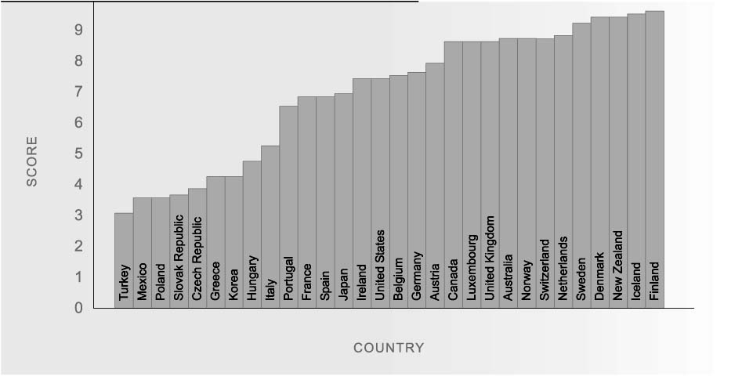
Source: Transparency International’s Corruption Perceptions Index 1995-2003

