Conclusion
The Social Report 2004 uses 43 indicators to document social wellbeing in New Zealand. These indicators present a snapshot of wellbeing in New Zealand, how it has changed over time, how different groups within our society fare, and how New Zealand compares with other countries. This section summarises the findings from these indicators.
The indicators for which we have long-term trend data show that many aspects of wellbeing have been improving in New Zealand. Compared to the mid 1990s, New Zealanders are on average living longer, they are more highly educated, less likely to be unemployed, and more prosperous.
Five indicators show no change since the mid 1990s. These are: absence of corruption, income inequality, housing affordability, criminal victimisation, and the proportion of women in government.
Two indicators – the proportion of school leavers with higher qualifications and voter turnout – have worsened slightly.
Nine of the 43 indicators are new to the social report this year, and together they provide information on a number of the non-economic dimensions of wellbeing. The new indicators show a high level of trust between New Zealanders. The large majority of New Zealanders also rarely or never experience loneliness, though unemployed people, people on low incomes, and young people are considerably more likely to feel lonely. Almost one in five employed people are dissatisfied with their work/life balance.
We also provide detail on the extent of overall life satisfaction of New Zealanders. Approximately 80 percent of adults in our recent Social Wellbeing Survey indicate being satisfied or very satisfied with their lives.
Social wellbeing in New Zealand also compares favourably with other developed countries.
New Zealand is in the top half of the OECD for the majority of indicators for which we are able to compare ourselves, including: indicators of life expectancy, a range of education indicators, employment and unemployment, trust in others, and absence of corruption. New Zealanders also report very high levels of satisfaction with their lives compared to people in many OECD countries.
New Zealand is in the bottom half of the OECD in relation to a smaller number of indicators. New Zealand is a below-average performer in relation to per capita incomes, income inequality, rates of child deaths by maltreatment, suicide, obesity, and quantitative and document adult literacy.
The Social Report 2004 also enables an analysis of how different groups within our society fare. Across a wide variety of indicators, people with low incomes, Mäori, Pacific peoples and other non-European/Päkehä ethnic groups tend to experience poorer average outcomes than the rest of the population. Comparisons between age groups, and between men and women reveal a more mixed picture.

Is social wellbeing improving?
Social wellbeing in New Zealand has improved since the mid-1990s
The diagram below compares wellbeing today with our performance in 1995-1997, using those indicators for which we have trend data.

Figure CO1 Changes in social wellbeing, 1995-1997 to 2001-2003
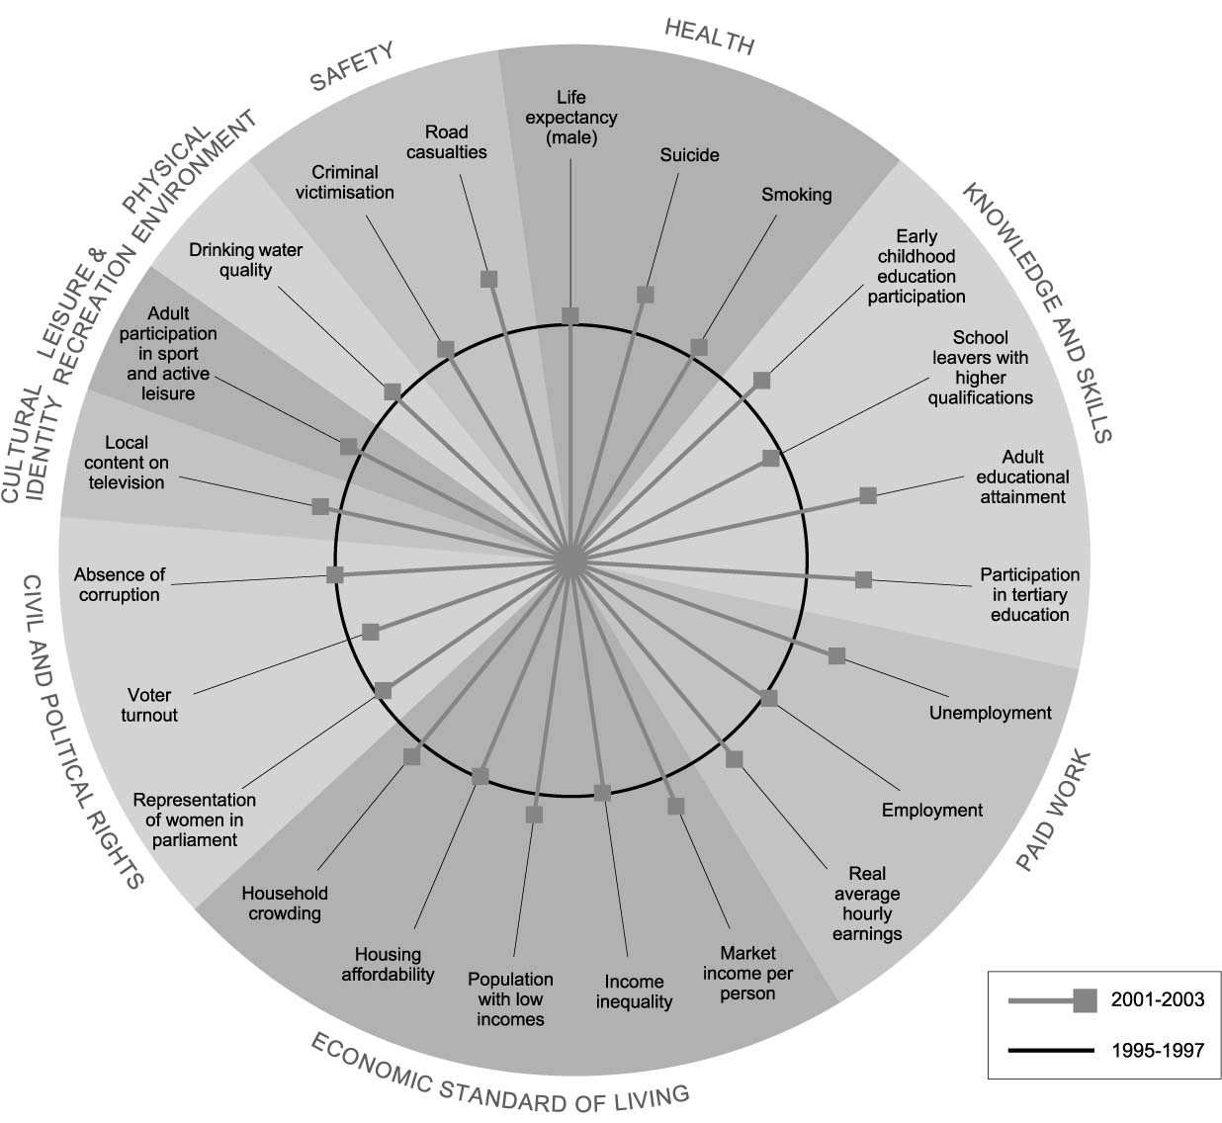

Interpreting ‘Changes in social wellbeing 1995/97 to 2001/03’
The blue circle represents average performance against each indicator between 1995 and 1997, and the spokes represent the most recent performance, where possible averaged over the most recent three years. Where a spoke falls outside of the circle, this means that outcomes have improved since the mid-1990s; the further from the circle it falls, the more significant the improvement. Where a spoke falls within the circle, outcomes in this area have | deteriorated since the mid-1990s; the further the spoke is from the blue circle, the more pronounced the deterioration. There are, however, some important limitations on this style of presentation. In particular, we cannot directly compare the size of changes for different indicators. The absence of trend data for some indicators also means that we can only show 23 of the 43 indicators used in The Social Report 2004.

Of the 23 indicators for which a time series is available, 16 have shown some improvement since the mid 1990s. There has been no change in five of the indicators. Two of the indicators - the proportion of young people leaving school with higher qualifications, and voter turnout - have deteriorated slightly since the mid-1990s.
The indicators enable overall conclusions about only some social report domains.
Indicators of life expectancy, suicide, and cigarette smoking point to improvements in the health of the population since the mid-1990s.
In the knowledge and skills area there is a generally positive picture. There has been significant growth in participation in early childhood and tertiary education, and improvements in the educational attainment of the adult population. However there has been a slight decline in the proportion of young people who leave school with higher qualifications.
The overall prosperity of the nation, average hourly earnings, and unemployment have all improved since the mid-1990s, but there has been little change in income inequality and housing affordability. The last two indicators are however based on data from 2001, and conditions may have changed since then.
In the area of civil and political rights there is a mixed picture. While there has been no change as measured by indicators of absence of corruption and the proportion of women in parliament, there has been a decline in voter turnout.

Many of the indicators for which there is long-term trend data available also show that wellbeing is as good as, or better now, than during the mid-1980s. New Zealanders are on average living longer lives, are better educated, and are more likely to be employed. There are some important exceptions, however, with housing affordability, poverty, income inequality, and voter turnout having deteriorated.
Social wellbeing is also better today than during the mid-1980s
Most of these indicators have steadily improved over the last two decades.
The exceptions are those directly linked to economic conditions. Poverty, unemployment, and suicide worsened during the 1990s but have subsequently improved, though not to mid-1980s levels in the case of poverty.

Are New Zealanders satisfied with their lives?
The Social Report 2004 measures a range of aspects of social wellbeing. For the first time, we have also measured the overall life satisfaction of New Zealanders.

In 2004, 27 percent of New Zealanders reported feeling very satisfied with their life. Fifty four percent reported feeling satisfied. Only 5 percent of people indicated that they felt dissatisfied with their life.⁹¹
Overall New Zealanders report relatively high levels of life satisfaction
There is a surprising lack of variation in the average levels of satisfaction across different groups in the population. For example, despite marked difference in outcomes across a wide range of indicators, there is very little variation in average life satisfaction between different ethnic groups. The factors that do seem to make a difference include: low income, unemployment, and loneliness which have a small adverse effect; and having a child, which has a small beneficial impact.
Overall life satisfaction is high in New Zealand compared to other countries, with New Zealand being amongst the top quarter of OECD countries.⁹²

How does New Zealand compare to other OECD countries?
Compared to other industrial countries, social wellbeing in New Zealand appears favourable
Figure CO2 Social Wellbeing in New Zealand relative to the OCED
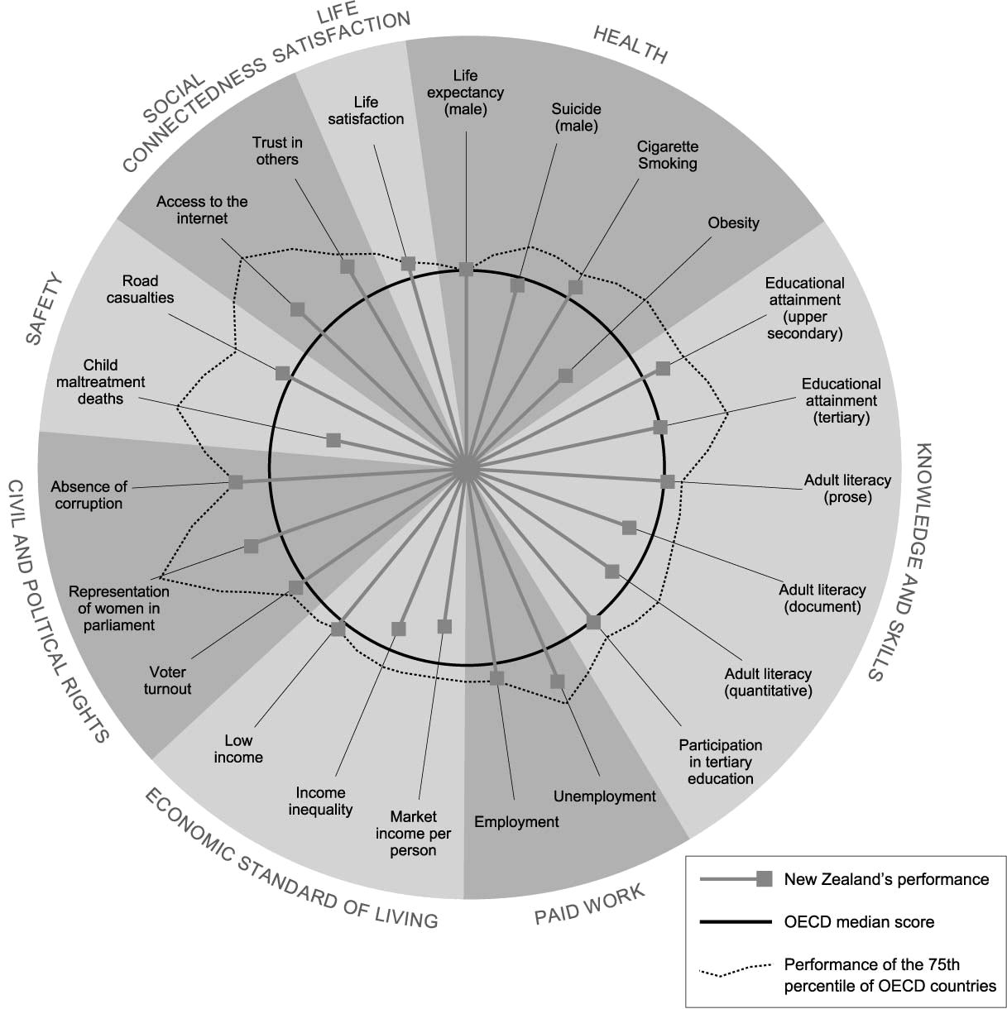

Interpreting ‘Social wellbeing in New Zealand relative to the OECD’
Figure CO2 shows wellbeing in New Zealand relative to the OECD against 23 indicators. The blue circle represents the OECD median score for each indicator, and the spokes represent outcomes in New Zealand relative to the OECD median. The irregular shape outside of the median circle represents outcomes for the 75th percentile. Where a spoke falls inside the circle, New Zealand is in the bottom half of the OECD. Where the spoke falls outside of the circle, outcomes in New Zealand are better than the OECD median. | Where a spoke falls past the irregular shape, New Zealand makes it to the top quarter of the OECD.  SOME CAUTION IS REQUIRED WITH THIS DATA: International comparisons are frequently difficult to interpret because of differences between countries in methods used to collect, classify and record social data. We only show 23 of the 43 indicators used in The Social Report 2004 in the graph, because comparable international data is not available for each indicator.
New Zealand makes it into the top half of the OECD for roughly two thirds of the 23 indicators for which internationally comparable data is available.
New Zealand performs well in the area of civil and political rights. We consistently have one of the lowest levels of perceived corruption across the OECD, and are in the top half of the OECD both for the percentage of women in parliament, and for voter turnout.
New Zealand also performs strongly for both our relatively high employment rates and relatively low unemployment rates. New Zealand’s performance has improved markedly in this area since the early 1990s.
New Zealand appears to sit around the middle of the OECD for our performance in the area of health. Life expectancy in New Zealand is similar to the median life expectancy in the OECD, though there is a relatively narrow range of outcomes across the OECD for this indicator. Our position declined over the 1970s and 1980s but improved in the 1990s. We perform well for the prevalence of cigarette smoking but have relatively high suicide rates. We are the sixth worst performer for obesity rates.
In the area of knowledge and skills, New Zealand is at or near the OECD median for adult literacy, for participation rates in tertiary education for the 20-29 year age group, and for the proportion of adults with tertiary qualifications. None of the measures used in this report enable us to look at the relative performance of children and young people. However results from the OECD’s PISA study, which is designed to look at trends in student achievement across time in 32 countries, ranked New Zealand 15 year-olds near the top for their overall performance.⁹³ However, compared to other countries, New Zealand has greater differences between the best and poorest achieving students – a pattern also reflected in other international studies of school students.
New Zealand sits below the middle ranked OECD country for Gross Domestic Product (GDP) per capita. We also do poorly for income inequality. However, we are slightly better than the OECD median in relation to the proportion of the population on low incomes.
We do not have enough comparable international data in the safety domain to make any strong conclusions. However, there is some evidence to suggest that New Zealand has relatively high rates of child maltreatment deaths, though there is some concern about the comparability of such data across countries.
Lastly, New Zealanders rate themselves highly in terms of life satisfaction and overall happiness. Out of 25 OECD countries, New Zealand has the fifth highest percentage of the population who are satisfied with their lives.

The distribution of social wellbeing in New Zealand
The indicators used in The Social Report 2004 enable us to compare how social wellbeing differs across broad groups within the New Zealand population. It is worth noting however, that these comparisons are for population group averages, and that in most cases, the variation in outcomes between members of any one group will be much greater than between group averages.

The overall risk of mortality and incidence of disability increases with age. Older people are less likely to have higher qualifications or higher literacy levels. Those aged 65 years or more are also less likely to participate in family activities, engage in cultural and arts activities, or to have internet access.
There are systematic differences across a wide variety of indicators by age
Employment levels and average earnings from wage and salary jobs peak in the ‘middle years’. However, this group also reports the greatest dissatisfaction with work/life balance and available leisure time.
Younger people report higher levels of loneliness. They are more likely than older age groups to be subject to criminal victimisation and road casualties. Younger people also have the highest rates of unemployment and the lowest rates of voting in general elections.
The risk of poverty, low living standards and household crowding are all greater for children.

Men have a lower life expectancy and higher rates of suicide. Men also have higher rates of workplace injury and of death and injury from road crashes. They are less likely than women to leave school with higher qualifications, have lower rates of tertiary participation, and indicate that they are more concerned about their work/life balance.
Sex differences are apparent across a range of indicators of social wellbeing
Women have much lower levels of representation in local and central government than men. Women also have lower rates of employment than men, lower hourly wages and a higher risk of poverty. Girls are less likely than boys to participate in active leisure, while women have higher rates of obesity.
There is no reported difference in overall levels of victimisation between men and women. However, girls are more likely than boys to be subject to child abuse and neglect, and women are more likely to report feeling unsafe than men. Women are also slightly less trusting of others, and are more likely to report experiencing loneliness than men.
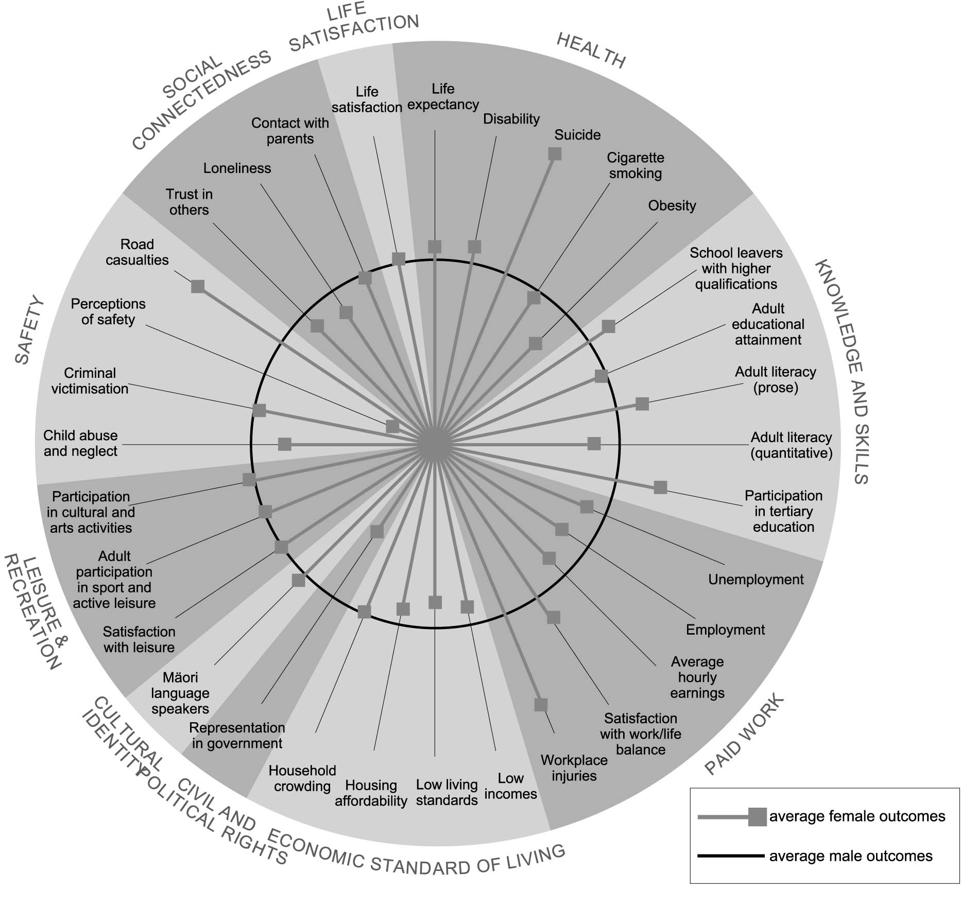
Figure CO3 Social wellbeing for women, relative to men

Interpreting ‘Social wellbeing for women, relative to men’
The blue circle represents average male outcomes against each indicator, and the spokes represent outcomes for women. Where a spoke falls outside of the circle, this means that outcomes for women are better than for men; the further the spoke from the circle, the more pronounced the difference. Where a spoke falls | within the circle, outcomes for women are worse than for men; the further the spoke is from the blue circle, the more pronounced this effect. There are, however, some important limitations on this style of presentation. In particular, we cannot directly compare the size of differences between indicators.

The majority of indicators for which we have time series data show social wellbeing improving for Mäori since the mid 1990s. In many instances improvements for Mäori have been greater than for Europeans/Päkehä. For example, the gaps between Mäori and Europeans/Päkehä for life expectancy, tertiary participation, and unemployment have narrowed since the mid 1990s.
There are clear ethnic differences across a range of indicators of social wellbeing
Wellbeing for Mäori is however still relatively poor in the areas of health, paid work and economic standards of living. Mäori report feeling safer than Europeans/Päkehä, but have higher levels of criminal victimisation, child abuse and neglect, and are more likely to be injured or killed in road crashes.
The difference in outcomes is less pronounced in the knowledge and skills area, with Mäori being more likely than Europeans/Päkehä to participate in tertiary education. However, Mäori are less likely than Europeans/Päkehä to participate in early childhood education, less likely to leave school with higher qualifications, and have lower levels of adult literacy.
Mäori report slightly more participation in cultural and arts activities and family/whänau activities than Europeans/Päkehä.
Figure CO4 Social wellbeing for Mäori, relative to Europeans/Päkehä
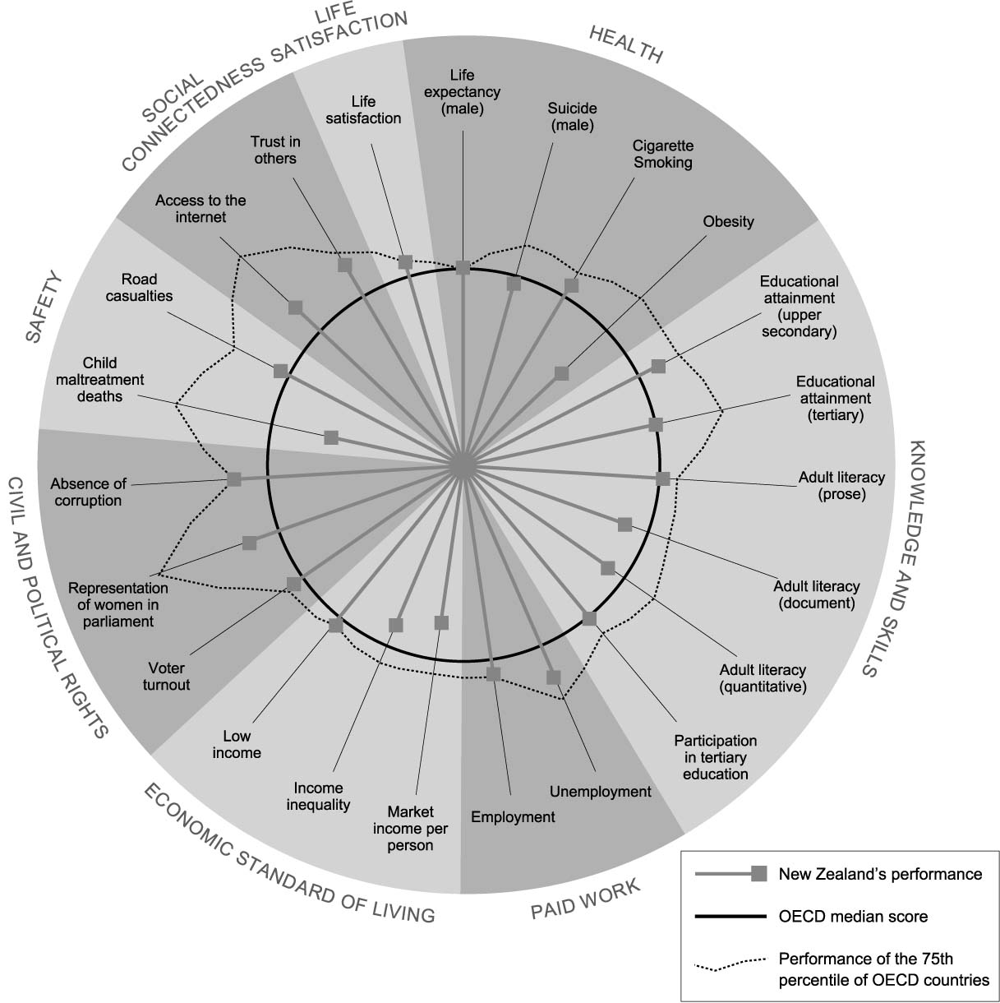
Interpreting ‘Social wellbeing for Mäori, relative to Europeans/Päkehä’
The blue circle represents average outcomes for Europeans/Päkehä against each indicator and the spokes represent outcomes for Mäori. Where a spoke falls outside of the circle this means that outcomes for Mäori are better than for Europeans/Päkehä; the further the spoke from the circle the more pronounced the difference. Where a spoke falls within the circle | outcomes for Mäori are worse than for Europeans/ Päkehä; the further the spoke is from the blue circle the more pronounced this effect. There are, however, some important limitations on this style of presentation. In particular we cannot directly compare the size of changes for different indicators.

The majority of indicators for which we have time series data, show social wellbeing has also improved for Pacific peoples since the mid 1990s. There has also been a reduction in the gap between Pacific peoples and Europeans/Päkehä for some indicators, including unemployment and educational attainment.
Pacific peoples however still have higher levels of unemployment, and are at greater risk of poverty and household crowding than Europeans/Päkehä. Pacific adults report lower levels of participation in active sport and leisure and have higher rates of cigarette smoking and obesity than Europeans/Päkehä. Pacific peoples also do relatively poorly in the area of knowledge and skills.
Pacific people are less likely to be injured or killed on our roads, and there are few reported differences in levels of criminal victimisation.
Figure CO5 Social wellbeing for Pacific peoples, relative to Europeans/Päkehä
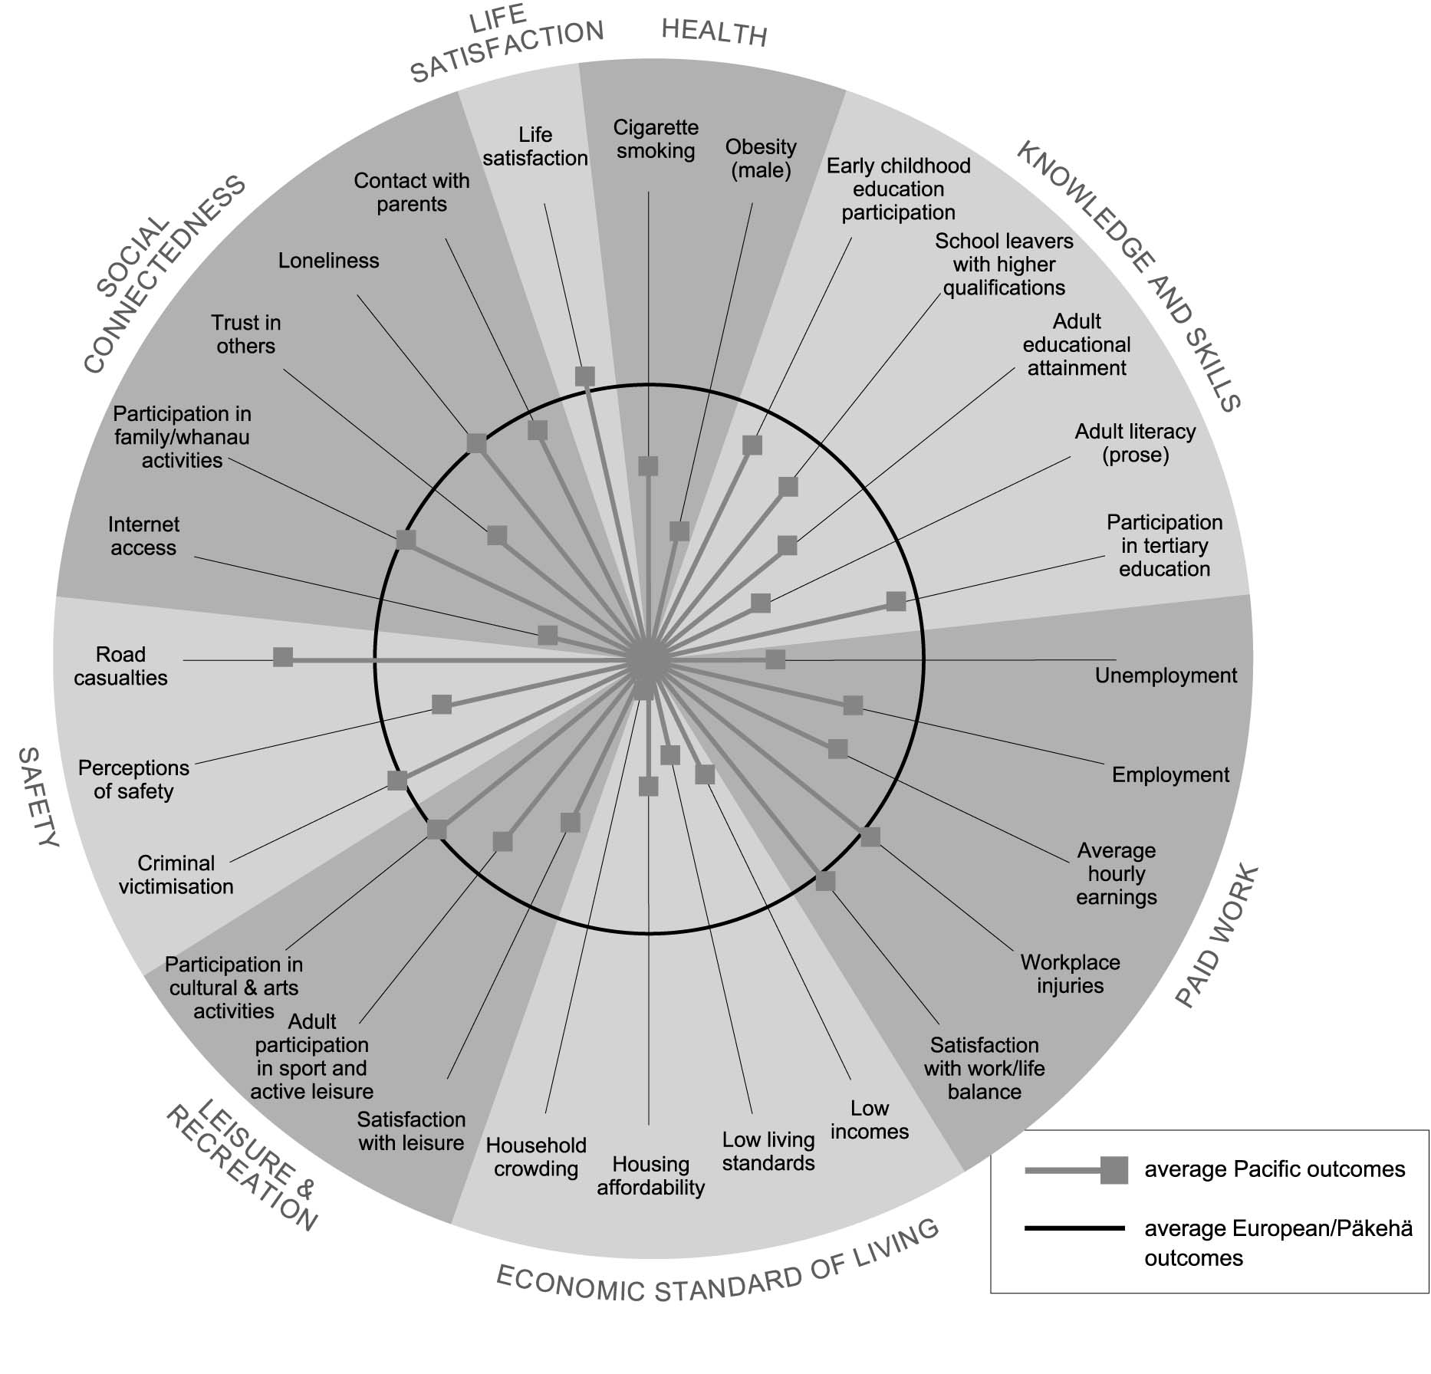

Interpreting ‘Social wellbeing for Pacific peoples, relative to Europeans/Päkehä’
The blue circle represents average outcomes for Europeans/Päkehä against each indicator and the spokes represent outcomes for Pacific peoples. Where a spoke falls outside of the circle this means that outcomes for Pacific peoples are better than for Europeans/Päkehä; the further the spoke from the circle the more pronounced the difference. | Where a spoke falls within the circle outcomes for Pacific peoples are worse than for Europeans/Päkehä; the further the spoke is from the blue circle the more pronounced this effect. There are, however, some important limitations on this style of presentation. In particular we cannot directly compare the size of changes for different indicators.
Only a limited number of indicators enable us to look at the outcomes for New Zealanders who identify with an ethnic group other than European/Päkehä, Mäori, or Pacific. Those that do, show a mixed picture. People of ‘other’ ethnicity generally perform well in the area of knowledge and skills, particularly for tertiary participation and educational attainment. They are also more likely to take part in sport and active leisure, and to be satisfied with their leisure time. However, people of ‘other’ ethnicity are more likely than Europeans/Päkehä to be unemployed and to have a low standard of living. They may also be more socially isolated than other ethnic groups – they have higher rates of loneliness, and are less likely to have family and friends over for dinner.

People living in materially deprived communities have a lower life expectancy, higher rates of cigarette smoking and obesity, and lower levels of educational achievement. Adults with low incomes are less likely to vote. Low income families are also less likely than those on higher incomes to have internet connections, while adults with low incomes report higher levels of loneliness, and lower levels of trust in others.
There is a strong connection between low income and poor outcomes in many areas of wellbeing

SUMMARY OF INDICATORS
Indicators | Current overall level of indicator (most recent year) | Variation within the population | Is this aspect of the quality of life improving overall? | How does this aspect of the quality of life compare with the OECD average (median)?
Health
Health expectancy | 64.8 years for males and 68.5 years for females (2001) | Lower for males and Mäori | Improved for females | No comparison available
Life expectancy | 76.3 years for males and 81.1 years for females (2000-02) | Lower for males, Mäori and Pacific peoples and those living in deprived areas | Improving | Average for both males and females
Disability requiring assistance | 10.2 % for males and 9.3 % for females (age standardised rate) | Higher for Mäori | No change since 1996/97 | No reliable comparison available
Suicide | 11.7 per 100,000 (age-std rate for all ages); youth 15–24 years, 20.0 per 100,000 (2001) | Suicide deaths higher for males, youth, young adults and Mäori; attempted suicide higher for females | Improved since 1998 | Average for all ages; poor for male youth
Prevalence of cigarette smoking | 25% of population aged 15 years and over smoke cigarettes (2002) | Higher rates among young people, Mäori, Pacific peoples and those living in deprived areas | Improved to 1991, steady since | Good for males, poor for females
Obesity | 17% for population 15+ (1997); 10% for children 5-14 years (2002) | Higher for females, Pacific people, Mäori, females in deprived areas | Worsened up to 1997. No more recent data | Poor

Indicators | Current overall level of indicator (most recent year) | Variation within the population | Is this aspect of the quality of life improving overall? | How does this aspect of the quality of life compare with the OECD average (median)?
Knowledge and skills
Participation in early childhood education | ‘Apparent’ participation rate of 94% for 3 year olds and 102% for 4 year olds (2003) | Mäori and Pacific rates lower than non-Mäori | Improving | No robust comparison available
School leavers with higher school qualifications | 63% of school leavers with at least Sixth Form Certificate (2002) | Proportions lower for males, Mäori and Pacific school leavers | Improved to 1991, slight decline since 1998 | No comparison available
Educational attainment of the adult population | 74% of the population aged 25–64 years with at least an upper secondary qualification; 15% of the population aged 25–64 years with tertiary (bachelor degree+) qualifications (2003) | Proportions lower for older people, women, Mäori and Pacific peoples | Improving | Good for upper secondary and average for tertiary
Adult literacy skills in English | 54% of population aged 16–65 have a level of literacy in English needed to meet the complex demands of everyday life and work; 50% meet the same standard for document literacy and 51% for quantitative (1996) | Literacy levels lower among older people, Mäori and Pacific peoples and Other ethnic groups | No trend available | Average for prose literacy, but below average for document and quantitative
Participation in tertiary education | 10.8% of population aged 15 and over enrolled in tertiary education institutions (2003) | Lower rates for males, students from deprived areas; higher for Mäori at ages under 18 and over 25 | Improving | No direct comparison available; average for 20-29 year olds

Indicators | Current overall level of indicator (most recent year) | Variation within the population | Is this aspect of the quality of life improving overall? | How does this aspect of the quality of life compare with the OECD average (median)?
Paid Work
Unemployment | 4.7% of the labour force (2003) | Higher rates for young people, Mäori, Pacific and Other ethnic groups | Improving since 1998 almost to mid-1980s levels | Good
Employment | 72.5% of the population aged 15-64 years (2003 | Lower rates for young people, women, Mäori, Pacific peoples and Other ethnic groups | Improved since 1998 to above mid-1980s levels | Good
Average hourly earnings | $17.82 per hour for wage and salary earners ($19.02 for males; $16.57 for females) | Lower for Mäori, Pacific, youth, females over 30 | Improving | No comparison available
Workplace injury claims | 141 claims per 1,000 full-time equivalent employees (2000/01) | Higher rates for men and Mäori | No change over past year | No comparison available
Satisfaction with work/life balance | 62% of the population say they are satisfied with their work/life balance | Men, Mäori, people of “other’ ethnicity, and people whose personal incomes are more than $60,000 less likely to be satisfied with their work/life balance | No data | No comparison available

Indicators | Current overall level of indicator (most recent year) | Variation within the population | Is this aspect of the quality of life improving overall? | How does this aspect of the quality of life compare with the OECD average (median)?
Economic Standard of Living
Market income per person | RGNDI of $27,237 per capita (in constant 1995/96 dollars) (2003) | Not measured | Improving | Poor
Income inequality | The household in the 80th percentile has an income 2.7 times the household in the bottom 20th percentile (2001) | Not relevant | Worsened to 1998 then stable | Poor in the mid 1990’s
Population with low incomes | 22.6 % of population lives in economic family units with incomes below 60% of median (2001) | Higher rates among large families, sole parents, Mäori or Pacific families, families from Other ethnic groups, families who rely on income-tested benefits and families in rented dwellings | Worsened to 1994 then improved slowly | Better than OECD median in mid 1990s
Population with low living standards | 20% of the total population with restricted living standards (ELSI Levels 1–3) (2000) | As for population with low incomes | No trend data available | No comparison available
Housing affordability | 24% of households spend more than 30% of income on housing (2001 | Higher proportions among Mäori, Pacific or Other ethnic groups | Worsened to 1998 then stable | No comparison available
Household crowding | 3.2% of individuals living in households requiring two or more additional bedrooms (2001) | More common among families with young children, youth, people in rental housing, Mäori and Pacific peoples, and in South Auckland | Some improvement | No comparison available

Indicators | Current overall level of indicator (most recent year) | Variation within the population | Is this aspect of the quality of life improving overall? | How does this aspect of the quality of life compare with the OECD average (median)?
Civil and Political Rights
Voter turnout (general elections) | 72.5% of the population eligible to vote (2002) | Non-voters more likely to be on lower incomes, younger people, Mäori or Pacific people | Worsened | Above average
Representation of women in government | 28% of seats in parliament (2002 general election); 31% of elected members (2001 local authority elections) | Not relevant | Improvement, then marginal decline in latest year | Good
Perceptions of discrimination | Asians most common group perceived to be subject to discrimination | Not relevant | Deteriorated for people who are overweight, people with disabilities | No comparison available
Absence of corruption | New Zealand ranked third least corrupt nation with a Corruption Perceptions Index score of 9.5 (2003) | Not relevant | Steady | Very good

Indicators | Current overall level of indicator (most recent year) | Variation within the population | Is this aspect of the quality of life improving overall? | How does this aspect of the quality of life compare with the OECD average (median)?
Cultural Identity
Mäori language speakers | 25% of Mäori report conversational fluency in Mäori (2001) | Fluent speakers more likely to be older | No trend available | Not relevant
Language retention | Varied from 17% of Cook Island Maori to 81% of Koreans (2001) | Not relevant | No trend available | No comparison available
Local content programming on New Zealand television | 42% of the prime time schedule (2003) | Not relevant | Improved since 2000 | Below average

Indicators | Current overall level of indicator (most recent year) | Variation within the population | Is this aspect of the quality of life improving overall? | How does this aspect of the quality of life compare with the OECD average (median)?
Leisure and Recreation
Satisfaction with leisure | 68% of the population are satisfied overall with their leisure time (2004) | Those aged 25-44 years and people with personal incomes over $40,000 report lower satisfaction rates | No trend available | No comparison available
Participation in cultural and arts activities | 93% of adult population took part in cultural activities (2001/02) | Higher participation rates among young people | No trend available | No comparison available
Participation in sport and active leisure | 70% of adults 18 and over, 66% of young people 5-17 years were physically active (2000/01) | Girls and Pacific young people; Maori and Pacific adults less likely to be physically active | Overall improvement, particularly for older adults; deterioration for Maori and Pacific young people | No comparison available

Indicators | Current overall level of indicator (most recent year) | Variation within the population | Is this aspect of the quality of life improving overall? | How does this aspect of the quality of life compare with the OECD average (median)?
Physical Environment
Air quality | PM10 levels exceeded recommended guidelines consistently in Christchurch (1995–2003) and Hamilton (1999-2000 and 2002-2003). Wellington levels exceeded guidelines in 2002 and 2003 | Not reported | Steady | No comparison available
Drinking water quality | 80% of the population had a water supply that conforms with the 1995 standards for E. Coli (2002) | Not reported | Steady | No comparison available Indicators
Safety
Child abuse and neglect | 7.4 substantiated notifications per 1,000 children aged 0–16 (2003) | Female and Mäori children more likely to be assessed as abused or neglected | Trend cannot be reliably interpreted | Poor
Criminal victimisation | 30% of population aged over 15 years were victims of criminal offending, either as individuals or members of households (2000) | Younger people and Mäori more likely to have been a victim of crime | Similar to 1995 level | No reliable comparison available
Perceptions of safety | 29% of population felt unsafe walking alone in their neighbourhood after dark | Higher among females, Pacific peoples | No trend available | No comparison available
Road casualties | 11.5 deaths per 100,000 population (2003, provisional) | High rates among men, young people, Mäori, and those aged 65 and over | Improvement since 1986 | Average

Indicators | Current overall level of indicator (most recent year) | Variation within the population | Is this aspect of the quality of life improving overall? | How does this aspect of the quality of life compare with the OECD average (median)?
Social Connectedness
Telephone and internet access in the home | 97% of adult population have access to telephone and 41% to internet in their homes (2000) | Access less likely among Mäori and Pacific families, families with unemployed adults and sole parent families | No trend available | Above average for internet
Participation in family/whänau activities and regular contact with family/friends | 71% of adults had family or friends over for dinner at least once a month in the previous year and 87% engage in family/whänau activities (2000) | Older people and Europeans less likely to be involved in family activities | No trend available | No comparison available
Trust in others | 57% of the adult population report that people can be trusted (2004) | Women, Mäori, Pacific peoples and those with incomes less than $20,000 report lower levels of trust | Improving | Good
Experience of loneliness | 50% of the adult population report having never felt lonely in the past 12 months (2004) | People of ‘other’ ethnicity, young people, people whose incomes are less than $20,000, unemployed people and unpartnered people report higher levels of loneliness | No trend available | No comparison available
Contact between young people and their parents | 63% of male and 61% of female students spent enough time with Mum or Dad | Mäori students more likely to report not getting enough time with their par | No trend available | No comparison available

