DESIRED OUTCOMES
New Zealanders share a strong national identity, have a sense of belonging, and value cultural diversity. All people are able to pass their cultural traditions on to future generations. Mäori culture is valued and protected.
Cultural Identity
INTRODUCTION
‘Culture’ refers to the customs, practices, languages, values and world views that define social groups such as those based on nationality, ethnicity, region, or common interests. Cultural identity is important for people’s sense of self and how they relate to others. A strong cultural identity can contribute to people's overall wellbeing.
Cultural identity is not exclusive. People may identify themselves as New Zealanders in some circumstances and as part of a particular culture – Mäori, Chinese or Scottish, for example – in other circumstances. They may also identify with more than one culture.
The desired outcomes recognise that it is important for people to feel a sense of national identity and also to be able to belong to particular social or ethnic groups. They recognise New Zealand as a multicultural society, while also acknowledging that Mäori culture has a unique place. Under the Treaty of Waitangi, the Crown has an obligation to protect the Mäori language.
Defining a national identity is not a simple matter. New Zealand is a diverse nation, made up of many cultural groups, with many different customs and traditions. While people may describe themselves as ‘New Zealander’, how they define their ‘New Zealand-ness’ may vary from person to person. For example, they might see a New Zealand identity in aspects of New Zealand history, in New Zealand achievements in sporting, artistic or other endeavours, through a sense of national characteristics or traits, or through national symbols and icons. Mäori culture may form one aspect of national identity, since it is unique to New Zealand and forms part of our identity in the outside world.
Cultural identity is an important contributor to people’s wellbeing. Identifying with a particular culture gives people feelings of belonging and security. It also provides people with access to social networks which provide support and shared values and aspirations. These can help break down barriers and build a sense of trust between people – a phenomenon sometimes referred to as social capital – although excessively strong cultural identity can also contribute to barriers between groups. An established cultural identity has also been linked with positive outcomes in areas such as health and education.⁶⁷
Conversely, members of minority cultures can feel excluded from society if the majority of those in authority obstruct or are intolerant of their cultural practices, as happened to the Mäori language and culture through much of New Zealand’s history.
Culture can also play a part in promoting social wellbeing in other ways. A strong national culture or identity, and strength in artistic endeavours, can be a source of economic strength and higher material standards of living.

INDICATORS Three indicators are used. They are: local content programming on television, the proportion of the Mäori population who can speak Mäori, and the proportion of people who can speak the first language (other than English and Mäori) of their identified ethnicity.
While they cannot provide an exhaustive picture of New Zealand’s cultural identity, they do provide snapshots of the health of particular aspects. There is a strong focus on the health of the Mäori culture.
The first indicator, the amount of New Zealand content on television, provides one way of measuring the strength of New Zealanders' sense of national identity.
The second indicator measures the current health of the Mäori language. Language is a central component of culture and a necessary skill for full participation in Mäori society.
The final indicator, the proportion of people who can speak the first language (other than English and Mäori) of their ethnicity, is an indicator of the degree to which people are able to retain their culture and traditions and to pass those on to subsequent generations.
Local content programming on
New Zealand television
DEFINITION
The number of hours of local content screened on New Zealand television channels during prime time (6pm to 10pm), as a proportion of the total prime time schedule, between 1988 and 2003. Local content is generally defined as material that is both predominantly made in New Zealand and reflective of New Zealand identity and culture.

RELEVANCE Television is the dominant cultural medium for most New Zealanders. The 1998/1999 Time Use Survey indicated that New Zealanders spend almost two hours per day watching television or videos.⁶⁸ Ninety-eight percent of New Zealand households have at least one television set.⁶⁹ For many people, television is a major source of news, information and entertainment and strongly influences their sense of local and national identity. A local content measure reflects the extent to which we see our culture reflected through this medium.

CURRENT LEVEL In 2003, local content on the three main television channels comprised 42 percent of
AND TRENDS the prime time schedule, an increase from 40 percent in 2002. The proportion of local content rose from 24 percent in 1988 to a peak of 42 percent in 1994, before dropping to 35 percent in 1995.
The percentage of local content in prime time transmission hours differs across the three main channels: TVOne: 60 percent (57 percent in 2002), TV2: 25 percent (20 percent in 2002), and TV3: 41 percent (41 percent in 2002).
Figure Cl1.1 Proportion of local content on prime time television, 1988-2003
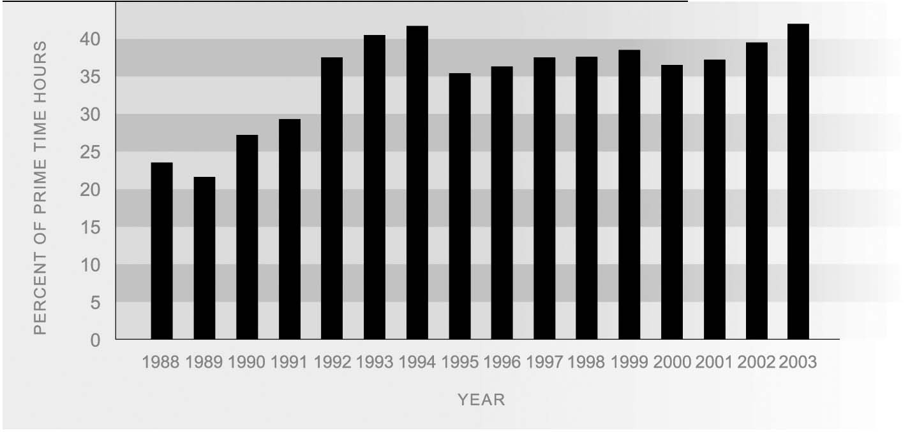
Source: New Zealand on Air (2004)
Note: These figures are for prime time (6pm-10pm) local content on TV One, TV2, and TV3 only
Since 1988, other free-to-air broadcasters (including Prime, a number of regional channels and the Mäori Television Service) as well as pay-television channels Sky (satellite) and Saturn (cable), have joined the three national television channels.
Table CI1.1 Percentage share of prime time local content by programme type, selected years, 1988-2003
Programme type | 1988 | 1990 | 1995 | 2000 | 2001 | 2002 | 2003
 | % | % | % | % | % | % | %
News, current affairs | 26 | 23 | 21 | 30 | 33 | 29 | 32
Information | 10 | 5 | 8 | 17 | 21 | 18 | 19
Sports | 24 | 39 | 31 | 20 | 13 | 18 | 14
Entertainment | 14 | 12 | 9 | 7 | 9 | 10 | 8
Children’s | 15 | 13 | 15 | 10 | 8 | 8 | 10
Drama/comedy | 2 | 1 | 7 | 6 | 6 | 6 | 6
Mäori | 6 | 3 | 3 | 6 | 6 | 5 | 6
Documentaries | 2 | 3 | 5 | 4 | 4 | 5 | 5
Children’s drama | 1 | 1 | 1 | 0 | 0 | 0 | 0
Total New Zealand  content hours | 2,112 | 4,249 | 5,018 | 6,185 | 6,190 | 7,201 | 6,526
Source: NZ On Air (2000) Appendix 3, p29; (2003) Figure 2, p8

Three programme types accounted for two-thirds of local content hours in 2003: news and current affairs (32 percent), information programmes (19 percent), and sports (14 percent). Hours of prime time sports content fell by 29 percent between 2002 and 2003, largely because in 2002, large sports events such as the Winter Olympics, the Commonwealth Games and the Louis Vuitton Cup were broadcast on prime time television.

INTERNATIONAL International comparisons are difficult due to inconsistencies in measurement
COMPARISON approaches by different countries. Available figures suggest that, while local content on New Zealand television is steadily increasing, in 1999 it accounted for 24 percent of total transmission time, and NZ had the smallest proportion of local content. This was compared to USA (90 percent), UK (BBC only, 78 percent), Canada (60 percent), Norway (56 percent), Finland (55 percent), Australia (which mandates a local content transmission quota of 55 percent on all free-to-air commercial networks) and Ireland (RTE only, 41 percent).⁷⁰ Note that this is a measure of total air time programming, rather than prime time programming, which is the measure the indicator in this report is based on.
Mäori language speakers
DEFINITION
The number of Mäori who reported in the census they could hold a conversation about everyday things in Mäori, as a proportion of the Mäori population.

RELEVANCE As a central component of Mäori culture, Mäori language is an important aspect of participation and identity. The Mäori language forms part of the broader cultural identity and heritage of New Zealand and in 1987 was granted the status of an official language of New Zealand.⁷¹

CURRENT LEVEL The 2001 Census showed that one-quarter of all Mäori (25 percent or 130,482 Mäori) and 28 percent of Mäori aged 15 and over (or 91,809) stated they could hold a conversation in Mäori about everyday things. Mäori accounted for 81 percent of the total number of Mäori language speakers (160,500). The 1996 Census also showed that the proportion of Mäori who speak te reo was around 25 percent, but because of changes in the census ethnicity measures this figure is not directly comparable with the figure for 2001.
The proportion of Mäori who were fluent Mäori speakers declined markedly over the last century, particularly following the rapid urbanisation of the Mäori population in the 1950s and 1960s. The first national Mäori language survey in 1973 estimated that the proportion of fluent speakers had fallen to 18 percent.
Information on the fluency of Mäori speakers is available from the survey of the health of the Mäori language, conducted in 2001. The survey showed that more people could understand Mäori (59 percent of Mäori aged 15 years and over, or 190,209) than speak it (42 percent, or 136,600). In terms of proficiency, while 42 percent could speak some Mäori, only 9 percent could speak Mäori ‘well’ or ‘very well’, 11 percent could speak Mäori ‘fairly well’, and 22 percent could speak Mäori but ‘not very well’. Similarly, while 59 percent of people could understand Mäori, only 15 percent could understand Mäori ‘well’ or ‘very well’, 18 percent could understand Mäori ‘fairly well’, and 25 percent could understand Mäori but ‘not very well’.⁷²
Figure CI2.1 Proportion of Mäori speakers in the Mäori population by age and sex, 2001
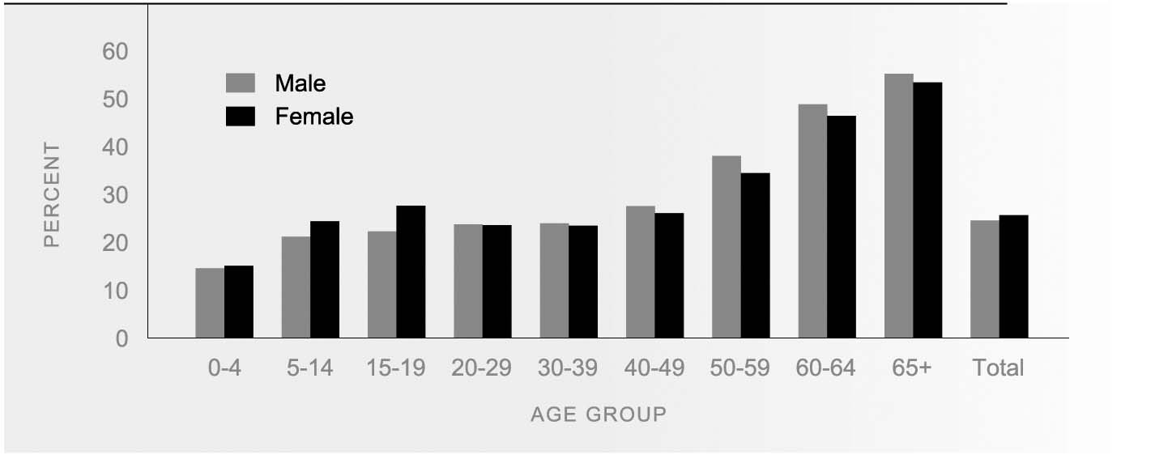
Source: Statistics New Zealand 2001 Census
AGE AND SEX Older Mäori are considerably more likely than younger Mäori to be able to converse
DIFFERENCES about everyday things in Mäori. In the 2001 Census, more than half of Mäori aged 65 and over (54 percent) reported having conversational fluency in the Mäori language, compared with less than one-quarter (22 percent) of Mäori under 40.
Sex differences in the proportion of Mäori language speakers were also apparent. From age 40 years onwards, males were more likely than females to be Mäori language speakers, while at younger ages (below 20 years) a higher proportion of females than males could speak Mäori.
Among non-Mäori, the proportion of Mäori language speakers was higher at the younger ages. Females were also more likely to be Mäori language speakers than males.

ETHNIC DIFFERENCES The 2001 Census showed that 4.5 percent of the total population could hold a conversation in Mäori. After Mäori, Pacific peoples had the highest proportion who could speak Mäori (5.8 percent), followed by Europeans (1.7 percent) and Asians (0.8 percent).

REGIONAL Mäori who live in areas with a high proportion of Mäori residents are the most likely to
DIFFERENCES be Mäori language speakers. Regions with the highest proportion of people with conversational Mäori skills were Gisborne (35 percent), Bay of Plenty (32 percent), Northland (30 percent), Waikato (28 percent) and Hawkes Bay (27 percent).

Language retention
DEFINITION
The proportion of people who can speak the ‘first language’ (excluding English) of their ethnic group, for ethnic groups (other than Mäori) with an established resident population in New Zealand, as recorded in the 2001 Population Census. Ability to speak a language is defined as being able to hold an everyday conversation in that language. ‘First language’ refers to an indigenous language associated with a given ethnicity, as opposed to the first language of a person. Sign language is not treated as a ‘first language’ for the purposes of this indicator.

RELEVANCE The ability to speak the language of one’s identified ethnicity is an indicator of the ability to retain and pass on one’s culture and traditions to future generations. Language is a central component of cultural identity.

CURRENT LEVEL In 2001, the proportion of people who could hold an everyday conversation in the ‘first language’ of their ethnic group varied widely between ethnic groups, from 17 percent of Cook Island Mäori to 81 percent of Koreans. In all ethnic groups, those who were born in New Zealand were less likely to be able to speak the ‘first language’ than those who were born overseas.
Figure CI3.1 Proportion of people who could speak the ‘first language’ of their ethnic group, by birthplace, 2001
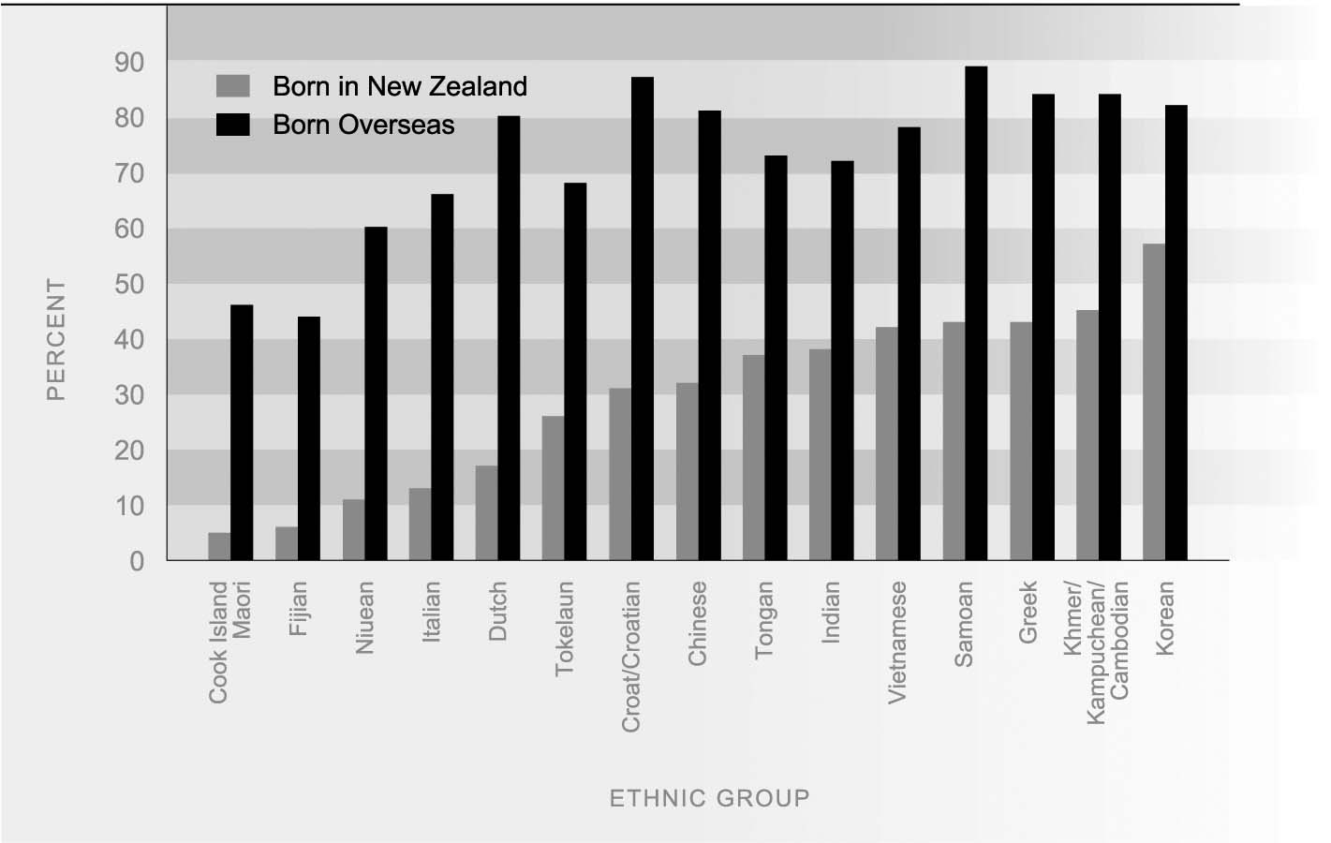
Source: Statistics New Zealand, 2001 Census, unpublished data
AGE AND SEX In all ethnic groups, young people were less likely than older people to be able to hold
DIFFERENCES an everyday conversation in the ‘first language’ of their ethnic group. The proportions were similar for males and females.
Table CI3.1 Proportion of people in selected ethnic groups who can speak the ‘first language’ of their ethnic group, by age group and sex, 2001
 | Age (years) |  |  | Sex |  | Total
 | 0-24 | 25-49 | 50+ | Males | Females
 | % | % | % | % | % | %
Pacific peoples
Samoan | 50 | 75 | 89 | 61 | 64 | 62
Cook Island Mäori | 7 | 26 | 53 | 16 | 18 | 17
Tongan | 44 | 66 | 73 | 53 | 54 | 54
Tokelauan | 27 | 57 | 76 | 38 | 43 | 40
Niuean | 13 | 38 | 61 | 24 | 27 | 26
Fijian (except Fiji Indian/  Indo-Fijian) | 14 | 36 | 50 | 26 | 26 | 26
Asian
Indian | 50 | 70 | 74 | 61 | 63 | 62
Chinese | 59 | 75 | 82 | 67 | 71 | 69
Khmer/Kampuchean/  Cambodian | 67 | 85 | 87 | 73 | 79 | 76
Vietnamese | 60 | 82 | 84 | 69 | 74 | 72
Korean | 78 | 84 | 84 | 80 | 82 | 81
European
Dutch/Netherlands | 21 | 63 | 81 | 59 | 60 | 59
Greek (incl. Greek Cypriot) | 27 | 73 | 89 | 64 | 61 | 63
Croat/Croatian | 41 | 70 | 81 | 66 | 63 | 65
Italian | 13 | 44 | 70 | 39 | 35 | 37
Source: Statistics New Zealand, 2001 Census, unpublished data

