DESIRED OUTCOMES
All people have the opportunity to enjoy long and healthy lives. Avoidable deaths, disease and injuries are prevented. All people have the ability to function, participate, and live independently or appropriately supported in society.
Health
Introduction
Good health is critical to wellbeing. Without it, people are less able to enjoy their lives to the fullest extent, their options are limited, and their general levels of contentment and happiness are likely to be reduced.
Good health has two core dimensions: how long people live and the quality of their lives. The desired outcomes recognise both aspects. As well as enjoying long lives, people want to be free from the pain, suffering and incapacity that injury and illness bring.
The desired outcomes also acknowledge that not all people can live fully independent lives. For some, illness or disability means they need support from families, government agencies or other networks. Getting this support is an important part of social wellbeing.
Injury and illness (both mental and physical) inhibit people's ability to participate in education, training and employment, leading to reduced economic standards of living. They can also reduce people’s ability to participate in other areas of life, such as family life, socialising with friends, joining community activities and taking part in recreation and leisure pursuits, which leads to feelings of frustration and isolation.
A range of factors affect and are affected by health outcomes, including genetic predisposition, behaviour, the physical and social environment and the availability of health services. Increasing attention is being paid to the interaction between socio-economic and health outcomes. People with low incomes, poor housing and few qualifications are likely to have disproportionately poorer health.¹¹

INDICATORS Six indicators are used in this chapter. Taken together, they provide an overall picture of the state of the nation’s health now and the likely trends in the future. They cover both the length and quality of life and include both physical and mental health. The indicators are: health expectancy, life expectancy, disability requiring assistance, suicide, cigarette smoking and obesity.
The first four indicators are relevant to the current state of the nation’s health. Together, they directly measure the desired outcomes relating to long and healthy lives, and people’s ability to participate in society. The last two indicators are strong predictors of future health outcomes.
Health expectancy refers to the number of years a person can expect to live independently, i.e. free of disability needing assistance from another person or from a complex assistive device. This is a summary measure of population health integrating both the length of life (life expectancy) and the quality of life (disability requiring assistance) dimensions of health.
The next two indicators measure each dimension of health separately. Life expectancy measures the survival experience of the population: how long people live. It is an indicator of fatal health outcomes. Disability requiring assistance measures non-fatal physical health outcomes and health-related quality of life. There may be some disquiet among the disability community about the inclusion of this indicator under the Health domain and whether having functional limitations necessarily, of itself, restrict people’s opportunity to live healthy lives, or to participate in society. People’s ability to participate in society also depends on the extent to which they receive the supports they need to enable them to live independently, and on the physical and social environment being accessible and inclusive.
The suicide rate serves as a proxy for mental health outcomes. Though the indicator covers the suicide rate for society as a whole, it includes details of youth suicide rates. New Zealand’s youth suicide rates are high by international standards.
The last two indicators are strong predictors of future health outcomes. The links between cigarette smoking and poor health are widely recognised. For example, cigarette smoking (active and passive) is a risk factor for many cancers, respiratory, and cardiovascular diseases, and has been linked with low birth weight, Sudden Infant Death Syndrome, and other adverse child health outcomes. Obesity is linked with poor health outcomes, such as increased risk of heart attacks, strokes, type 2 diabetes, and some cancers.¹²

Health expectancy
DEFINITION
The number of years a person could expect to live in good health. The particular measure of health expectancy used here is the number of years a person could expect to live independently, ie without any functional limitation (disability) requiring the assistance of another person or complex assistive device. Hence it is also described as independent life expectancy at birth.

RELEVANCE Health expectancy is a summary measure of population health that captures both the ‘quantity’ and ‘quality’ of life dimensions of physical health. Independent life expectancy at birth is a positive measure, capturing expectations of life free from disability requiring assistance. Improvements in health expectancy reflect changes in social and economic conditions, lifestyle changes, medical advances and better access to health services.

CURRENT LEVEL In 2001, males had an independent life expectancy at birth of 64.8 years. The figure for
AND TRENDS females was 68.5 years, a difference of 3.7 years. For the total population, independent life expectancy at birth has improved for females since 1996 but not for males (64.7 years for males and 67.5 years for females). This has resulted in an increase of almost one year in the overall sex gap in independent life expectancy at birth.
Figure H1.1 Independent life expectancy at birth, by sex, 1996, 2001
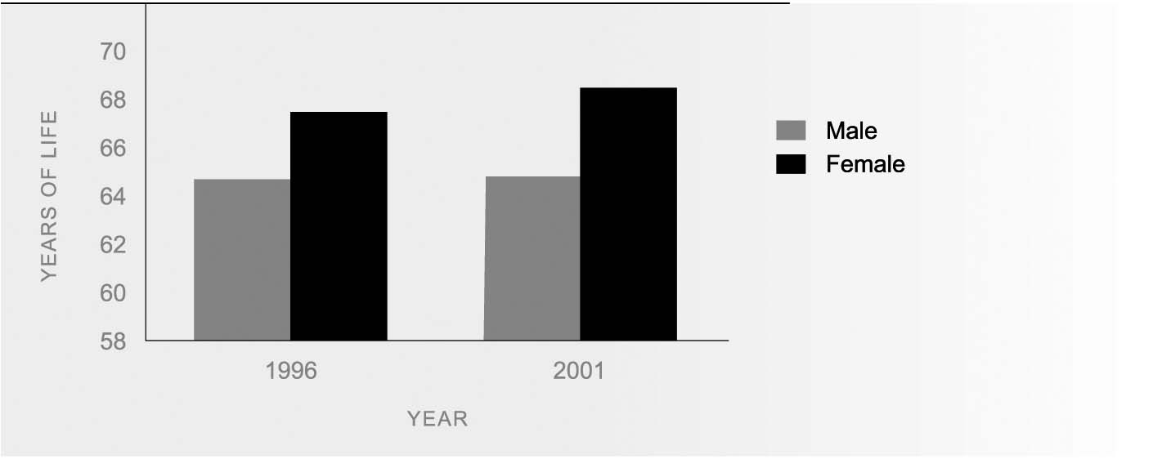
Source: Ministry of Health, revised data

ETHNIC DIFFERENCES Only partial (0-85 years) independent life expectancy can be estimated for ethnic comparisons because of the small number of Mäori aged over 85 years. These ethnic-specific statistics are not comparable with those for the total population.
There are large differences between Mäori and non-Mäori in their probability of living a long and healthy life. Revised estimates for 2001 indicate a newborn Mäori male had a partial (0-85 years) independent life expectancy of 58.0 years, compared to 65.2 years for a non-Mäori male, a gap of 7.2 years. The difference is greater for females: a Mäori female born in 2001 could expect to have a partial independent life expectancy 9.2 years less than her non-Mäori counterpart (59.0 years, compared to 68.2 years for non-Mäori females).
Between 1996 and 2001, partial (0-85 years) independent life expectancy improved marginally for Mäori males and non-Mäori females, but there was no change for non-Mäori males and Mäori females.
The sex gap for Mäori declined between 1996 and 2001.
Figure H1.2 Independent life expectancy, Mäori by sex ,1996, 2001
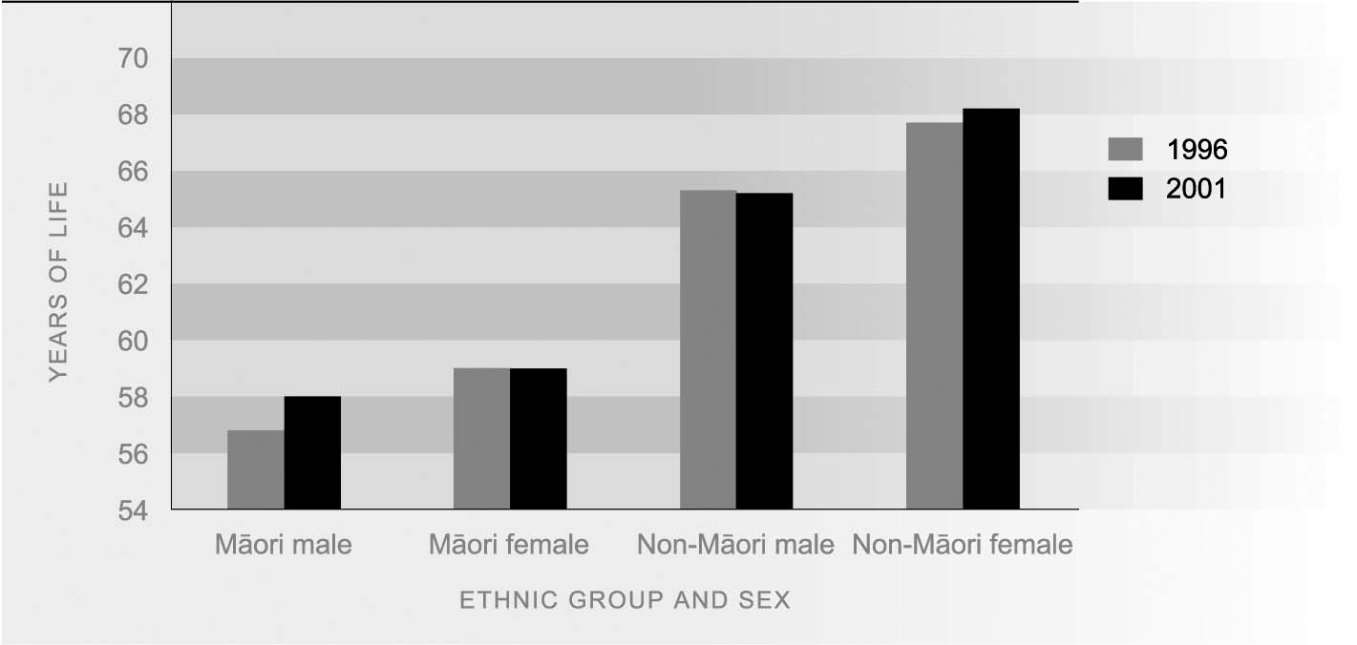
Source: Ministry of Health, revised data
Note: These Mäori, non-Mäori comparisons in independent life expectancy are based on estimates for the 0-85 year age group because of the small number of Mäori over 85 years of age

INTERNATIONAL In June 2000, the World Health Organisation (WHO) introduced a new health
COMPARISON expectancy measure, now called 'healthy life expectancy' (HLE). Unlike independent life expectancy, which uses a single disability threshold, HLE uses a continuous scale that includes all levels of disability. The necessary health state valuations required to construct this measure are not yet available for New Zealand. When these become available, the Ministry of Health intends to replace the independent life expectancy indicator with HLE.
Life expectancy
DEfinition
Life expectancy at birth indicates the total number of years a person could expect to live, based on the mortality rates of the population at each age in a given year.

RELEVANCE Life expectancy at birth is a key summary indicator of fatal health outcomes, ie the survival experience of the population.

CURRENT TRENDS In the period 2000-2002, life expectancy at birth was 76.3 years for males and 81.1
AND LEVELS years for females. Since the mid-1980s, gains in longevity have been greater for males than for females. Between 1985-1987 and 2000-2002, life expectancy at birth increased by 5.2 years for males and 4.0 years for females.
With the decline in the infant mortality rate (from 11.2 deaths per 1,000 live births in 1986 to 4.9 per 1,000 in 2003), the impact of infant death on life expectancy has fallen. The gains in life expectancy since the mid-1980s can be attributed mainly to reduced mortality in middle aged and older age groups (45-84 years). Reduced mortality rates are due to generational effects, better living standards, and improved public and personal health care.
Figure H2.1 Life expectancy at birth, by sex, 1985-87 to 2000-02
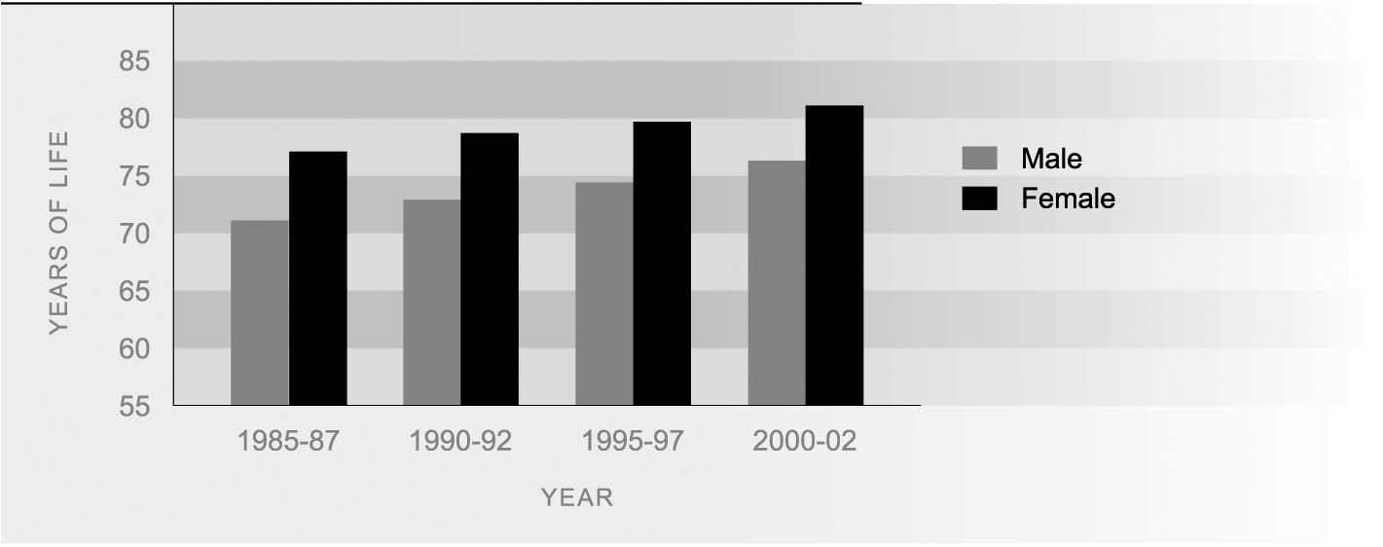
Source: Statistics New Zealand (2004)

ETHNIC DIFFERENCES There are marked ethnic differences in life expectancy. In 2000-2002, male life expectancy at birth was 77.2 years for non-Mäori and 69.0 years for Mäori, a difference of 8.2 years. Female life expectancy at birth was 81.9 years for non- Mäori and 73.2 years for Mäori, a difference of 8.7 years.
The pace of improvement in life expectancy has varied by ethnic group. For non- Mäori, there was a fairly steady increase in life expectancy at birth over the period from 1985-1987 to 2000-2002, males gaining 5.8 years and females 4.5 years overall. For Mäori, there was little change during the 1980s, but a dramatic improvement in the five years to 2000-2002. While the gain in Mäori life expectancy over the whole period 1985-1987 to 2000-2002 (4.1 years for males, 2.7 years for females), was less than that for non-Mäori, Mäori gained more than non-Mäori in the most recent five-year period.
As a result, the gap in life expectancy at birth between non-Mäori and Mäori, which widened by 2.4 years between 1985-1987 and 1995-1997, reduced by 0.6 years in the five years to 2000-2002.
Figure H2.2 Life expectancy at birth, by ethnic group and sex 1950-52 to 2000-02
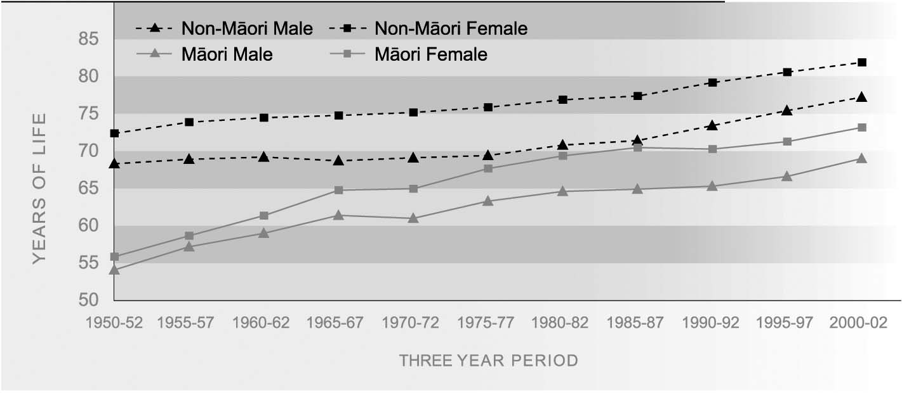
Source: Statistics New Zealand/Ministry of Health
Note: Figures for 1981-1996 have been adjusted for undercount, using Statistics New Zealand estimates for 1996

SOCIO-ECONOMIC There is an association between life expectancy and the level of deprivation in the area
DIFFERENCES where people live. In 1998-2000, males in the least deprived 10th of small areas in New Zealand could expect to live 9.5 years longer than males in the most deprived 10th of small areas (meshblocks with median populations of at least 90 people). For females, the difference was smaller, but still substantial, at 5.6 years. These figures clearly illustrate the links between socio-economic status and health.¹³

INTERNATIONAL In 2000, New Zealanders’ life expectancy at birth was 80.8 for females and 75.7 years
COMPARISON for males. This was equal to the OECD median of 80.8 years for females, and close to the OECD median of 75.2 years for males. New Zealand was ranked 14th out of 27 countries for females, and ninth equal for males. New Zealand’s ranking was more favourable than this in 1960 (sixth for males, seventh for females). Over the 1970s and 1980s, longevity improved faster in other OECD countries than in New Zealand. In the 1990s, faster than average gains in life expectancy in New Zealand improved its relative position. In 2000, life expectancy at birth was best for females in Japan (84.6 years) and best for males in Iceland (78.0 years). For females, life expectancy was slightly higher in Australia and Canada (both 82 years) than in New Zealand, similar in United Kingdom (80.2 years) and slightly lower in the United States (79.5 years). The pattern was similar for males: Australia (76.6 years), Canada (76.7 years), United Kingdom (75.4 years) and the United States (74.1 years).¹⁴
Disability requiring assistance
DEFINITION
The proportion of the population who acknowledge one or more functional limitations requiring assistance from either a person or a complex assistive device, either intermittently or on a daily basis.

RELEVANCE The disability requiring assistance prevalence rate is an important summary measure of non-fatal health outcomes.

CURRENT LEVEL In 2001, the age standardised prevalence rate of disability requiring assistance was 10.2
AND TRENDS percent for males and 9.3 percent for females. The rate has barely changed since 1996/1997, when it was 9.7 percent for males and 9.9 percent for females.
Figure H3.1 Disability requiring assistance prevalence rate by sex, 1996/97, 2001
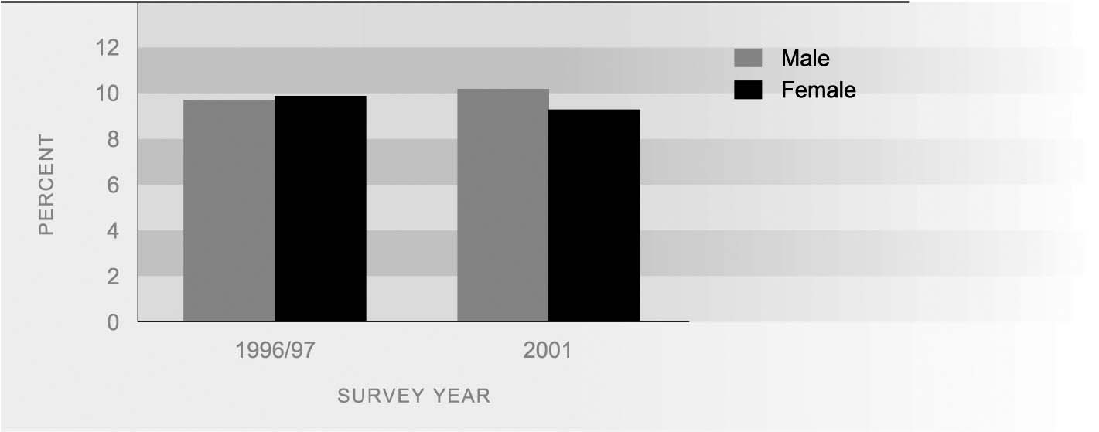
Source: Statistics New Zealand/Ministry of Health
Note: Age-standardised to the WHO World Population
Most people who have disabilities requiring assistance need only intermittent help. In 2001, 7.8 percent of males and 7.0 percent of females had this moderate level of disability. A further 2.4 percent of males and 2.3 percent of females had a more severe level of disability requiring daily help.

SEX DIFFERENCES On an age-standardised basis, the prevalence of disability requiring assistance is marginally higher among males than among females. However, because rates of disability requiring assistance are higher among older age groups, where women predominate, the majority of people with disability requiring assistance are women.

ETHNIC DIFFERENCES Mäori are more likely than non-Mäori to have a functional disability requiring assistance. In 2001, the disability requiring assistance prevalence rate for males was 13.4 percent for Mäori and 9.9 percent for non-Mäori. Prevalence rates for females were 14.5 percent for Mäori and 9 percent for non-Mäori. There was almost no change in levels of disability requiring assistance for Mäori from 1996-1997 to 2001.
Table H3.1 Disability requiring assistance prevalence rate, Mäori, non-Mäori, by level of functional disability, 2001
 | Moderate | Severe | Total
Mäori males  Mäori females | 9.4  9.9 | 4.0  4.6 | 13.4  14.5
Non-Mäori males  Non-Mäori females | 7.6  6.8 | 2.3  2.2 | 9.9  9.0
Total males  Total females | 7.8  7.0 | 2.4  2.3 | 10.2  9.3
Source: Ministry of Health
Note: Age-standardised to the WHO world population
Moderate = Requiring intermittent (ie non-daily) assistance
Severe = Requiring continuous or daily assistance, generally in the self-care domain

INTERNATIONAL The rate of disability requiring assistance in New Zealand appears to be higher than
COMPARISON that reported in similar studies in Australia, Canada and the United States, although this may be influenced by differences in the collection and classification of data.¹⁵
Suicide
DEFINITION
The number of suicide deaths per 100,000 population.

RELEVANCE Suicide is an indicator of mental health in the population and a major cause of death among younger adults.

CURRENT LEVEL In 2001, 499 people died by suicide, an increase from 458 in 2000 but fewer than the
AND TRENDS 516 recorded in 1999. The age-standardised¹⁶ suicide death rate was 11.7 per 100,000 in 2001, compared with 11.2 in 2000 and 12.6 in 1999. Over the 1980s and 1990s there was an upward trend in the suicide death rate, which reached a peak of 14.3 per 100,000 in 1998. Since then the trend has generally been downward and the 2001 rate was similar to the 1986 rate of 11.5 per 100,000.
Figure H4.1 Age-standardised suicide death rate by sex, 1986-2001
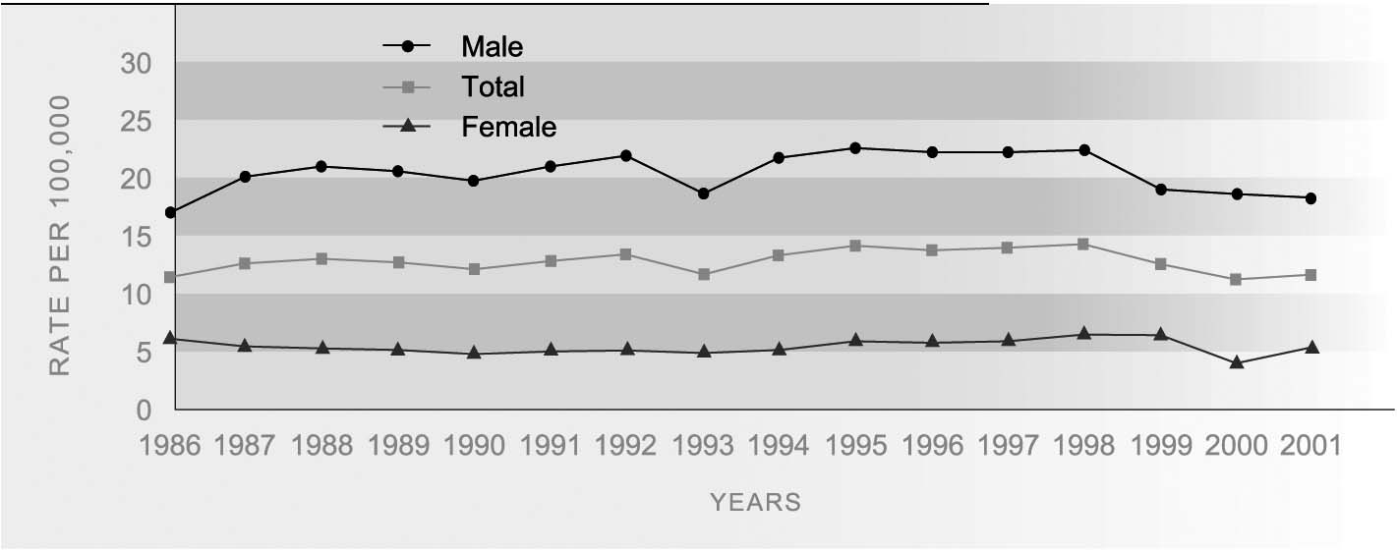
Source: Ministry of Health, New Zealand Health Information Service
Note: 2000 and 2001 figures are provisional. Age-standardised to Segi’s world population

SEX DIFFERENCES Males have a much higher rate of death by suicide than females, with 18.3 deaths per 100,000 males in 2001, compared with 5.5 deaths per 100,000 females. The difference is associated with choice of methods.¹⁷ The male suicide rate increased sharply in the late 1980s and declined after 1998, but was still higher in 2001 than it was in 1986. In comparison, the female rate has been relatively stable. It increased slightly during 1996-1999, fell in 2000 and rose in 2001 but not to the level it had been in 1999. Because of the small numbers involved, it is more reliable to consider the trend over several years.
While males account for most suicide deaths (77 percent in 2001), females account for the majority of recorded suicide attempts that do not result in death (66 percent in 2001/2002).

AGE DIFFERENCES In 2001, the 25–34-year age group had the worst rate of suicide death (21.4 per 100,000, or 118 deaths), followed by the 15–24-year age group (20.0 per 100,000, with 107 deaths). For many decades, the rate of suicide was consistently worst at ages 65 and over but this changed in the late 1980s during a steep increase in youth suicide. The youth suicide rate peaked in 1995, when there were 156 deaths (a rate of 28.7 per 100,000) and has fallen since 1998, though not to the levels recorded in the early 1980s. The pattern is similar for 25–34-year-olds. Suicide rates have been falling among people over 45 years and in 2001, the rate for age group 45-64 was the lowest (10.5 per 100,000). These age patterns may reflect, in part, cohort effects.
Figure H4.2 Suicide death rates by age group, 1984-1986 to 1999-2001
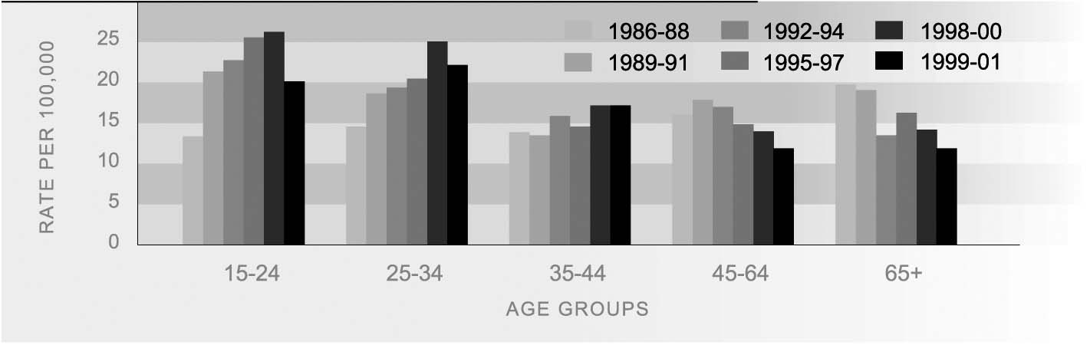
Source: Ministry of Health, New Zealand Health Information Service
Note: 1. Three-year average rates for 10-year age groups calculated by Ministry of Social Development
Note: 2. 2000 and 2001 figures are provisional

ETHNIC DIFFERENCES In 2001, there were 79 Mäori deaths from suicide, accounting for 16 percent of all suicides in that year. The age-standardised rate of suicide death was 13.4 per 100,000 for Mäori, compared to 11.2 for non-Mäori. The suicide rate for Mäori youth in 2001 was 28.0 per 100,000, compared with the non-Mäori rate of 18.1 per 100,000. Suicide deaths for both Mäori and non-Mäori were lower in 1999-2001 than in 1996-1998. Because of small numbers, trends in Mäori suicide rates should be treated with caution.
Table H4.1 Age-standardised suicide rates and number of suicide deaths, Mäori and non-Mäori, 1996-2001
Year | Age-standardised rate per 100,000 |  | Number
 | Mäori | Non-Mäori | Mäori | Non-Mäori
1996 | 17.5 | 12.9 | 95 | 445
1997 | 17.5 | 13.1 | 103 | 458
1998 | 19.2 | 13.1 | 112 | 465
1999 | 12.1 | 12.2 | 78 | 438
2000 | 13.1 | 10.7 | 80 | 378
2001 | 13.4 | 11.2 | 79 | 420
Source: Ministry of Health; New Zealand Health Information Service
Note: 2000 and 2001 figures are provisional. Age-standardised to Segi’s world population

INTERNATIONAL A comparison of age-standardised suicide rates in 12 OECD countries for the years
COMPARISON 1998-2001 shows that New Zealand’s rate for males was fifth worst at 18.4 per 100,000, while the female rate of 5.4 was the sixth worst.¹⁸ Finland had the worst male suicide rate (28.8 per 100,000 in 1999), while Japan had the worst female rate (9.3 per 100,000 in 2000). Australia (18.5) and Canada (17.9) had slightly worse rates of male suicide than New Zealand. The United Kingdom (9.9) and the United States (15.0) fared considerably better. In regards to females, Australia (4.5), Canada (4.6), the United Kingdom (2.6) and the United States (3.5) all reported better results than New Zealand.
Comparing youth suicide rates in the same 12 OECD countries, New Zealand had the worst male youth suicide rates, equal with Finland, and the second worst female youth suicide rates (after Norway). New Zealand is one of a small number of countries which have higher suicide rates at the younger ages.¹⁹
Prevalence of cigarette smoking
DEFINITION
The proportion of the population aged 15 and over who currently smoke cigarettes.

RATIONALE Tobacco smoking is a well-recognised risk factor for many cancers and for respiratory and cardiovascular diseases. In addition, exposure to environmental tobacco smoke (particularly maternal smoking) has been identified as a major risk factor for Sudden Infant Death Syndrome (SIDS) and respiratory problems in children. Internationally, smoking has been identified as the major cause of preventable death in OECD countries.²⁰

CURRENT LEVEL In 2002, 25 percent of New Zealanders aged 15 years and over were cigarette smokers.
AND TRENDS The prevalence of smoking has declined from 30 percent in 1986 with most of the decline occurring between 1987 and 1991. Since 1998 there has been little change.
Figure H5.1 Prevalence of cigarette smoking, 1986-2002
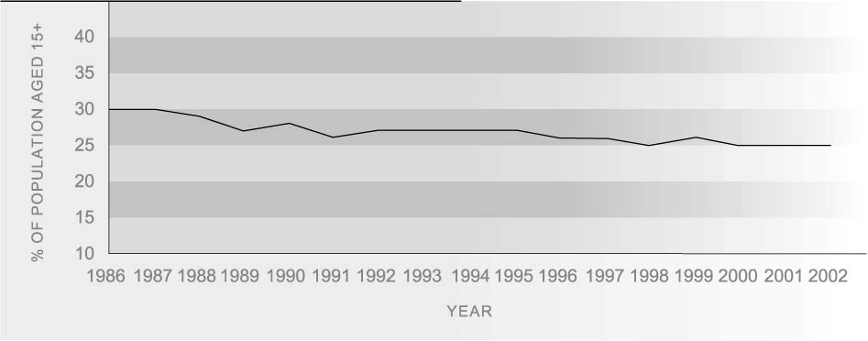Source: Ministry of Health (2003b) Appendix 1, Table 11

AGE AND SEX Smoking is most prevalent among people aged 25-34 years, followed by those aged 15-
DIFFERENCES 24 years, and those aged 35-54. Older people aged 55 and over are much less likely to smoke and have experienced the greatest decline in smoking prevalence over the past 15 years.
Smoking prevalence has been similar for both sexes since the mid-1980s. In 2002, the rate was 25 percent for males and 24 percent for females. Females are slightly more likely than males to smoke at ages 15-34, but for those aged 35 and over, smoking has generally been more prevalent among males; over the 1990s, both sexes became less likely to smoke.
Table H5.1 Prevalence of smoking by sex and age group, 2001
 | Percentage in each group who smoke cigarettes
 | 15-24 | 25-34 | 35-54 | 55+ | Total
Male | 31.6 | 31.1 | 26.7 | 13.6 | 25.2
Female | 33.2 | 32.0 | 25.3 | 11.1 | 23.9
Source: Ministry of Health (2003b) Appendix 1, Table 6

ETHNIC DIFFERENCES Mäori women have the highest smoking prevalence (52 percent), followed by Mäori men (39 percent). Among Pacific peoples, smoking is more prevalent among men (35 percent) than among women (29 percent).
Since the early 1990s, smoking prevalence has declined by about three percentage points for European/Other ethnic groups but has remained relatively unchanged for Mäori and Pacific peoples.²¹
Table H5.2 Age-standardised prevalence of smoking by sex and ethnicity, 2002
 | Percentage in each ethnic group who smoke cigarettes
 | Mäori | Pacific peoples | European/Other | Total
Male | 39.3 | 34.6 | 23.8 | 26.2
Female | 51.9 | 28.5 | 20.6 | 25.5
Total | 46.4 | 31.9 | 22.1 | 25.8
Source: Ministry of Health (2003b) Table 1
Note: Rates are age-standardised using the WHO world population

SOCIO-ECONOMIC Smoking is more prevalent among those with lower incomes, beneficiaries, and those
DIFFERENCES living in the most deprived areas. An analysis of 1996 Census data shows that the proportion of smokers in the most deprived (decile 10) areas is two to three times the proportion of smokers in the least deprived (decile 1) areas for all age groups, and for both men and women.²²

INTERNATIONAL In a 2001 comparison of adult smoking prevalence rates, New Zealand had a rate of 25
COMPARISON percent, compared with an OECD median of 27 percent.²³ New Zealand ranked eighth best out of 17 OECD countries. Smoking prevalence was worst in the Netherlands (34 percent). New Zealand’s rate was slightly better than that of the United Kingdom (27 percent), but considerably worse than those of Australia (19.8 percent), the United States (18.5 percent) and Canada (18.0 percent). When compared to other developed countries, New Zealand smoking levels are relatively low for males and relatively high for females.²⁴
Obesity
DEFINITION
The proportion of the population aged 15 and over who are obese. Obesity is defined as having a Body Mass Index (BMI) greater than 30 for New Zealand European/Other, or greater than 32 for Mäori and Pacific people.²⁵ For the population under 15, the measure is the proportion of children aged 5-14 years whose BMI met an international definition of obesity in the 2002 National Children’s Nutrition Survey.²⁶

RATIONALE Obesity is associated with heart disease, diabetes, stroke, high blood pressure and some cancers. The increase in the prevalence of obesity has been identified as a major cause of the projected increase in diabetes.²⁷

CURRENT LEVEL In 1997, 17 percent of adults aged 15 and over were obese (15 percent of adult males
AND TRENDS and 19 percent of adult females). In 2002, 10 percent of children aged 5-14 years were obese.
In New Zealand, obesity is becoming increasingly common, with a 50 percent increase in adult obesity from the late 1980s to the mid-1990s. In 1989/1990, obesity was found in 10 percent of adult males and 13 percent of adult females.²⁸
Internationally, increasing levels of obesity are related to social changes, including easier access to foods high in fat and energy, shifts towards less physically demanding work, increased use of automated transport, labour-saving technology in the home, and passive leisure.
Figure H6.1 Proportion of the population aged 15+ who are obese, by age group & sex, 1997
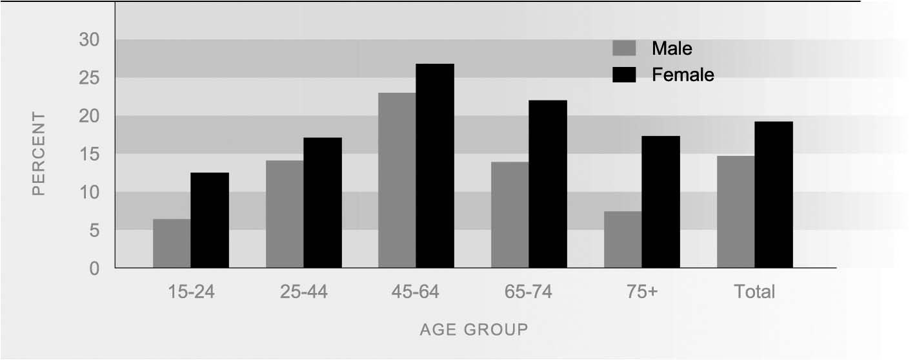
Source: Ministry of Health (1999d) p170. Rates for 15-24-year-olds derived by Ministry of Health

AGE AND SEX Obesity increases with age, peaking at the 45-64 year age group (23 percent for males,
DIFFERENCES 27 percent for females), then declining at the older age groups. This age pattern may reflect in part a cohort effect. Adult females are more likely than adult males to be obese. This pattern is also evident among children aged 7-14 years. The sex difference in obesity is greatest at ages 65 years and over.
ETHNIC DIFFERENCES Mäori and Pacific people have higher rates of obesity than other ethnic groups. Among adults in 1997, 28 percent of Mäori females and 27 percent of Mäori males were obese. For Pacific adults, the figures were 47 percent for females and 26 percent for males. This compares with 17 percent for European/Other females and 13 percent for European/Other males. Among children aged 5-14 in 2002, there was a similar pattern (Pacific children: 31 percent and 26 percent for females and males respectively; Mäori children: 17 percent, 16 percent; European/Other: 6 percent, 5 percent).
Figure H6.2 Proportion of the population aged 15+ who are obese, by sex & ethnic group, 1997
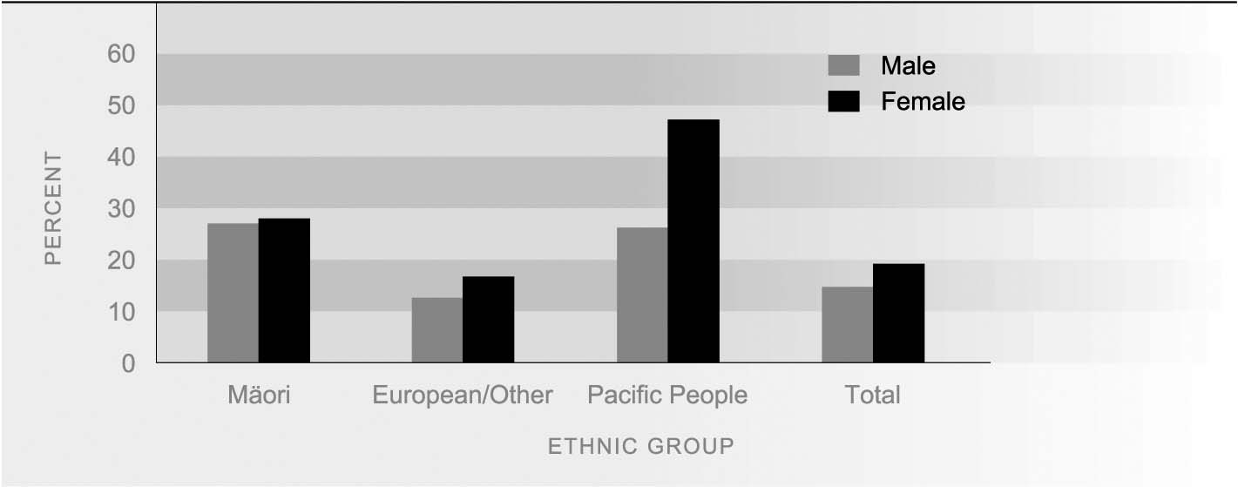
Source: Ministry of Health (1999d) p171
Table H6.1 Obesity prevalence rates, Mäori, non-Mäori, 1989/1990, 1997
 | 1989/1990 |  | 1997
 | Mäori % | Non-Mäori % | Mäori % | Non-Mäori %
Male | 19.3 | 8.7 | 27.2 | 13.1
Female | 20.0 | 12.2 | 27.9 | 18.1
Source: Ministry of Health (1997) and Russell and Wilson (1991)
Note: Rates are age-standardised using the WHO world population

SOCIO-ECONOMIC For females, there is an association between obesity and the level of deprivation in the
DIFFERENCES area where people live. Females living in the least deprived quartile of small areas in New Zealand had the lowest level of obesity (13.1 percent), while those in the most deprived quartile had the highest level (25.4 percent). This relationship was not statistically significant for males.²⁹

INTERNATIONAL New Zealand has a relatively high prevalence of obesity compared with other OECD
COMPARISON countries, with a rate of 17 percent in 1997, compared to an OECD median of 11.5 percent. New Zealand ranked poorly at twenty-second out of 27 countries in the late 1990s. The United States had the worst rate of obesity (31 percent in 1999). The United Kingdom (22 percent in 2001) and Australia (21 percent in 1999) also had higher obesity rates than New Zealand, while the rate in Canada was slightly lower (15 percent in 2001). Japan has the lowest prevalence of obesity (3 percent in 2001).³⁰

