DESIRED OUTCOMES
All people have the knowledge and skills they need to participate fully in society. Lifelong learning and education are valued and supported. All people have the necessary skills to participate in a knowledge society.
Knowledge and Skills
INTRODUCTION
Knowledge and skills enhance people’s ability to meet their basic needs, widen the range of options open to them in every sphere of life, and empower them to influence the direction their lives take. The skills people possess can also enhance people’s sense of self-worth, security and belonging.
We now live in a ‘knowledge society’, where access to information and proficiency with technology are becoming increasingly important. An inclusive society will increasingly require all people to have high levels of knowledge and skills.
Knowledge and skills include not only education and training, but also abilities gained though work and daily life: for example, parenting skills or skills relevant to recreation or leisure activities.
For many people, the acts of learning and of mastering new skills are important in themselves. Possession of knowledge and skills can be integral to a person’s sense of belonging and self-worth: many people define themselves by what they can ‘do’, not only in employment but elsewhere in life.
Knowledge and skills relate directly to employment decisions and career choices. Those with relatively few educational qualifications are more likely to be unemployed and, on average, have lower incomes when in work. This affects not only the economic standard of living people are able to enjoy, but also their security and ability to make choices about their lives. Knowledge and skills are important for gaining access to services and for understanding and exercising civil and political rights.

INDICATORS Five indicators are used in this chapter. Each provides a snapshot of New Zealanders’ acquisition of knowledge and skills at a particular stage in their lives, from early childhood to school leaving age to adulthood. The indicators are: participation in early childhood education, the number of school leavers with higher qualifications, the overall educational attainment of the adult population, adult literacy in English, and participation in tertiary education.
The focus of four of the five indicators is on formal education and training. This reflects the importance of formal education and training and the availability of data.
The indicators are relevant to both current and future social wellbeing. Participation in early childhood education is included because early childhood contributes significantly to a child’s later development. Going to kindergarten, köhanga reo or some other pre-school institution prepares children for further learning and helps equip them to cope socially at school. Quality early childhood programmes can help narrow the achievement gap between children from low-income families and more advantaged children.³¹
Students who attain higher qualifications (Sixth Form Certificate or higher) at school have a wider range of options for higher education and future employment. Those who leave school early are at greater risk of unemployment or having low incomes.³²
Educational attainment of the adult population provides a broad picture of New Zealanders’ overall attainment of knowledge and skills. It is influenced by factors not measured in the other indicators, such as adults gaining new qualifications and new migrants arriving with qualifications.
Literacy is a fundamental skill. A good level of literacy in English, including numeracy and the ability to understand documents and tables, is vital in the workplace and in everyday life.
Participation in tertiary education opens up career opportunities and provides people with the skills they need to participate in society. This has become particularly important with increasing dependence on ‘knowledge’ industries that require well-educated, highly-skilled workforces. It also captures aspects of lifelong learning through the participation of adults in tertiary education.

Participation in early childhood education
DEFINITION
The number of enrolments of children aged three and four years in early childhood centres or home-based education programmes as a proportion of all 3- and 4-year-olds. The measure includes all forms of organised and sustained centre and home-based programmes designed to foster learning and emotional and social development in children. The measure overestimates participation because children enrolled in more than one early childhood centre will be double-counted. Information from an alternative measure which avoids double counting, the proportion of Year One students who participated in early childhood education, is also included.

RELEVANCE Evidence from New Zealand and international research shows that the early years of childhood are vital to a child’s development and future ability to learn.³³ Quality early childhood programmes prepare young children socially, physically, and academically for entry into primary education and can help narrow the achievement gap separating children from low-income families from more advantaged children.

CURRENT LEVEL As at 1 July 2003, the ‘apparent’ early childhood education participation rate for 3-
AND TRENDS year-olds was 94 percent and for 4-year-olds it was 102 percent, indicating that some 4-year-olds attend more than one service. These figures represent a substantial increase from 43 percent and 73 percent respectively in 1986. Much of the growth in participation in early childhood education occurred in the five years between 1986 and 1991 with slower growth in subsequent years.
Figure K1.1 Early childhood education “apparent” participation rate, 3-4 years olds, 1986-2003
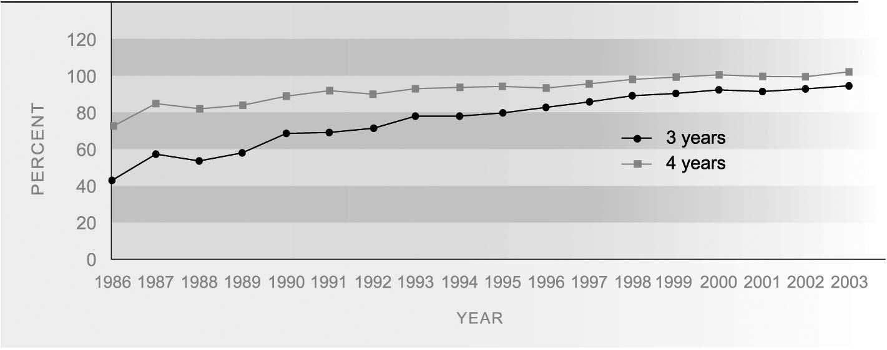
Source: Ministry of Education, Ministry of Social Development
Note: These figures overestimate the true participation rate. Rates in excess of 100 percent are possible, because children can be enrolled in more than one service
A new measure of early childhood education participation, which avoids the problem of double-counting, comes from information collected when children are in Year One at school. This shows that, as at July 2003, 94 percent of all Year One students had attended some form of early childhood education service before starting school. This compares with 91 percent of Year One students in 2000.

ETHNIC DIFFERENCES There are marked ethnic differences in the proportion of Year One students who had attended an early childhood education service, with European students being the most likely to have attended: 97 percent compared with 88 percent of Mäori and 83 percent of Pacific Year One students in 2003. However the gap in participation rates declined in the three years to 2003.
Table K1.1 Early childhood education attendance by Year One students, by ethnic group, as at 1 July 2000-2003
 | European | Mäori | Pacific | Asian | Other | Total
2000 | 95.4 | 84.8 | 76.1 | 89.2 | 83.0 | 91.0
2001 | 96.0 | 85.3 | 76.3 | 89.8 | 84.1 | 91.3
2002 | 96.6 | 86.5 | 79.4 | 92.1 | 86.6 | 92.3
2003 | 97.4 | 88.4 | 83.4 | 92.4 | 88.9 | 93.5
Source: Ministry of Education
Note: These figures exclude cases for which attendance was unknown and differ from those published in The Social Report 2003

PARTICIPATION BY In 2003, childcare centres (40 percent) and kindergartens (39 percent) catered for the
TYPE OF EARLY largest group of enrolments of 3- and 4-year-olds in early childhood education. Much
CHILDHOOD smaller proportions were enrolled in play centres (6 percent) and köhanga reo (5
EDUCATION SERVICE percent).
School leavers with higher qualifications
DEFINITION
The proportion of secondary school leavers who leave school with Sixth Form Certificate in at least one subject, or with a higher qualification.

RELEVANCE Upper secondary education serves as the foundation for higher (post-secondary) learning and training opportunities as well as preparation for direct entry into the labour market. Those who leave school early with few qualifications are at a much greater risk of unemployment or vulnerability in the labour force and of having low incomes.³⁴

CURRENT LEVEL In 2002, 63 percent of school leavers (33,000) left school with at least Sixth Form
AND TRENDS Certificate. This proportion has increased considerably from 47 percent in 1986. However, most of the increase occurred in the late 1980s. Since 1990, the proportion has fluctuated between 63 percent and 66 percent.
The proportion of school leavers attaining an A or B Bursary or Scholarship also increased during the period 1986 to 1991 and has remained around 18-22 percent over the past decade. In 2002, 19 percent of school leavers (10,000) had attained an A or B Bursary.
The lack of growth in the proportion of school leavers with higher qualifications since the early 1990s may be partly explained by an increase in employment and training opportunities for those without higher qualifications. Trends in the proportion of school leavers with higher qualifications are also influenced by changes in policy – such as the school leaving age – as well as student achievement.
Table K2.1 Proportion (%) of school leavers with higher qualifications, by sex, selected years,
1986-2002
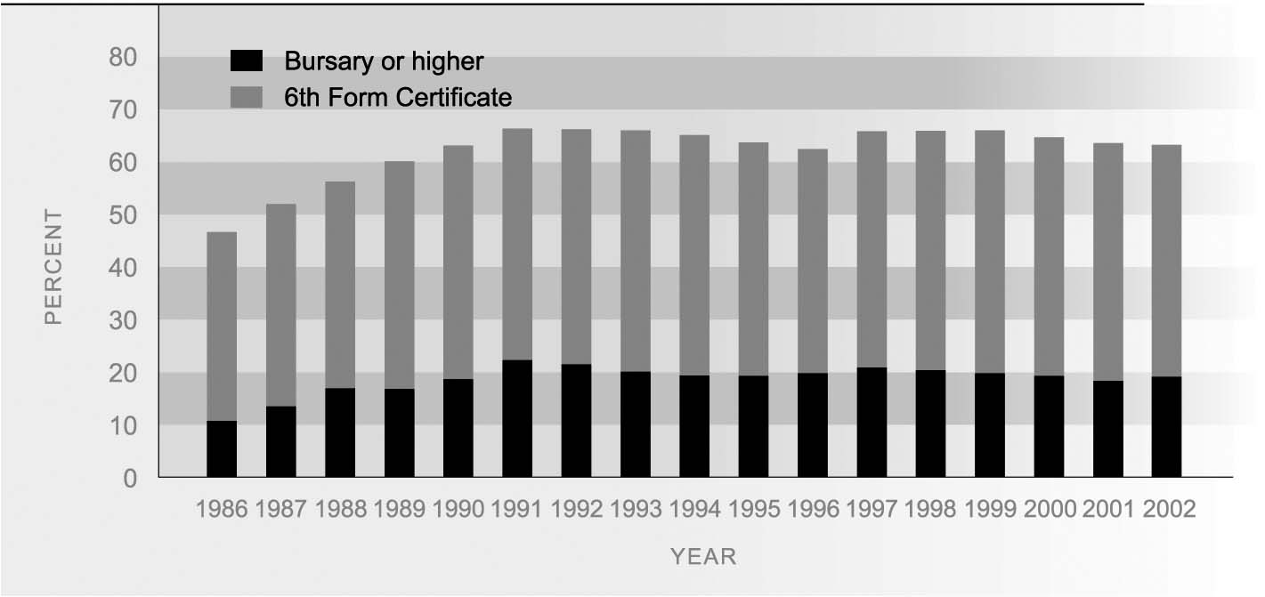
Source: Ministry of Education
Note: Bursary or higher includes A or B Bursary, Scholarship (to 1989) and National Certificate Level 3 or above (from 1996)

SEX DIFFERENCES In 2002, 68 percent of female school leavers had Sixth Form Certificate or higher qualifications compared to 59 percent of males. Between 1986 and 2002 the proportion of school leavers with at least Sixth Form Certificate improved at a faster rate for females than for males.
Table K2.1 Proportion (%) of school leavers with higher qualifications, by sex, selected years 1986-2002
 | Sixth Form Certificate or higher |  | Bursary or higher
 | Male | Female | Male | Female
1986 | 45.2 | 48.1 | 11.6 | 10.0
1991 | 63.5 | 69.2 | 21.1 | 23.4
1996 | 59.0 | 66.5 | 17.8 | 22.0
2001 | 59.4 | 68.1 | 15.8 | 21.2
2002 | 59.0 | 67.6 | 16.7 | 21.5
Source: Ministry of Education

ETHNIC DIFFERENCES Mäori lag considerably behind other ethnic groups in the qualifications they attain at school. In 2002, 39 percent of Mäori school leavers and 54 percent of Pacific school leavers attained Sixth Form Certificate or a higher qualification. This compares with 68 percent of European students and 84 percent of Asian students.
There is also a substantial difference between ethnic groups in the proportions leaving school with Bursary or similar higher qualifications. In 2001, 4 percent of Mäori and Pacific school leavers gained an A or B Bursary or National Certificate at Level 3 or above, compared with 22 percent of European and 41 percent of Asian school leavers. There has been little change in these proportions over the decade to 2002.
Table K2.2 Proportion (%) of school leavers with higher qualifications by ethnic group, 1991, 1996, 2001, 2002
 | European | Mäori |  | Pacific | Asian | Other | Total
Sixth Form Certificate or higher
1991 | na | 37.4 |  | 52.2 | na | na | 66.3
1996 | 68.9 | 37.4 |  | 53.7 | 81.5 | 60.0 | 62.7
2001 | 68.5 | 40.6 |  | 54.7 | 84.7 | 63.7 | 63.6
2002 | 68.4 | 38.9 |  | 53.5 | 84.4 | 67.7 | 63.3
Bursary or higher
1991 | na | 5.1 |  | 7.4 | na | na | 22.3
1996 | 23.7 | 4.1 |  | 5.8 | 41.7 | 18.8 | 19.9
2001 | 21.2 | 4.0 |  | 4.7 | 42.2 | 20.5 | 18.4
2002 | 22.2 | 3.9 |  | 4.2 | 41.3 | 21.1 | 19.1
Source: Ministry of Education
Note: Bursary or higher includes A or B Bursary, Scholarship (to 1989) and National Certificate Level 3 or above (from 1996)

SOCIO-ECONOMIC Young people from schools that draw their students from low socio-economic DIFFERENCES communities are less likely than other young people to attain higher school qualifications. In 2002, only 45 percent of school leavers from decile 1-3 schools (in the most disadvantaged communities) attained Sixth Form Certificate or higher qualifications, compared with 60 percent of those leaving decile 4-7 schools and 77 percent of those leaving decile 8-10 schools.

Educational attainment of the adult population
Definition
The proportion of adults aged 25-64 years with educational attainment of at least upper secondary school level.

RELEVANCE The educational attainment of the adult population is an indicator of the skills available in the economy. The level of formal educational qualifications in the population is a commonly used proxy for the stock of ‘human capital’ ie the skills available in the population and labour force.

CURRENT LEVEL At June 2003, 74 percent of the population aged 25-64 years (1.5 million people) had
AND TRENDS attained an educational qualification of upper secondary level or above. This proportion has steadily increased from 62 percent in 1991. Over the same period the proportion of adults with a bachelor’s degree or higher qualification has risen from 8 percent to 15 percent (297,000). While some of the increase is due to adults gaining additional qualifications, most of the upward trend is due to new entrants to the 25-64 age group (young people and migrants) being better qualified on average than people reaching retirement age.
Figure K3.1 Proportion of adults aged 25-64 with educational achievement of at least upper secondary level and tertiary level, 1991-2003
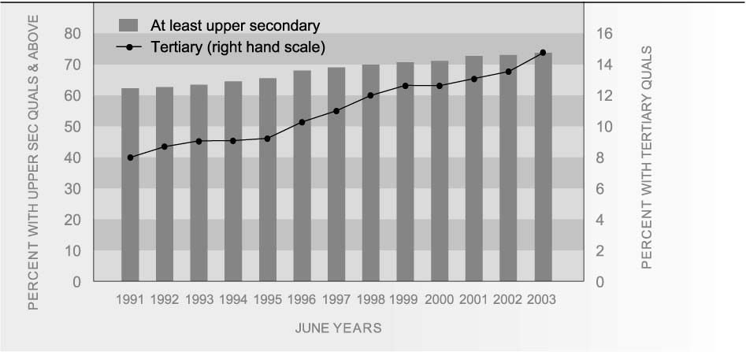
Source: Statistics New Zealand, Household Labour Force Survey
Note: Tertiary = bachelor’s degree or higher

AGE AND SEX Younger adults aged 25-34 years are much more likely to have at least upper secondary
DIFFERENCES school qualifications than adults aged 55-64 (79 percent, compared to 61 percent). Similarly, young adults are more likely than older people to have tertiary qualifications (18 percent, compared to 9 percent).
Sex differences in educational attainment have narrowed over time. In 2003, women were more likely than men to have higher educational qualifications at ages 25-34. In contrast, at older ages men are much more likely than women to have higher educational qualifications.
Table K3.1 Proportion (%) of population aged 25-64 with higher qualifications, by age and sex, 2003
 | 25-34 | 35-44 | 45-54 |  | 55-64 | Total 25-64
At least upper secondary
Males | 78.7 | 77.9 | 75.3 |  | 66.2 | 75.3
Females | 80.2 | 76.5 | 70.8 |  | 55.4 | 72.3
Total | 79.5 | 77.2 | 73.0 |  | 60.8 | 73.7
Tertiary
Males | 17.1 | 17.0 | 16.3 |  | 12.0 | 16.0
Females | 19.2 | 14.6 | 12.3 |  | 6.3 | 13.8
Total | 18.2 | 15.8 | 14.3 |  | 9.1 | 14.8
Source: Statistics New Zealand, Household Labour Force Survey
Note: Tertiary = bachelor’s degree or higher

ETHNIC DIFFERENCES Mäori and Pacific adults are much less likely than European and Other ethnic groups to have higher qualifications. In the year ended June 2003, 62 percent of Mäori and 50 percent of Pacific adults aged 25-64 held upper secondary qualifications, compared to 78 percent of Europeans. Similarly, just 6 percent of Mäori and 7 percent of Pacific adults held a tertiary qualification at bachelor’s degree level or above, compared to 15 percent of Europeans. However, since 1991, growth in the proportion of adults with higher qualifications was fastest among Mäori and Pacific adults.
The growth in the proportion of Pacific peoples with higher qualifications reflects the increasing proportion of the Pacific population who are born and educated in New Zealand. The relatively high percentage of the ‘Other’ ethnic group with higher qualifications reflects the selective process of immigration, which tends to target those with higher qualifications.
Table K3.2 Proportion (%) of population aged 25-64 with higher qualifications, by ethnic group, selected years, 1991-2003
 | European | Mäori |  | Pacific | Other | Total
At least upper secondary
1991 | 66.1 | 39.3 |  | 27.9 | 57.7 | 62.3
1996 | 72.2 | 47.4 |  | 38.1 | 59.9 | 68.0
2002 | 76.9 | 59.6 |  | 49.8 | 67.5 | 73.0
2003 | 77.6 | 62.3 |  | 50.2 | 67.5 | 73.7
Tertiary
1991 | 8.4 | 1.3 |  | .s | 19.7 | 8.0
1996 | 10.4 | 2.3 |  | 2.2 | 27.1 | 10.2
2002 | 13.5 | 5.5 |  | 5.8 | 31.5 | 13.7
2003 | 14.6 | 6.0 |  | 7.4 | 32.2 | 14.8
Source: Statistics New Zealand, Household Labour Force Survey
Note: .s = sampling error too high for publication; Tertiary = bachelor's degree or higher

INTERNATIONAL In 2001, 76 percent of New Zealand adults had at least upper secondary level
COMPARISON qualifications, compared with an OECD median of 67 percent.³⁵ New Zealand ranked 12th out of 30 OECD countries. New Zealand also ranked 15th (equal with Ireland and Hungary) in the proportion who have completed tertiary qualifications to bachelor’s degree or higher, with a rate of 14 percent (the same as the OECD median). Countries which had higher proportions of adults with tertiary qualifications at this level included the United States and Norway (both 28 percent - the highest rate), Canada (20 percent), Australia (19 percent), and the United Kingdom (18 percent).
Adult literacy skills in English
DEFINITION
The proportion of the population aged 16-65 with literacy skills in English (defined as prose, document and quantitative skills at Level 3 or above), as measured in the 1996 International Adult Literacy Survey (IALS). Level 3 is a ‘suitable minimum for coping with the demands of everyday life and work in a complex, advanced society. It denotes roughly the skill level required for successful secondary school completion and college entry’.³⁶ Prose literacy is the ability to understand and use information from texts including editorials, news stories, brochures and instruction materials. Document literacy is the ability to locate and use information contained in formats, including maps, tables and job application forms. Quantitative literacy is the ability to apply arithmetic operations to numbers embedded in printed materials, such as balancing a chequebook or completing an order form.

RELEVANCE The increasing complexity of our society and the need for a more flexible and highly educated workforce mean that individuals need to be able to understand and apply information of varying difficulty from a range of sources to function effectively at work and in everyday life. The IALS was designed to measure adult literacy skills in English by assessing proficiency levels, using test materials derived from specific contexts within countries.

CURRENT LEVEL Results from the first international literacy survey in 1996 show that 54 percent of New Zealand’s population aged 16-65 had prose literacy skills at Level 3 or above, 50 percent had document skills at Level 3 or above, and 51 percent had quantitative skills at Level 3 or above.
Figure K4.1 Proportion of adults aged 16-65 years with higher literacy skills, by age group, 1996
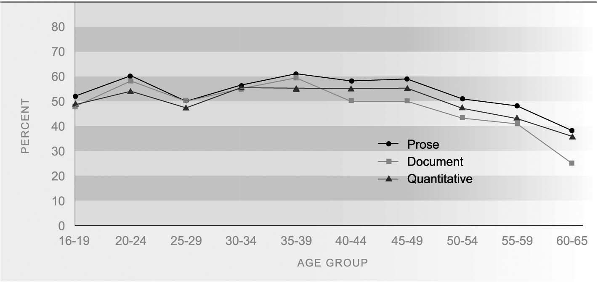
Source: OECD (2000c)
AGE DIFFERENCES Across all three domains the proportion of people with literacy skills above or at Level 3 and above was broadly similar for people aged 16-49 but then declined with age for people aged over 50. Poorer literacy levels among those aged over 50 may be due either to differences in the education received by older people or to a decline in these skills as people age.

SEX DIFFERENCES Women performed better than men in prose literacy (58 percent at Level 3 or above compared with 50 percent for men). The reverse was true in respect of quantitative skills: 55 percent of men had quantitative literacy skills at Level 3 or above, compared with 47 percent of women. Differences between men and women in respect of document literacy skills at those levels were negligible.

ETHNIC DIFFERENCES Across all three domains, over half of all Europeans had literacy skills at Level 3 or above. Pacific peoples consistently had the smallest proportions at this level (less than a third in each domain). Mäori had a larger proportion than other non-European ethnic groups in prose literacy at Level 3 or above but a smaller proportion in the document and quantitative literacy domains.
Table K4.1 Proportion (%) of adults aged 16-65 years with higher level literacy skills (Level 3 or above), 1996

 | Prose literacy | Document literacy | Quantitative literacy
European | 61 | 56 | 57
Mäori | 36 | 30 | 30
Pacific | 27 | 25 | 28
Other | 32 | 34 | 37
Total | 54 | 50 | 51
Source: Ministry of Education (2001b)
Among Mäori and Pacific adults, there were considerable sex differences favouring males in the document and quantitative domains that were not evident among Europeans. For example, only 18 percent of Pacific females were at Level 3 or above for quantitative literacy compared with 42 percent of Pacific males. The sex disparity was not as great among Mäori but was still substantial, with 26 percent of females at Level 3 or above for quantitative literacy compared with 36 percent of males.³⁷

INTERNATIONAL New Zealand’s prose literacy rate of 54.2 percent was close to the OECD median of
COMPARISON 53.5, and placed New Zealand seventh out of 17 OECD countries.³⁸ The top prose literacy performer in the OECD was Sweden (72.1). Outcomes for other countries include Canada (57.8), Australia (55.8), the United States (53.5) and the United Kingdom (47.9). New Zealand had a document literacy score of 49.5 percent, slightly lower than the OECD median of 52.9. This placed New Zealand 13th in the OECD for document literacy. Scores for other countries included: Canada (57.2), Australia (55.1), the United States (50.4) and the United Kingdom (49.6). Concerning quantitative literacy, New Zealand scored 50.6 percent. This was significantly lower than the OECD median of 57.0 and ranked New Zealand at 12th place. Canada scored 57.0, Australia (56.8), the United States (53.8) and the United Kingdom (49.0).³⁹
Participation in tertiary education
DEFINITION
The proportion of the population aged 15 and over enrolled on 31 July in formal tertiary education leading to a recognised New Zealand qualification. Tertiary education providers include public institutions (universities, polytechnics, colleges of education, wänanga), and private tertiary education providers receiving government funding or approval, or registered with the New Zealand Qualifications Authority. Qualifications range from certificates and diplomas to bachelor and post-graduate degrees.

RELEVANCE Participation in tertiary education provides individuals with skills and knowledge that allow them to participate in society and the economy.

CURRENT LEVEL In July 2003, 11 percent of the population aged 15 and over (337,000 people) were
AND TRENDS enrolled in formal tertiary education, an increase from 8 percent (246,600 people) in 1997. Long-term trend data is only available for public tertiary education institutions. In the mid-1980s, around 5 percent of the population aged 15 and over were enrolled in public tertiary education, compared to 9 percent in July 2003.
Figure K5.1 Tertiary education participation rate, 1987-2003
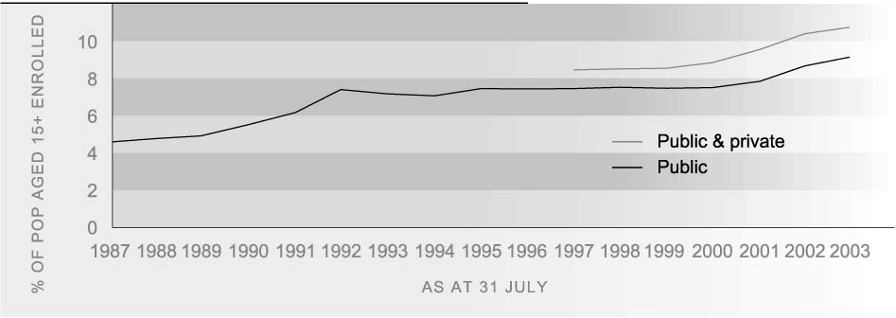Source: Ministry of Education; Ministry of Social Development
Enrolments for courses that lead to qualifications below the level of a bachelor degree have risen faster than enrolments at degree level or above in recent years. In July 2003, 6 percent of the population aged 15 and over were enrolled in sub-degree tertiary education courses, an increase from 3 percent in 1994. In comparison, 5 percent of the population were enrolled in degree and post-graduate courses in 2003, a rise from 3 percent in 1994.

AGE AND SEX Tertiary education participation is highest among 18–24-year-olds. Recent increases in
DIFFERENCES tertiary participation rates have been greatest at ages 25 and over, while participation under 18 years has declined.
Women are increasingly more likely than men to participate in tertiary study at ages 18 and over. The difference is greatest in the high incidence age group of 18-24 years, where the sex gap increased from four to seven percentage points between 1999 and 2003. There is little difference between males and females in the levels at which they are enrolled. Of all tertiary students enrolled in mid-2003, 38 percent of females and 37 percent of males were enrolled in degree courses and 8 percent of students of both sexes were enrolled in post-graduate courses.
Table K5.1 Tertiary participation rates (%) by age and sex, 1999-2003
Sex, year | 15-17 years | 18-24 years | 25-39 years | 40+ years | Total
Males
1999 | 5.6 | 29.6 | 7.9 | 1.9 | 7.5
2000 | 7.9 | 31.2 | 8.4 | 2.1 | 8.0
2001 | 9.0 | 32.7 | 9.1 | 2.4 | 8.5
2002 | 8.0 | 33.3 | 9.9 | 2.8 | 9.0
2003 | 5.4 | 33.1 | 10.6 | 3.2 | 9.3
Females
1999 | 5.5 | 33.9 | 10.2 | 3.4 | 9.2
2000 | 8.7 | 35.1 | 11.0 | 3.6 | 9.7
2001 | 8.5 | 37.3 | 12.4 | 4.0 | 10.6
2002 | 8.4 | 39.5 | 14.1 | 4.9 | 11.8
2003 | 4.5 | 39.8 | 15.1 | 5.5 | 12.2
Source: Ministry of Education, Ministry of Social Development

ETHNIC DIFFERENCES Mäori participation in tertiary education has increased sharply in recent years. In July 2003, the age-standardised tertiary education participation rate for Mäori was 16 percent, almost double the rate in 1999 (8 percent). In comparison, non-Mäori participation increased from 8 percent in 1999 to 10 percent in 2003. The age-standardised rate has been higher for Mäori than non-Mäori since 2000.⁴⁰
Mäori participation in tertiary education is higher than non-Mäori participation among those under 18 and over 25, but considerably lower than non-Mäori participation at the core tertiary education ages of 18-24 years. However, participation in this age group has been growing. In 2003, 26 percent of Mäori aged 18-24 were enrolled in tertiary education, compared with 19 percent in 1999. The non-Mäori participation rate at 18-24 years was 35 percent in 1999 and 39 percent in 2003.
Table K5.2 Tertiary participation rates (%) by age and sex, Mäori, non-Mäori, 2003
Age group |  | Mäori % |  |  | Non-Mäori %
 | Male | Female | Total | Male | Female | Total
15-17 | 8.6 | 8.5 | 8.6 | 4.5 | 3.5 | 4.0
18-24 | 19.2 | 32.5 | 25.9 | 35.9 | 41.4 | 38.6
25-39 | 13.2 | 26.6 | 20.2 | 10.1 | 12.9 | 11.5
40+ | 8.7 | 17.4 | 13.2 | 2.7 | 4.3 | 3.6
Total | 12.2 | 22.4 | 17.5 | 8.9 | 10.7 | 9.8
Source: Ministry of Education; Ministry of Social Development
There are marked ethnic differences in the level at which tertiary students are enrolled, with Mäori and Pacific students being less likely to be enrolled in degree level courses than students from European, Asian or Other ethnic groups.

INTERNATIONAL There are currently no robust measures of tertiary participation across OECD countries.
COMPARISON Some indication of New Zealand’s relative standing can be gained from the proportion of the population enrolled in education at various ages. Taking the 20–29 year age group, who are more likely to be enrolled in tertiary than secondary education, in 2001, New Zealand ranked 14th with a rate of 23 percent; the same as the OECD median. The New Zealand rate was about the same as that of the United States and the United Kingdom, slightly above that of Canada (21 percent) but below the rate for Australia (28 percent).⁴¹

