DESIRED OUTCOMES
All people are satisfied with their participation in leisure and recreation activities. All people have adequate time in which they can do what they want to do and can access an adequate range of different opportunities for leisure and recreation.
Leisure and Recreation
INTRODUCTION
Both leisure and recreation are crucial components of a balanced and healthy lifestyle. Leisure time is a time when people can do what they want, separate from work and other commitments.
Recreation and leisure play an important role in social wellbeing by providing people with a sense of identity and personal autonomy. Involvement in leisure time activities gives greater meaning to individual and community life and contributes to people’s overall quality of life. Recreation can encourage personal growth, self-expression and increased learning opportunities, satisfying needs not met in people’s non-leisure time.
For many people, participation in leisure and recreation increases physical and mental health. Recreation often involves a physical activity or sport. Increased physical activity can lead to decreased health problems, and higher productivity at work, especially when combined with a balanced diet and healthy lifestyle.
The benefits for mental health are equally important. Several studies have demonstrated links between regular physical activity and a reduction in the symptoms of mild or moderate depression, stress, and anxiety. Passive leisure also has benefits for mental health, by providing an outlet for the mind. It may provide physical rest, tension release, opportunities to enjoy nature and escape from daily routine.
Participation in leisure and recreation can also have social benefits. It creates opportunities for socialisation and contributes to social cohesion by allowing people to connect and network with others. It can also contribute to family bonding as families participate together in leisure activities.
INDICATORS Three indicators are used in this chapter. They are: subjective satisfaction with leisure, participation in sport and active leisure and experience of cultural activities. Together, these indicators present a picture of how people feel about their leisure time and also what they do in their leisure time.
The first indicator is subjective satisfaction with leisure. This measures how people feel about both the quality and quantity of their leisure.
The second indicator measures people’s participation in sport and active leisure. Moderate physical activity can improve a number of health outcomes, risk factors and diseases. This indicator gives us a sense of how active New Zealanders are.
The final indicator, participation in cultural and arts activities, measures people’s involvement in cultural activities. Cultural activities contribute to individual growth, as well as providing opportunities for personal development, social cohesion and the passing on of cultural traditions.
Satisfaction with leisure
DEFINITION
The proportion of people aged 15 and over who are ‘satisfied’ or ‘very satisfied’ with their leisure-time as reported in the Social Wellbeing Survey 2004.

RELEVANCE Leisure-time is a crucial component of a balanced and healthy lifestyle. It is a time when people can do what they want, separate from work and other commitments. New Zealanders’ subjective feelings about their leisure-time provide information on how people feel about both the quality and quantity of their leisure.

CURRENT LEVEL According to the Social Wellbeing Survey 2004, just over two-thirds of New
AND TRENDS Zealanders (68 percent) are satisfied overall with their leisure. Specifically, 40 percent are ‘satisfied’ and 28 percent are ‘very satisfied’.
FigureL1.1 Satisfaction with leisure, 2004
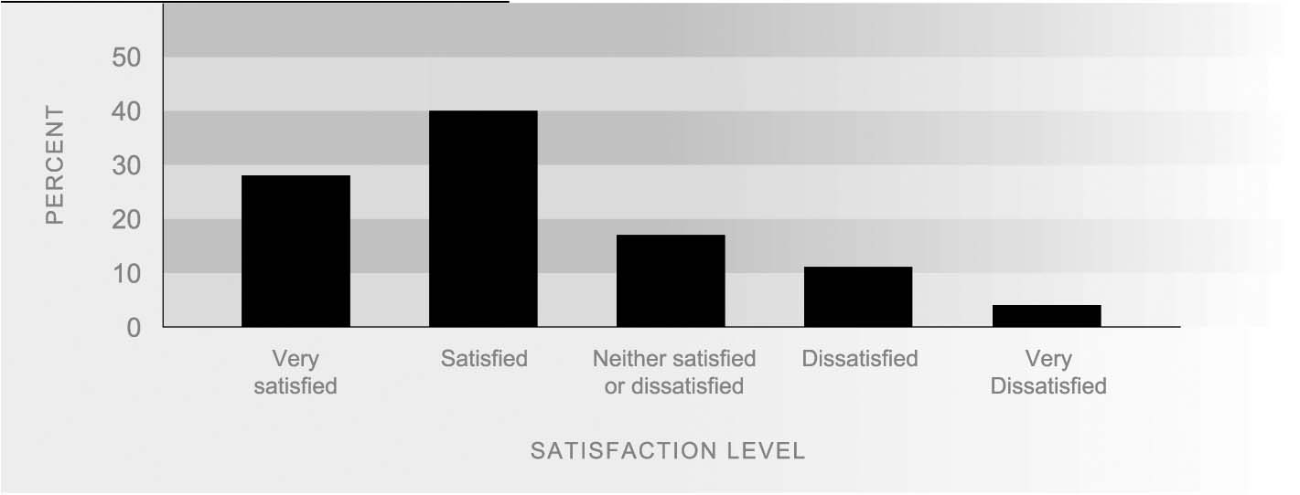
Source: Ministry of Social Development (2004)

AGE DIFFERENCES While over half of New Zealanders are satisfied with their leisure-time, those aged between 25 and 44 years are less satisfied overall (57 percent). This age group tends to have larger work and family commitments than other groups, which may impinge on the time they have available for leisure. In comparison, those aged between 46 and 64 years and 15 and 24 years are more likely to report being satisfied with their leisure-time with total satisfaction levels of 71 percent and 78 percent respectively. Those aged over 60 report the highest levels of overall satisfaction with their leisure time (84 percent).

SEX DIFFERENCES There are minimal differences in reported satisfaction with leisure-time between the sexes. Sixty-nine percent of both men and women report that they are satisfied with their leisure-time.
Figure L1.2 Levels of satisfaction with leisure, by age, 2004
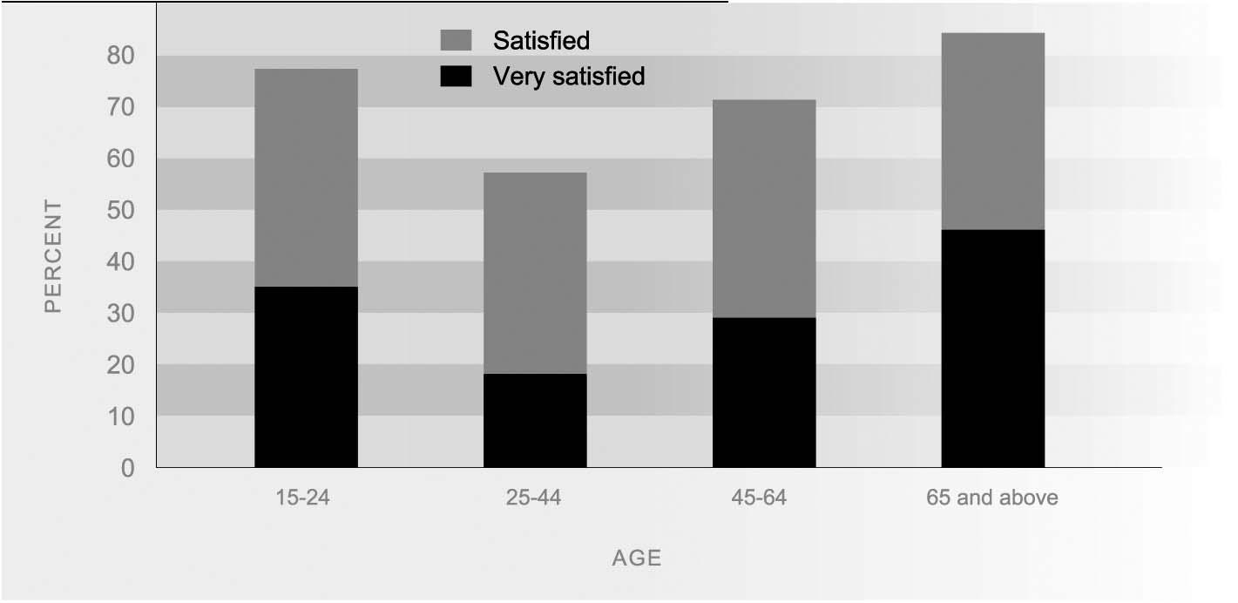
Source: Ministry of Social Development (2004)

ETHNIC Most New Zealanders, regardless of ethnicity, are satisfied overall with their leisure-
DIFFERENCES time. The European ethnic group reports the highest level of total satisfaction (70 percent), followed by those of Other ethnic groups (65 percent), Mäori (66 percent) and Pacific peoples (64 percent).

PERSONAL INCOME As income increases the proportion of people reporting satisfaction with their leisure-
DIFFERENCES time tends to decrease. Seventy-seven percent of people with incomes of less than $20,000 report that they are ‘very satisfied’ or ‘satisfied’ with their leisure-time, compared to 57 percent of those earning over $40,000. As income increases to between $20,000 and $40,000, satisfaction levels decrease to 70 percent. Satisfaction levels continue to decrease for New Zealanders who are earning over $40,000 (57 percent) and remain at this level for incomes over $60,000.
Figure L1.3 Levels of satisfaction with leisure, by personal income, 2004
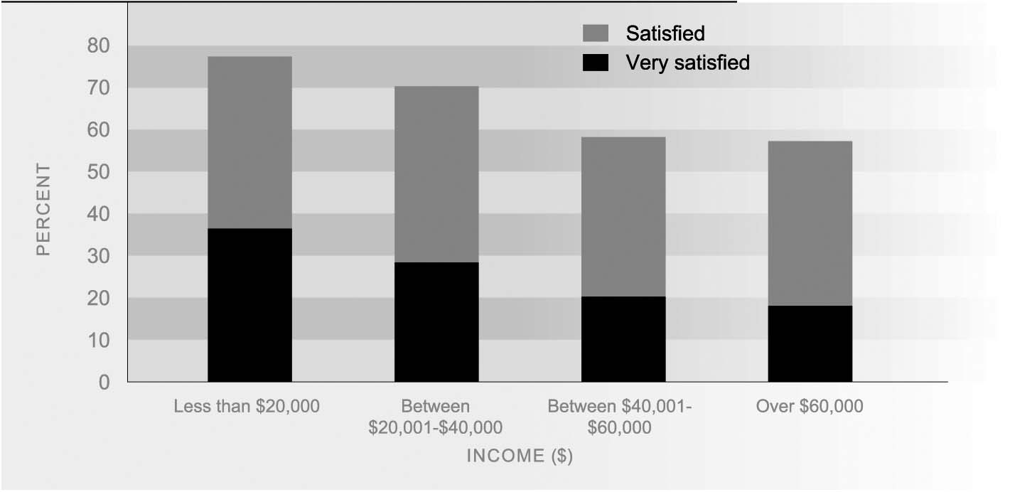
Source: Ministry of Social Development (2004)
Participation in sport and active leisure
DEFINITION
The proportion of adults aged 18 years and over and young people aged 5-17 years who were physically active, as measured by the Sport and Physical Activity Surveys of 1997/1998, 1998/1999 and 2000/2001. Being physically active means they took part in at least 2.5 hours of sport and/or leisure-time physical activity in the seven days prior to being interviewed.

RELEVANCE People participate in sport and active leisure for a wide variety of reasons: for physical fitness and mental wellbeing, enjoyment and entertainment, for personal growth and development, and as a means to meet new people.

CURRENT LEVEL Seventy percent of adults aged 18 years or over and 66 percent of young people aged 5
AND TRENDS to 17 years were reported to be physically active in 2000/2001.
More adults were physically active in 2000/2001 than in 1997/1998 (67 percent). Over the same period there was no significant change in the proportion of young people who were active. However young people who were sedentary (who had done no activity in past two weeks) increased from 8 percent to 13 percent.
Table L2.1 Activity level of adults and young people by sex, 2000/2001
Activity level | Young people 5-17 years |  |  | Adults 18 years and over
 | Boys | Girls | All | Men | Women | All
 | % | % | % | % | % | %
Sedentary | 11.6 | 14.1 | 12.8 | 8.9 | 9.6 | 9.3
Relatively inactive | 17.9 | 23.4 | 20.7 | 21.0 | 20.7 | 20.9
Inactive | 29.5 | 37.6 | 33.5 | 30.0 | 30.4 | 30.2
Relatively active | 20.9 | 26.1 | 23.5 | 13.3 | 18.3 | 15.9
Highly active | 49.6 | 36.3 | 43.0 | 56.7 | 51.4 | 54.0
Active | 70.5 | 62.4 | 66.5 | 70.0 | 69.6 | 69.8
Source: SPARC Trends, 1997-2000

SEX DIFFERENCES Men and women were equally likely to be physically active in 2000/2001. This resulted from an increase in the proportion of women who were physically active, from 65 percent in 1997/1998 to 70 percent in 2000/2001. In each of the survey years, men were more likely than women to be highly active (five hours or more in the seven days prior to interview).
In 2000/2001, a smaller proportion of girls (62 percent) were physically active than boys (70 percent) and boys were much more likely to be highly active than girls. An increase in the proportion doing no physical activity at all in the past two weeks occurred for boys and girls between 1997/1998 and 2000/2001.
AGE DIFFERENCES Adults aged 65 or over became the most active adult age group in 2000/2001 (76 percent) with the proportion of active adults of this age increasing from 67 percent in 1997/1998. Smaller but significant increases were also apparent for 50–64 year-olds and 35–49 year-olds.
Comparing across all age groups, 16–17 year-olds were the least likely to be active (49 percent in 2000/2001). The proportion of young people aged 13-15 that were active fell from 74 percent in 1997/1998 to 62 percent in 2000/2001.

ETHNIC DIFFERENCES European adults were more likely to be physically active than adults of other ethnic groups in 2000/2001. In that year the proportion of Europeans who were physically active reached 72 percent, an increase from 68 percent in 1997/1998.
Young Mäori and Pacific people were much less likely to be physically active in 2000/2001 than in 1997/1998. The proportion of young Pacific people who were sedentary (did no activity in the two weeks prior to interview) rose from 6 percent in 1997/1998 to 33 percent in 2000/2001. The proportion of young Mäori who were sedentary rose from 6 percent to 18 percent over this period.
Table L2.2 Activity level of young people aged 5-17 years by ethnic group, 2000/2001
Activity level | European | Mäori | Pacific | Other
 | % | % | % | %
Sedentary | 9.3 | 18.4 | 32.9 | 7.1
Relatively inactive | 21.7 | 15.9 | 19.8 | 24.0
Inactive | 31.0 | 34.3 | 52.7 | 31.1
Relatively active | 23.8 | 18.4 | 21.7 | 38.0
Highly active | 45.2 | 47.3 | 25.6 | 30.9
Active | 69.0 | 65.7 | 47.3 | 68.9
Source: SPARC (2003b)
Table L2.3 Activity level of adults aged 18 years and above by ethnic group, 2000/2001
Activity level | European | Mäori | Pacific | Other
 | % | % | % | %
Sedentary | 7.8 | 14.8 | 9.5 | 21.0
Relatively inactive | 19.8 | 20.9 | 28.2 | 30.0
Inactive | 27.6 | 35.7 | 37.7 | 51.1
Relatively active | 16.1 | 13.4 | 14.8 | 19.3
Highly active | 56.4 | 50.9 | 47.5 | 29.6
Active | 72.4 | 64.3 | 62.3 | 48.9
Source: SPARC (2003b)
Participation in cultural and
arts activities
DEFINITION
The proportion of the population aged 15 and over who had experienced one or more of the cultural activities included in the 2002 Cultural Experiences Survey. Respondents were asked to report on activities they experienced over either a 12-month period (for goods and services accessed or experienced relatively infrequently) or a four-week recall period (for activities experienced on a more regular basis).

RELEVANCE Cultural activities are an integral part of leisure and recreation. People participate in cultural activities for a wide variety of reasons: for enjoyment and entertainment, for personal growth and development, as a means of expression, to learn new skills and to meet new people, and to pass on cultural traditions.

CURRENT LEVEL The vast majority of New Zealanders aged 15 and over (93 percent or 2.6 million
AND TRENDS people) experienced one or more of the cultural activities included in the 2002 Cultural Experiences Survey. The most popular of the less frequent activities included in the survey (those experienced over the past year) were visiting an art gallery or museum (48 percent) and attending a popular live music performance (37 percent). The most popular activities undertaken in the previous four weeks were purchasing books (43 percent) and visiting a public library (39 percent). Lack of time and cost were the main barriers to experiencing cultural activities more often, or at all.

Figure L3.1 Proportion of the population aged 15 and over who experienced cultural activities, by activity type and sex, 2001/02
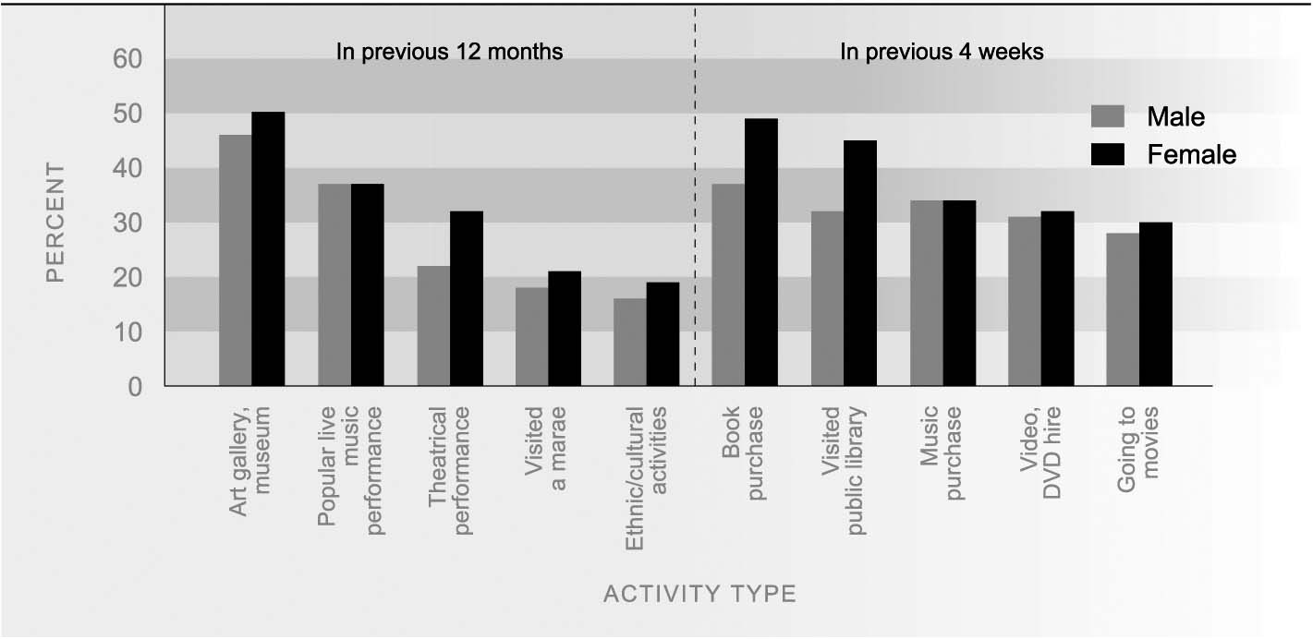
Source: Statistics New Zealand (2002a)

SEX AND AGE Women (95 percent) were slightly more likely to experience one or more of the cultural
DIFFERNCES activities included in the survey than men (92 percent). Activities with a much higher proportion of women than men participating included purchasing a book, visiting a library, and going to a theatrical performance. There was no difference in the proportion of men and women who had purchased music.
Younger people were more likely to experience at least one of the cultural activities included in the survey than people in the older age groups. In 2002, virtually all 15–24 year-olds (98 percent) and 96 percent of 25–44 year-olds took part in one or more of the surveyed activities. Participation was lowest among the 65+ age group (81 percent). Popular activities among younger people included hiring a video or DVD (53 percent) and purchasing music (49 percent). Older people (65+ years) were more likely to visit a public library than other age groups, with 46 percent reporting this activity.

ETHNIC DIFFERENCES Mäori were more likely to have participated in at least one of the cultural activities included in the survey than the European or Pacific groups (Mäori 97 percent; European 93 percent; Pacific 92 percent). Popular activities experienced by Mäori included visiting a marae (69 percent) and attending a popular live music performance (40 percent). European New Zealanders were more likely to report visiting an art gallery or museum than other groups (51 percent), while Pacific people had the highest rate of participation in community-based ethnic or cultural activities (39 percent).
Table L3.1 Proportion (%) of population aged 15+ who had participated in cultural activities by activity type and ethnic group
 | Mäori | Pacific people | European
In the previous 12 months
Art gallery/museum | 42 | 27 | 51
Book purchase | 40 | 29 | 45
Popular live music performance | 40 | 27 | 39
Theatrical performance | 18 | 19 | 30
Visited a marae | 69 | 22 | 14
Community-based ethnic/cultural activities | 20 | 39 | 14
In the previous four weeks
Visited public library | 34 | 31 | 39
Music purchase | 32 | 33 | 34
Video, DVD hire | 39 | 26 | 31
Going to movies | 23 | 21 | 30
Any cultural activity | 97 | 92 | 93
Source: Statistics New Zealand (2002a)

REGIONAL In 2002, 94 percent of people living in urban areas experienced one or more of the
DIFFERENCES cultural activities included in the survey, compared to 93 percent of people living in secondary urban areas and 91 percent of those living in minor urban and rural areas. Comparing across regional council areas, Wellington had the highest proportion of people who experienced at least one of the surveyed activities (97 percent), while Taranaki had the lowest level of participation (87 percent)

