DESIRED OUTCOMES
All people have access to meaningful, rewarding and safe employment. An appropriate balance is maintained between paid work and other aspects of life.
Paid Work
INTRODUCTION
Paid work has an important role in social wellbeing by providing people with incomes to meet their basic needs and contribute to their material comfort, as well as by giving them options for how they live their lives. Paid work is also important for the social contact and sense of self-worth or satisfaction it can give people.
The desired outcomes highlight four aspects of paid work: access to work, the financial return of work, quality of work, and the balance between work and other areas of life.
For most people, income from paid work is the main factor determining their material standards of living. On average, about two-thirds of total household income is derived directly from labour market income, and the figure is substantially greater for most households.⁴² Income saved during working life contributes to the standard of living of many retired people.
The social and personal dimensions of paid work are equally important. Ideally, work should be not only materially rewarding but contribute to other aspects of wellbeing. Meeting challenges at work can contribute to a sense of satisfaction and self-worth. In this sense, it is important people are able to get work which matches their skills and abilities.
Social contact is an important part of wellbeing. For many people, much of their social contact is through their jobs. People often gain a sense of belonging or identity from their jobs, recognising themselves and others because of the organisation they work for or the type of work they do.
Conversely, unemployment can isolate people from society and cause them to lose self-confidence. Unemployment is associated with poorer mental and physical health, and lower levels of satisfaction with life.
The quality of work is of critical importance. A meaningful job can enhance people’s satisfaction with their work. An unsafe job, on the other hand, places people’s wellbeing at risk.
Work can also be stressful. People may be required to work longer hours than they want or need to. The desired outcomes acknowledge wellbeing is best served by maintaining a balance between paid work and other aspects of life, though where that balance lies will differ from person to person.
INDICATORS Five indicators are used in this chapter. They are: the unemployment rate, the employment rate, average hourly earnings from all wages and salaries, the number of workplace injury claims, and the proportion of the population in paid employment who are satisfied with their work/life balance.
Together, these indicators present a picture of people’s access to employment, how financially rewarding employment is, the level of safety of employment, and the balance between work and other areas of life.
The first two indicators relate to the quantity of paid work on offer and taken up. This is affected by several factors, including economic conditions, investment decisions, migration flows, people’s qualifications and abilities, and their decisions on how much time to allocate to paid work.
The first indicator is the unemployment rate. This measures the proportion of people who are out of work, actively seeking and available to take up work. This is a relatively narrow measure of unemployment but it accords closely with the OECD standard measure, allowing international comparisons. Information about long-term unemployment is also provided.
The second indicator is the employment rate. This provides an alternative picture of people’s access to paid work, as it is influenced not only by the amount of work available but also by trends in labour force participation. The indicator measures the proportion of working-age people employed for one hour or more a week. Information is provided on the breakdown between full-time and part-time employment. This gives some indication of the types of work people are taking on and the overall level of employment.
The third indicator is a new indicator, and measures average hourly earnings from waged and salaried employment. The level of financial return to paid employment independent of the quantity of hours worked is central to the quality of paid work.
The fourth indicator is the rate of workplace injury claims per 1000 full-time equivalent employees. Workplace safety is important in its own right, but may also be a proxy for the quality of employment. Jobs should not pose an unreasonable risk to people's lives or physical wellbeing.
The final indicator measures the proportion of the population in paid employment who are satisfied with their work/life balance. This is a new measure for The Social Report 2004 and replaces the indicator in last year’s report of the proportion of the population in paid employment working 50 hours or more.
Unemployment
DEFINITION
The official unemployment rate is the number of people aged 15 and over who are not employed and are actively seeking and available for paid work, expressed as a percentage of the total labour force. The labour force is defined as the population aged 15 and over who are either employed or unemployed (not employed but actively seeking and available for paid work).

RELEVANCE This is a key indicator of labour market outcomes and lack of access to employment. The unemployment rate is an important reflection of overall economic conditions and of the ease with which people are able to move into employment.

CURRENT LEVEL In 2003, 4.7 percent of the labour force, or 93,900 people, were unemployed and
AND TRENDS actively seeking work. The unemployment rate has steadily declined since 1998 and is considerably lower than the peak rate of 10.3 percent in 1991/1992 (almost 170,000 people unemployed), but is still a little higher than the rate of 4.0 percent in 1986 (64,000 people unemployed).
In 2003, 27 percent of the surveyed unemployed were unemployed for a continuous period of six months or more, compared with 29 percent in 2002. This was still higher in 2003 than it had been in 1986, when it was 22 percent, but was substantially lower than the peak of 53 percent in 1992/1993.
Figure PW1.1 Unemployment rate, 1986-2003
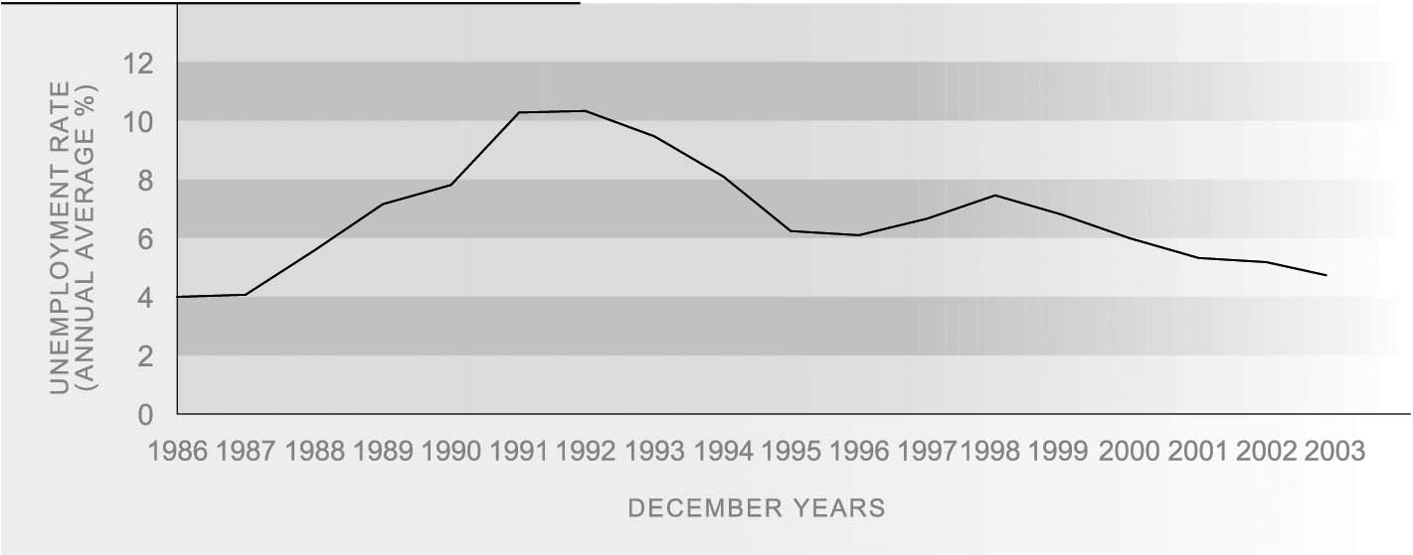
Source: Statistics New Zealand, Household Labour Force Survey
The economy’s improved performance over the last decade has contributed to the steady decline in the unemployment rate over this time. Changes in the regulation of the labour market and the benefit system may also have had some effect.⁴³

ETHNIC DIFFERENCES Substantial differences in unemployment rates persist for different ethnic groups. Mäori unemployment rose from 10.7 percent in 1986 to a peak of 25.4 percent in 1992 but fell back to 10.2 percent by 2003, the best rate recorded since the survey began. Between 1986 and 1991, the unemployment rate for Pacific peoples rose from 6.5 percent to 28.0 percent, the highest rate for any ethnic group. Pacific peoples’ unemployment rate has declined more than that of Mäori since the mid-1990s, and was 7.7 percent in 2003. Pacific unemployment is still higher than it was in 1986.
Unemployment is lowest among people of European ethnicity; their unemployment rate rose from 3.2 percent in 1986 to a peak of 7.9 percent in 1992 and had declined to 3.5 percent by 2003. The unemployment rate among the ‘Other’ ethnic group category (which comprises predominantly people of Asian ethnicity and includes many recent migrants) increased from 3.6 percent in 1986 to 14.7 percent in 1992, and was still relatively high at 7.2 percent in 2003.
Figure PW1.2 Unemployment rate by ethnic group, 1986-2003
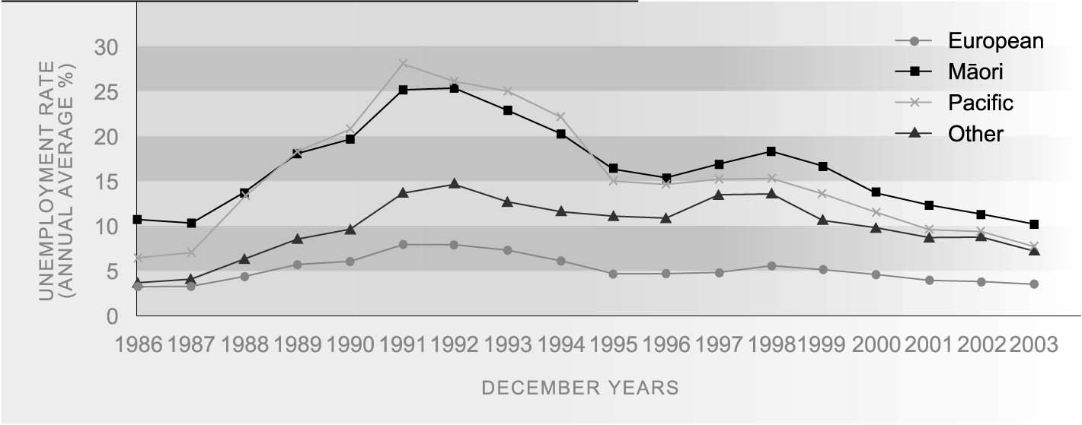
Source: Statistics New Zealand, Household Labour Force Survey

AGE AND SEX Unemployment rates among different age groups have followed similar trends but the
DIFFERENCES level among those aged 15-24 (10.2 percent in 2003) has been consistently more than twice the rate for older groups. This group comprised 39 percent of all unemployed in 2003. Unemployment rates have been fairly similar for males and females since the mid-1990s. However in 2003, the female unemployment rate was marginally higher than the male unemployment rate.
Table PW1.1 Unemployment rates (%), by age and sex, selected years, 1986-2003
Year | 15-24 | 25-44 | 45-64 | Total 15+ | Males | Females
1986 | 7.9 | 3.1 | 1.7 | 4.0 | 3.5 | 4.6
1991 | 18.8 | 8.8 | 5.8 | 10.3 | 10.9 | 9.5
1996 | 11.8 | 5.2 | 4.0 | 6.1 | 6.1 | 6.1
2001 | 11.8 | 4.4 | 3.3 | 5.3 | 5.4 | 5.3
2002 | 11.4 | 4.4 | 3.1 | 5.2 | 5.1 | 5.3
2003 | 10.2 | 4.1 | 2.8 | 4.7 | 4.4 | 5.0
Source: Statistics New Zealand, Household Labour Force Survey. Note: Average for December years

REGIONAL In 2003, regional unemployment rates were highest in Northland (8.0 percent) and Bay
DIFFERENCES of Plenty (6.3 percent), and lowest in Southland and Tasman-Nelson-Marlborough-West Coast (each 3.5 percent). The fall in unemployment between 1992 and 2003 was greatest in the Auckland region.

INTERNATIONAL In 2003, New Zealand ranked eighth best out of 27 OECD countries with a
COMPARISON standardised unemployment rate of 4.7 percent, compared with an OECD median of 6.0 percent. Since the mid-1980s, New Zealand’s unemployment rate relative to other OECD countries has ranged from one of the best (ranked fifth in 1986 with a rate of 4.0 percent) to one of the worst (ranked 17th in 1992 with a rate of 10.3 percent) to a more favourable position in recent years. South Korea had the best unemployment rate in 2003 (3.6 percent). The New Zealand unemployment rate in 2003 was lower than that of Australia (6.1 percent), Canada (7.6 percent), the United Kingdom (5.0 percent) and the United States (6.0 percent).⁴⁴ In 2002, New Zealand ranked seventh best in terms of the proportion of the unemployed who had been unemployed for six months or longer.⁴⁵
Employment
DEFINITION
The proportion of the population aged 15-64 years who are in paid employment for at least one hour per week.

RELEVANCE The employment rate is the best available indicator of the prevalence of paid employment. It captures trends in both unemployment and labour force participation (the proportion of the working age population either employed or unemployed).

CURRENT LEVEL In 2003, 72.5 percent of 15–64 year-olds (1.878 million people) were employed for one hour or more per week. This was slightly above the rates recorded in 1986 and 1987 (72 percent). The employment rate has been rising since 1992, except during the economic downturn in 1997 and 1998. The increase from 65.3 percent in 1992 to 72.5 percent in 2003 corresponds to a rise of 423,000 in the number of employed people aged 15-64. Over the same period, the number of people aged 15-64 increased by 361,400.
Full-time employment rates declined between 1986 (60.3 percent) and 1991 (52 percent) and have yet to recover to 1986 levels among men. Part-time employment rates have increased for both sexes over the period (from 11.7 percent in 1986 to 15.9 percent in 2003), almost doubling among men. However, women (23 percent) continue to have higher part-time employment rates than men (8 percent).
Figure PW2.1 Employment rate, 1986-2003
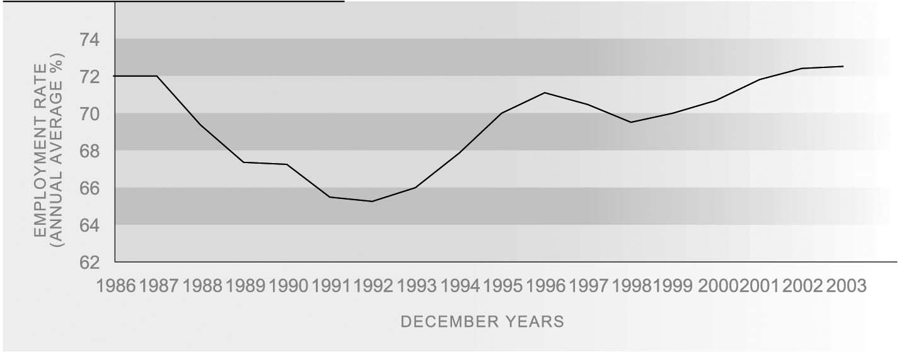
Source: Statistics New Zealand, Household Labour Force Survey
Note: Based on population aged 15-64

AGE AND SEX The employment rate decline between 1987 and 1992 affected all age groups but was
DIFFERENCES most pronounced for young people aged 15-24. Youth employment rates have remained relatively low during the period of employment growth since 1992, possibly due to a growth in participation in tertiary education and training. Conversely, employment rates for people aged 45-64 have grown strongly since 1992, driven mainly by the phasing in of the higher age of eligibility for New Zealand Superannuation, rising employment among women, and an increase in labour demand.
Women’s employment rate is significantly lower than that of men, owing mainly to the fact that women spend more time on childcare and other unpaid household work. The gap has, however, narrowed substantially since the mid-1980s, from 24 to 13 percentage points.

Table PW2.1 Employment rates (%), by age and sex, selected years, 1986-2003
Year | 15-24 | 25-44 | 45-64 | Total | Males | Females
1986 | 67.1 | 79.4 | 65.1 | 72.0 | 84.1 | 60.0
1991 | 54.3 | 74.0 | 61.7 | 65.5 | 73.7 | 57.5
1996 | 59.4 | 77.3 | 70.2 | 71.1 | 79.0 | 63.3
2001 | 56.0 | 77.9 | 73.6 | 71.8 | 78.9 | 64.9
2002 | 56.8 | 78.3 | 74.7 | 72.4 | 79.6 | 65.4
2003 | 56.6 | 78.3 | 75.3 | 72.5 | 79.3 | 65.8
Source: Statistics New Zealand, Household Labour Force Survey
Note: Average for December years

ETHNIC DIFFERENCES The proportions of the European, Mäori and Pacific working-age populations in employment all fell between 1987 and 1992 and have risen since then. The only ethnic group to have higher employment rates in 2003 than in the mid-1980s was the European only group (77.5 percent employed in 2003, compared with 73.5 percent in 1986). The Mäori employment rate, at 61.7 percent in 2003, has almost recovered to 1986 levels (61.9 percent), but Pacific people were still much less likely to be employed (67.2 percent in 1986, 59.9 percent in 2003). The employment rate for the ‘Other’ ethnic category has fallen from being the second highest in the late 1980s to the lowest since the mid-1990s, reflecting in part the difficulties experienced by some newer migrants in integrating into the New Zealand labour market.⁴⁶
Figure PW2.2 Employment rate by ethnic group, 1986-2003
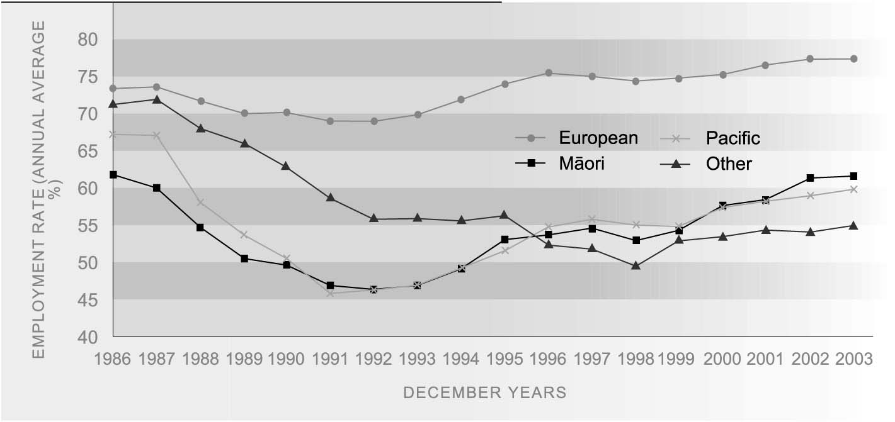
Source: Statistics New Zealand, Household Labour Force Survey
Note: Based on population aged 15-64

REGIONAL In 2003, employment rates were highest in Waikato (65.8 percent) and Wellington
DIFFERENCES (65.5 percent), and lowest in Bay of Plenty (58.8 percent) and Northland (57.0 percent).

INTERNATIONAL In 2002, the New Zealand employment rate of 72.4 percent for people aged 15-64 years
COMPARISON was higher than the OECD median of 66.7 percent and ranked eighth best out of 30 OECD countries. New Zealand’s position has improved from 13th place in 1990, almost entirely due to the recovery in male employment rates. Iceland had the best employment rate in 2002 (82.8 percent). The New Zealand rate in 2002 was similar to that of the United Kingdom (72.7 percent), the United States (71.9 percent) and Canada (71.5 percent) and higher than that of Australia (69.4 percent).
Average earnings from wage and
salary jobs
DEFINITION
Average hourly earnings from all wages and salaries for employees earning income from wage and salary jobs, as measured by the New Zealand Income Survey.

RELEVANCE Average hourly earnings from wage and salary jobs is an indicator of the financial return to paid employment, independent of the quantity of hours worked.

CURRENT LEVEL In June 2003, the average hourly wage of wage and salary earners was $17.82. Male AND TRENDS employees earned on average $19.02 an hour from wage and salary jobs and female employees earned on average $16.57 an hour.
After adjusting for the effects of inflation, average hourly earnings increased by $1.66 per hour or 10 percent in the six years to June 2003.
Figure PW3.1 Average hourly earnings from wage and salary jobs by sex, June 1997 to June 2003
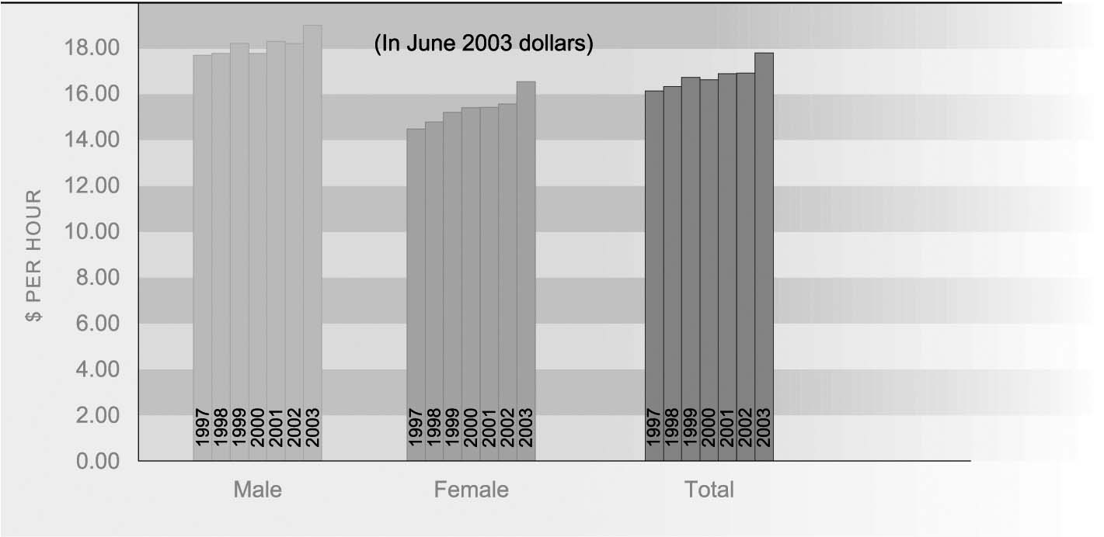
Source: New Zealand Income Survey (1997-2003) Statistics New Zealand

AGE AND SEX Average hourly earnings from wage and salary jobs rise with increasing age to peak at
DIFFERENCES 45-49 years. In June 2003, 15-19 year-olds earned $9.55 an hour on average from wage and salary jobs compared with $20.68 an hour on average for 45-49 year-olds. Real average hourly earnings for 15-24 year-olds increased by 6 percent between 1997 and 2003, which was less than the increase for older workers (11 percent for the 25-44 age group and 12 percent for the 45-64 age group).
In 2003, men and women below 30 years had similar average hourly earnings from wage and salary jobs. Men earned more per hour on average from wage and salary jobs than women in every five-year age group above 30 years. The increase in average hourly earnings over the six years to June 2003 was greater for female employees (14 percent) than for male employees (7 percent).
Figure PW3.2 Average hourly wage and salary earnings by age and sex, June 2003
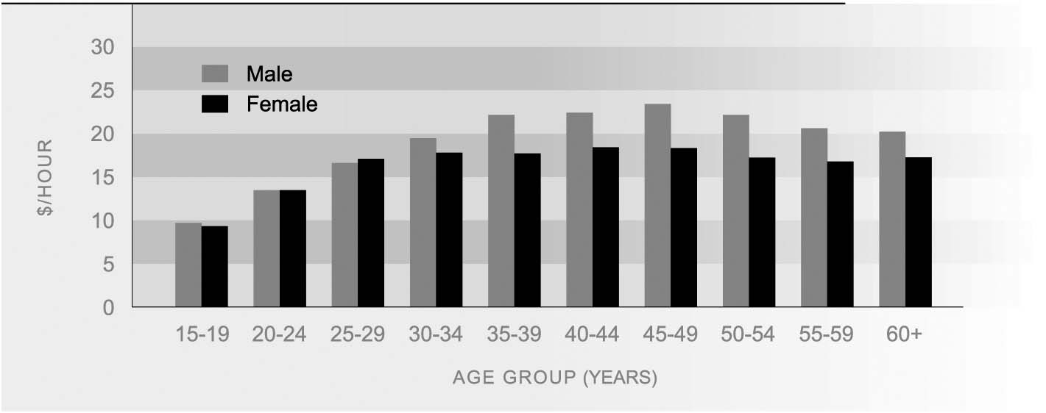
Source: Statistics New Zealand, New Zealand Income Survey

ETHNIC DIFFERENCES Mäori in wage and salary jobs earned $15.44 an hour on average in June 2003. This was less than European/Päkehä ($18.44 an hour) and more than Pacific people ($13.85 an hour). Wage and salary earners from other ethnic groups earned on average $17.65 an hour.
Over the six years to June 2003, increases in real average hourly earnings for Mäori, at just below 12 percent, were similar to increases for European/Päkehä (11 percent) over the six years to June 2003. Over the same period, Pacific people and those from other ethnic groups experienced lower increases in average hourly earnings from wage and salary jobs (9 percent and 10 percent, respectively).
Workplace injury claims
DEFINITION
The number of workplace accident insurance claims reported to the Accident Compensation Corporation (ACC) per 1,000 full-time equivalent employees, excluding those employees who received accident and emergency treatment only.

RELEVANCE Safety at work is an important contributor to wellbeing and the risk of work-related accidents or illness can be seen as one component of the quality of work. The best currently available measure of the incidence of workplace injuries comes from the database of claims made to the ACC.

CURRENT LEVEL By September 2002, 229,489 work-related injury claims had been reported to the Accident Compensation Corporation for injuries incurred over the year ended June 2002, an increase of 1,595 (0.7 percent) on the year ended June 2001. This represents a rate of 141 claims per 1,000 full-time equivalent employees (FTEs), about the same as the previous year (a rate of 144 per 1,000 FTEs). The majority of claims were for medical treatment only (ie not including weekly compensation). Eighty percent of claims were in respect of employees, and people who employed others in their own business. The remainder were the self-employed who did not employ others in their business. The incidence rate for the self-employed not employing others was twice that of the rest of the workforce, as defined above, (246 per 1,000 FTEs compared with 127 per 1,000 FTEs).
Information on workplace injuries for 2002 is based on a new set of indicators developed by Statistics New Zealand. These figures have been backdated to 2001 but are not directly comparable with previous figures on workplace injuries. A comparison of the general trend over time, however, shows the number of claims reported to the ACC was approximately constant between 1995 and 1997 and then fell up to 1999. Numbers have continued to decline since 1999 but it is difficult to conclude much from this because of differences in the methods of collection.
Figure PW4.1 Estimated claim rate per 1,000 FTE employed by age and sex, 2001-2002
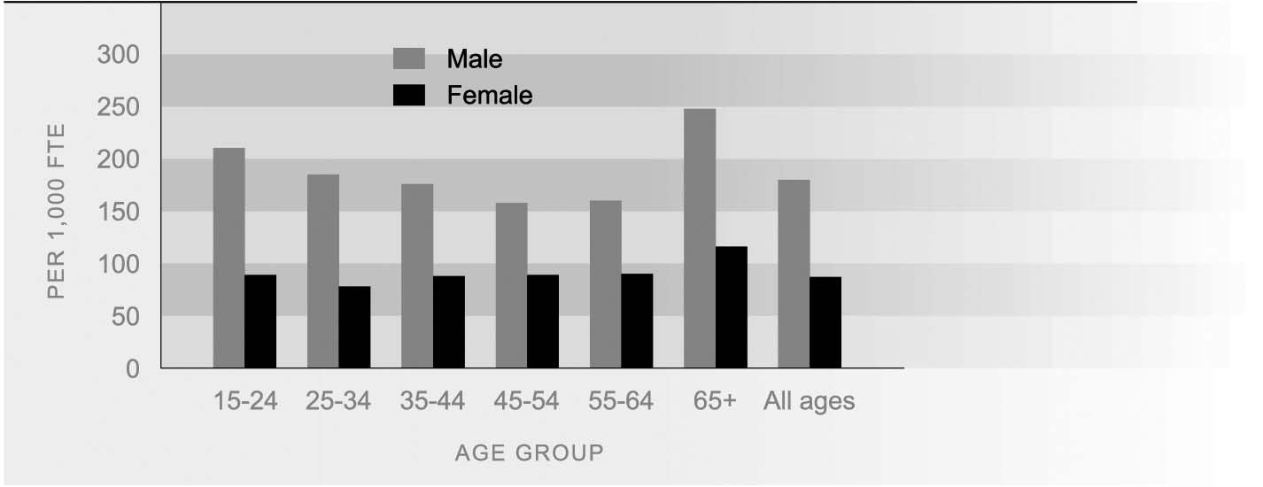
Source: Statistics New Zealand (2003b)
Injury claims for the year ending June 2002 that had been reported by September 2002 included 85 work-related fatalities. This is likely to be an underestimate of the final number of fatalities, because some deaths may subsequently have occurred for injuries in that period, and not all fatal work-related accidents result in a claim to ACC. Agriculture accounted for 20 percent of work-related fatalities, followed by manufacturing (14 percent) and construction (13 percent).

AGE AND SEX Males are more than twice as likely as females to suffer workplace injuries involving
DIFFERENCES an injury insurance claim (180 per 1,000 FTEs for males compared with 87 per 1,000 FTEs for females). This reflects in part male predominance in relatively dangerous occupations. Among males, the highest injury claim rate was for those aged 65 and over followed by those aged under 35. Among females, age differences in the injury claim rate were less pronounced.

ETHNIC DIFFERENCES Workplace injury claim rates are higher for Mäori (175 per 1,000 FTEs) than for other ethnic groups. This is likely to reflect the fact that Mäori are disproportionately employed in industries and occupations that have high injury rates, such as forestry. In 2002, the next highest rate was that for Europeans (129 per 1,000 FTEs), followed by Pacific peoples (125 per 1,000 FTEs). The ‘Other’ ethnic group has the lowest accident claim rate (103 per 1,000 FTEs).
Table PW4.1 New workplace injury claims, by ethnicity, 2001/2002
Ethnic group | Number of claims | Rate per 1,000 FTEs
European | 166,548 | 129
Mäori | 26,765 | 175
Pacific | 9,533 | 125
Other | 10,973 | 103
Total | 229,489 | 141
Source: Statistics New Zealand (2003b)

INDUSTRY Variation in injury rates for different industries underlies many of the differences in
DIFFERENCES injury rates for males and females, and ethnic and age groups. The highest injury rates are in mining (279 per 1,000 FTEs), agriculture (212 per 1,000 FTEs), construction (197 per 1,000 FTEs) and forestry (190 per 1,000 FTEs).
Table PW4.2 New workplace injury claims, by industry, 2001/2002
Industry | Number of claims | Rate per 1,000 FTEs
Mining | 837 | 279
Agriculture | 25,632 | 212
Construction | 21,227 | 197
Forestry | 1,902 | 190
Manufacturing | 47,462 | 172
Transport and storage | 9,969 | 142
Hunting and fishing | 1,107 | 123
Electricity, gas and water supply | 1,072 | 107
Accommodation, cafes and restaurants | 6,490 | 100
Wholesale and retail trade | 26,288 | 94
Communication services | 2,613 | 84
Health and community services | 9,788 | 73
Education | 7,652 | 64
Property and business services | 10,236 | 58
Finance and insurance | 1,307 | 27
Source: Statistics New Zealand (2003b)

Satisfaction with work/life balance
DEFINITION
The proportion of employed people who are ‘satisfied’ or ‘very satisfied’ with their work/life balance, as reported in the Social Wellbeing Survey 2004.⁴⁷

RELEVANCE It is important that people find a balance between paid work and other aspects of life. When this balance is not found people can find themselves suffering from stress or anxiety. Long working hours or non-standard working hours (e.g. night shifts) may compromise work/life balance.

CURRENT LEVEL Results from the Social Wellbeing Survey 2004, indicate that most employed New
AND TRENDS Zealanders (62 percent) are ‘satisfied’ or ‘very satisfied’ with their work/life balance. People in part-time employment (75 percent) are more likely to be ‘satisfied’ or ‘very satisfied’ with their work/life balance than people in full-time employment (56 percent).
Figure PW5.1 Satisfaction with work/life balance, by employment status, 2004
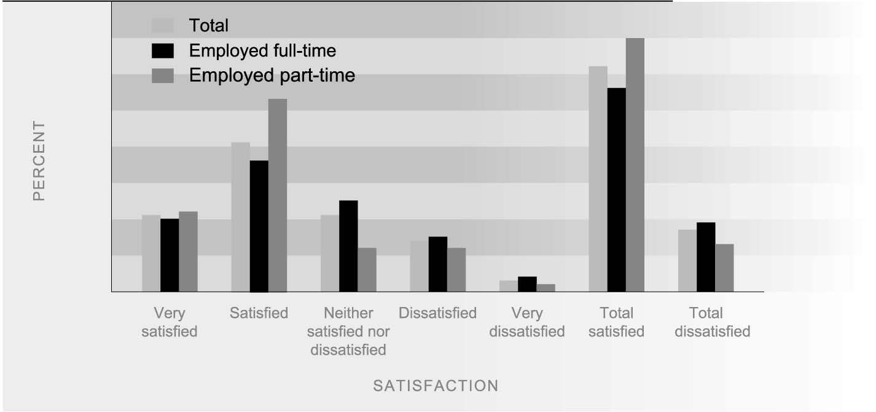
Source: Ministry of Social Development (2004)

AGE AND SEX Those least likely to be satisfied with their work/life balance are people aged 15-24
DIFFERENCES years and 45-64 years (both have total satisfaction levels of 59 percent).
Females (66 percent) are more likely to report being satisfied with their work/life balance than males (57 percent). This difference partly reflects the fact that females are more likely to be in part-time work. Among full-time workers, males (55 percent) and females (57 percent) report similar levels of satisfaction with their work/life balance.

ETHNIC DIFFERENCES Pacific people (65 percent) report the highest levels of satisfaction with work/life balance, followed by people of European ethnicity (63 percent). Mäori (55 percent) and Other ethnicities (56 percent) reported lower levels of satisfaction. Across all ethnicities, hours of employment affect satisfaction with work/life balance, with those working part-time having higher levels of satisfaction than those working full-time.
Figure PW5.2 Levels of satisfaction with work/life balance by ethnicity, 2004
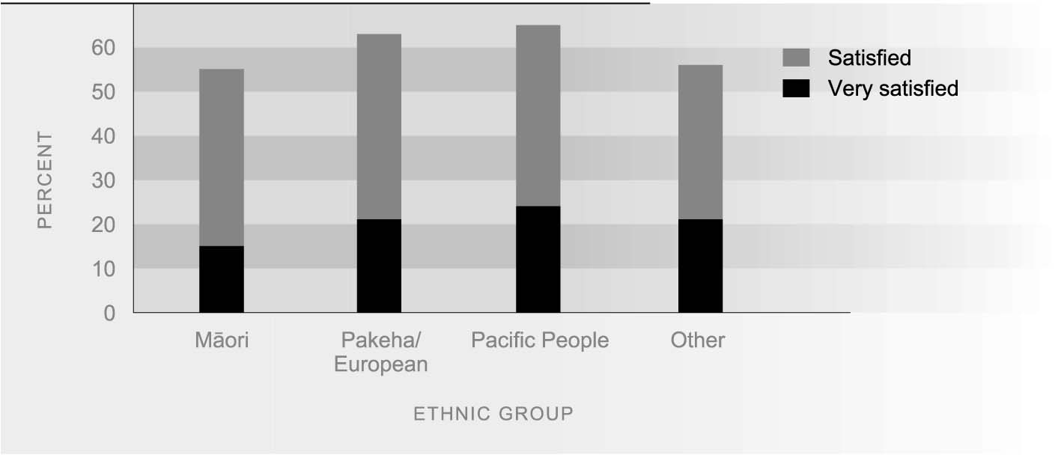
Source: Ministry of Social Development (2004)

PERSONAL INCOME Reported levels of satisfaction with work/life balance tend to decline with higher levels
DIFFERENCES of income. Those New Zealanders whose personal incomes are less than $20,000 are the most likely to be satisfied overall with their balance of work and life (71 percent), while those with incomes over $60,000 are the least likely (54 percent).

Figure PW5.3 Satisfaction with work/life balance, by personal income, 2004
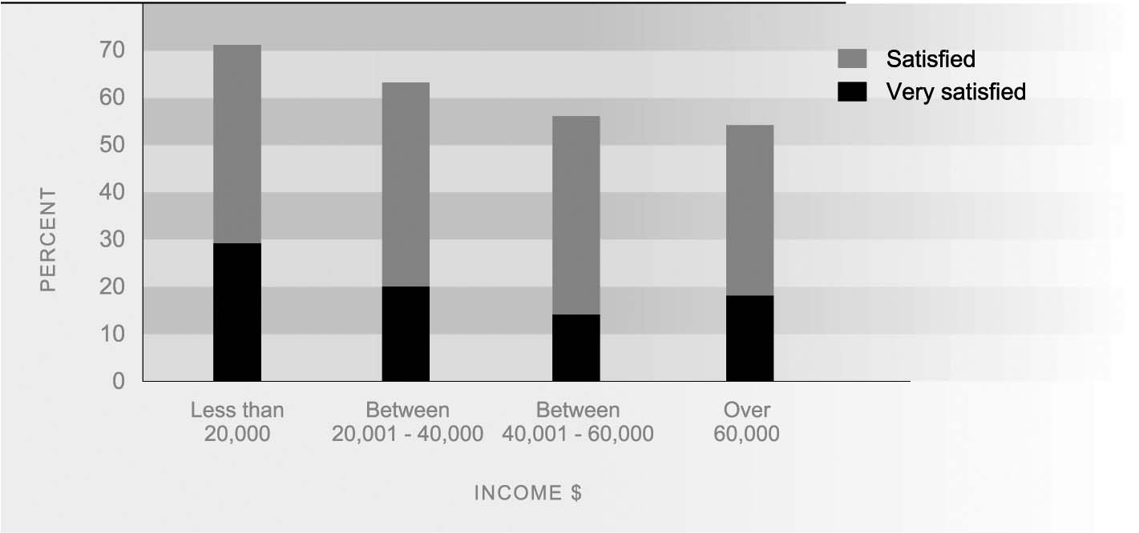
Source: Ministry of Social Development (2004)

