The social report monitors outcomes for the New Zealand population. This section contains background information on the size and characteristics of the population to provide a context for the indicators that follow.
People

Population size and growth
New Zealand’s resident population reached 4 million in April 2003 and was estimated to be 4.04 million at the end of December 2003.
During the 2003 year, the population grew by 63,000 or 1.6 percent, the same rate of growth as in 2002. These estimated growth rates were relatively high compared with most years since 1991.
Under medium population projection assumptions, the population is expected to grow by an average of 1.2 percent per year up to 2006, reflecting significant net migration gains during this period. Assuming net migration of 5,000 people per year after that, the growth rate is then expected to slow gradually to 0.6 percent per year during the decade following 2010. Such a growth rate would add around half a million people to the population by 2021.
Figure P1 Historical and projected resident population, 1981-2001
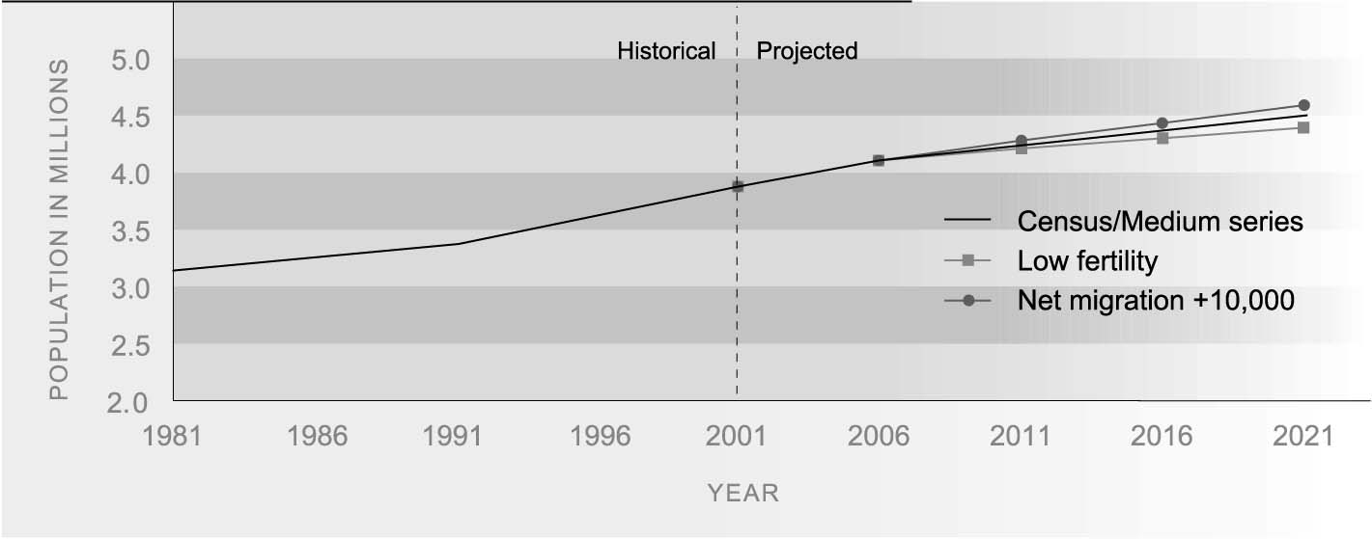
Source: Statistics New Zealand
Note: All three projections assume medium mortality. The medium projection series assumes medium fertility and a long-term annual net migration gain of 5,000

Components of population change
Changes in population size are driven by two key factors: natural increase (births minus deaths) and net annual migration.
Births exceeded deaths by 28,100 in the December 2003 year, an increase from 26,000 in 2002. Historically, natural increase has been the main component of population growth in New Zealand, but its contribution is slowly declining as the population ages and fertility declines.
The number of people coming to live in New Zealand in 2003 exceeded those leaving the country to live elsewhere by 34,900, a slightly smaller net migration gain than in 2002 (38,200). In the December 2002 and 2003 years, the net gain from permanent and long-term migration accounted for 60 and 55 percent, respectively, of population growth.
Figure P2 Components of population change, 1982 to 2003
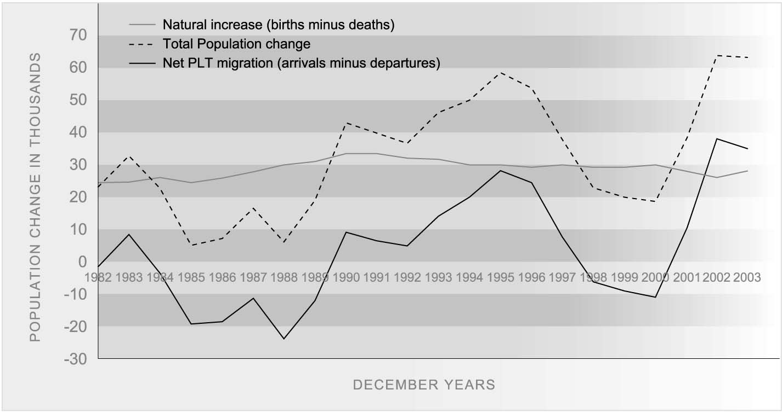
Source: Statistics New Zealand
Almost 70 percent of New Zealand nationals returning home in 2003 after a long-term absence came from either the United Kingdom or Australia. These two countries were also the most popular destinations for New Zealand citizens departing for a permanent or long-term absence.
The net inflow of non-New Zealand citizens more than doubled between 2000 and 2002 (from 26,600 to 54,900), before falling to 46,100 in 2003. The main contributing countries in 2003 were China (11,300), the United Kingdom (8,400), India (5,500), Japan (2,400), Australia (2,200), Fiji (1,900) and South Africa (1,600). Auckland is the destination of the largest group of new migrants.

Fertility
Provisional fertility rates for the year 2003 indicate that New Zealand women average 1.96 births per woman. This figure is about 7 percent below the level required by any population to replace itself without migration (2.10 births per woman). Sub-replacement fertility is a feature of most developed countries, including Australia (1.7 births per woman), Canada (1.6), Denmark (1.7), England and Wales (1.7), France (1.9), the Netherlands (1.7) and Sweden (1.6), but not the United States (2.12 in 2001). The comparatively high rate in New Zealand reflects the higher fertility rates of Mäori (2.55 births per woman in 2003) and Pacific women (2.94 in 2000-02), who make up a fifth (22 percent) of women in the reproductive ages.
Since 1992, the median age of women giving birth has risen from 28 to 30 years (half were older, half were younger). The median age of Mäori women giving birth is younger but is also increasing (from 25 years in 1996 to 26 years in 2003).
New Zealand has a relatively high rate of childbearing at young ages compared with other developed countries, but the trend has been downward in recent years. The birth rate for young adolescents under 18 years was 18.0 per 1,000 females aged 15-17 years in 1996 and 14.8 per 1,000 in 2003. The rate for young Mäori is higher but has fallen faster over the same period (from 48.3 to 39.4 births per 1,000 15–17-year-old females). The birth rate for Pacific females under 18 years declined from 28.2 to 22.9 per 1,000 between 1996 and 2001.⁴

Distribution of the population
Over three-quarters (76 percent) of the population live in the North Island, and nearly a third (32 percent) in the Auckland region.
Reflecting the impact of migration, growth in the population of the Auckland region accounted for just over two-thirds (68 percent) of the total population growth over the period between the 1996 and 2001 censuses.
The Mäori population is heavily concentrated in the North Island (88 percent), but only 24 percent of Mäori live in the Auckland region.
The New Zealand population is highly urbanised. At the 2001 Census, 86 percent of the population were living in an urban area. This includes 71 percent living in main urban areas (population 30,000 or more), 6 percent living in secondary urban areas (10,000-30,000) and 8 percent living in minor urban areas (1,000-10,000).
There are marked ethnic differences in urbanisation, with the vast majority of Pacific, Asian and Other ethnic groups living in main urban areas and very few in rural areas.
Table P1 Urban and rural residence (%), by ethnic group, 2001
 | European | Mäori | Pacific | Asian | Other | Total
Main urban area (30,000+) | 69 | 64 | 92 | 94 | 92 | 71
Secondary urban area  (10,000-29,999) | 7 | 7 | 3 | 2 | 2 | 6
Minor urban area (1,000-9,999) | 9 | 13 | 2 | 2 | 2 | 8
Total urban | 84 | 84 | 98 | 98 | 97 | 86
Rural | 16 | 16 | 2 | 2 | 3 | 14
Total | 100 | 100 | 100 | 100 | 100 | 100
Source: Statistics New Zealand, 2001 Census, Ethnic Groups, Table 5a

Ethnic composition of the population
The New Zealand population is becoming more ethnically diverse.
While the European ethnic group category still has the largest share (80 percent), the number of people identifying as European increased by only 3 percent between 1991 and 2001. Over the same period, the number who identified as Mäori increased by 21 percent, the Pacific peoples ethnic group increased by 39 percent, and the number of Asian people increased by 138 percent.
Table P2 Ethnic distribution of the population 1991, 2001
Ethnic group | 1991 | % | 2001 | %
European | 2,783,025 | 83.2 | 2,868,009 | 80.0
Mäori | 434,847 | 13.0 | 526,281 | 14.7
Pacific peoples | 167,070 | 5.0 | 231,801 | 6.5
Asian | 99,756 | 3.0 | 237,459 | 6.6
Other | 6,693 | 0.2 | 24,924 | 0.7
Total with ethnicity specified | 3,345,813 | 104.3 | 3,586,731 | 108.5
Source: Statistics New Zealand, 2001 census, National Summary, Table 8
Note: The ethnic data in this table allows up to three responses per person. Where a person reported more than one ethnic group, they have been counted in each applicable group. Totals therefore do not add up to 100 percent
In 2001, Mäori made up 14.7 percent of the usually resident population compared with 13 percent in 1991. More people said they belonged to an Asian ethnic group than a Pacific peoples ethnic group in 2001 (6.6 percent, compared with 6.5 percent for Pacific peoples). Ethnic groups other than European, Mäori, Asian or Pacific made up 0.7 percent of the population in 2001. By 2021, the Mäori share of the population is projected to be 17 percent, the Pacific share 9 percent, and the Asian share 13 percent.
Ethnic diversity varies by age: among those under 25 years in 2001, 22 percent were Mäori, 10 percent were Pacific peoples, 8 percent Asian and 1 percent other ethnic groups. Among those aged 65 and over, Mäori made up 4 percent, Pacific people and Asians each made up 2 percent, and other ethnic groups 0.2 percent.
The number of people with multiple ethnic identities is increasing. In 2001, 91 percent of the population identified with one ethnic group, down from 95 percent in 1991. Having multiple ethnic identities is particularly common among Mäori. Of those who said they belong to the Mäori ethnic group in 2001, 44 percent identified with at least one other ethnic group. Younger people are far more likely to be identified with more than one ethnic group than older people. Birth registration data for 2001 shows that about one in five babies was identified with more than one ethnic group, compared to one in 10 mothers.⁵
The figures for the ethnic distribution used in this section are based on the number of people identifying with each ethnicity. Because people can identify with more than one ethnicity, the total number may be greater than the size of the population. Elsewhere in the report, the approach to measuring ethnicity varies with the data source used.

Age and sex structure of the population
Just over half the New Zealand population (51 percent) is female. Males outnumber females among children and youth, but females predominate among adults, particularly from the late twenties to the mid-forties, and from the late fifties onwards. More males are born than females, but male youth have higher mortality rates than females. The imbalance in the middle years is an outcome of sex differences in net migration (there were more males than females in the net migration loss in the three years before the 2001 Census, and more females than males in the net migration gain of the previous five years). At older ages it reflects the higher mortality rates of males.
Figure P3 Population by age and sex, 2002
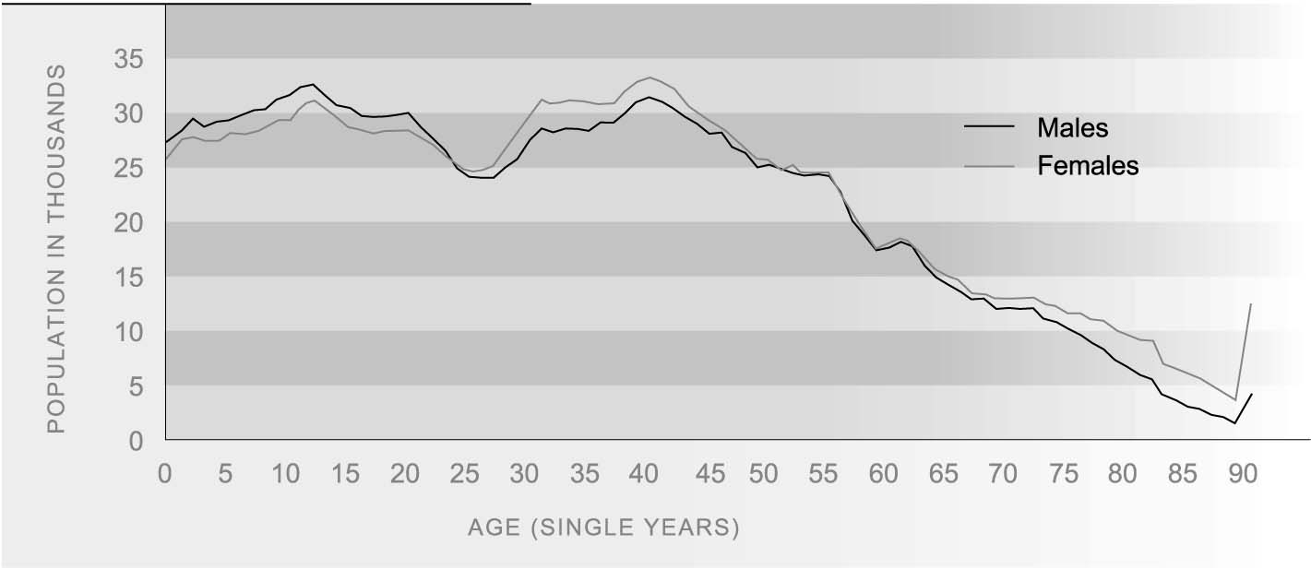
Source: Statistics New Zealand
The New Zealand population is ageing: the median age of the population was 35 years in 2001, and is expected to rise to 38 years by 2011, and to 40 years by 2021.⁶
The proportion of the population under 15 years of age has declined from 26 percent in 1982 to 22 percent in 2002 and is expected to fall to 19 percent by 2012. The population aged 65 and over has increased from 10 percent of the total population in 1982 to 12 percent in 2002. This figure is projected to reach 14 percent by 2012, assuming medium fertility, medium mortality, and long-term an annual net migration gain of 5,000.
Population ageing within the working age group will be partly offset over the next decade by the entry of the ‘baby blip’ – the relatively large generation of babies born around 1990 - into the young adult age groups. By 2012, the 15-24 age group is expected to be 16 percent larger than it was in 2002. Over the same period, there will be a slight decline in the number of people aged 25-44, and an increase of 26 percent in the population aged 45-64 years. By 2012, 45–64-year-olds will make up 39 percent of the working age population, compared with 34 percent in 2002.
Age structure varies by ethnic group. In 2001, the European ethnic group population was the oldest, with a median age of 37 years, followed by Asians (28 years), other ethnic groups (26 years), Mäori (22 years) and Pacific peoples (21 years). By 2021, half of all Mäori will be older than 27 years, and half of all Pacific peoples older than 24 years. Over the same period, the median age of European and Asian New Zealanders is expected to have risen to 44 years and 36 years, respectively.⁷

Households
A household may contain a single person living alone, or two or more people who usually live together and share facilities, either as families (couples, parents with children), or groups of individuals flatting together. There were 1.3 million households in New Zealand in 2001, an increase of 23 percent over the number recorded in 1986.
Twenty-seven percent of households contained couples without children in 2001, 30 percent contained two-parent families with children, 12 percent were one-parent family households, 2 percent contained more than one family, 5 percent comprised a group of individuals, and 23 percent were one-person households.
Figure P4 Distribution of households, by household type, 1086-2001
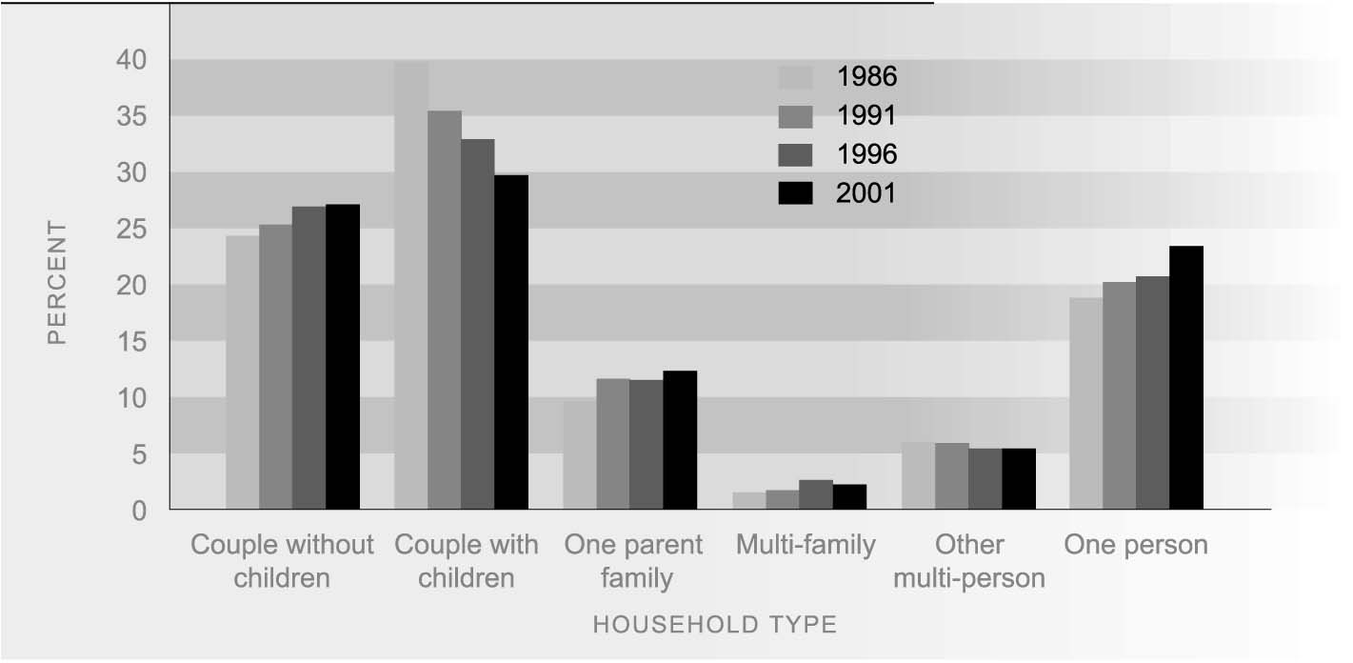
Source: Statistics New Zealand
Couple-only and one-person households are the fastest growing household types and are projected to increase the most over the next 15 years. Population ageing is the major factor behind both of these changes. But declining fertility and the closing gap between male and female life expectancy are also contributing to the rising number of couples without children, while delayed marriage, divorce and changing lifestyle preferences are contributing to the growing number of one-person households.

Families with children
In 2001, there were 591,700 families with children living within New Zealand households, 81 percent of which contained dependent children (aged under 18 years and not in full-time employment).
The number of families with dependent children increased by 6.6 percent in the decade to 2001, compared with just 1.5 percent in the previous decade. The most significant change in families in the past two decades has been the shift from two-parent to one-parent families. This was more pronounced in the 1980s, when the share of one-parent families increased from 14 to 24 percent, than in the 1990s, when it rose to 29 percent. One-parent families are expected to continue to increase, but at a slower rate. Family projections based on trends since 1986 suggest that by 2021, one-parent families are likely to make up around 35 percent of all families with dependent children. For many of these families there will be parents living in another household who are actively involved in the care and upbringing of the children.
Table P3 Families with dependent children, by family type, 1976 to 2001
 | 1976 | 1981 | 1986 | 1991 | 1996 | 2001
Number
Two-parent family | 398,772 | 380,886 | 363,489 | 339,681 | 346,086 | 339,159
One-parent family | 46,296 | 62,280 | 82,632 | 110,055 | 126,585 | 140,178
Mother only | 39,153 | 52,938 | 71,388 | 92,028 | 107,394 | 117,018
Father only | 7,143 | 9,342 | 11,244 | 18,024 | 19,191 | 23,163
Total families | 445,068 | 443,166 | 446,121 | 449,736 | 472,671 | 479,337
Percentage distribution
Two-parent family | 89.6 | 85.9 | 81.5 | 75.5 | 73.2 | 70.8
One-parent family | 10.4 | 14.1 | 18.5 | 24.5 | 26.8 | 29.2
Mother only | 8.8 | 11.9 | 16.0 | 20.5 | 22.7 | 24.4
Father only | 1.6 | 2.1 | 2.5 | 4.0 | 4.1 | 4.8
Total families | 100.0 | 100.0 | 100.0 | 100.0 | 100.0 | 100.0
Sources: Statistics New Zealand, published and unpublished census data
Note: The census definition of child dependency has changed over time. From 1996, a dependent child is a person aged less than 18 years who is not in full-time employment. For earlier years, a dependent child is a person under 16 years or aged 16-18 and still at school
New Zealand has a relatively high proportion of families with children under 18 headed by sole parents, second only to the United States (31 percent in 2001) and higher than the United Kingdom (22 percent), Australia and Canada (both 21 percent).

Disabled New Zealanders
One in five New Zealanders experiences disability.⁸ The New Zealand Disability Survey found that 743,800 New Zealanders had some level of disability in 2001. This included an estimated 107,200 Mäori and 28,100 Pacific people with a disability.
The vast majority (96 percent) of adults with disabilities live in households. The remaining 4 percent (27,300) live in residential facilities. Provisional data suggests an estimated 88,100 New Zealanders living in households have a severe disability requiring daily assistance. A further 317,000 New Zealanders living in households have a moderate disability, requiring some type of assistive equipment and/or regular help with certain household tasks.⁹
Disability increases with age. The prevalence of disability ranges from 11 percent of children (0-14 years), to 54 percent of people aged 65 years and over.
Table P4 Number and prevalence rate of people with disabilities (total population residing in households and residential facilities), by age group and sex, New Zealand, 2001
Age group (years) | Male |  | Female |  | Total
 | Number | Rate (%) | Number | Rate (%) | Number | Rate (%)
0-14 | 54,200 | 13 | 35,700 | 9 | 90,000 | 11
15-44 | 88,600 | 12 | 114,000 | 14 | 202,600 | 13
45-64 | 115,800 | 27 | 94,800 | 23 | 210,600 | 25
65+ | 100,300 | 51 | 140,300 | 56 | 240,600 | 54
Total | 358,900 | 20 | 384,900 | 20 | 743,800 | 20
Source: Statistics New Zealand (2001d) Tables 1.01a, 1.02a
Many disabled New Zealanders face barriers to full participation in society. The 2001 New Zealand Disability Survey found that 39 percent of disabled adults in households had no educational qualification, compared to 24 percent of non-disabled adults. Fifty-seven percent of 15-64 year-olds with a disability were employed, compared with 71 percent of non-disabled 15-64 year-olds. More than half (56 percent) of adults with disabilities had a gross personal income of less than $15,000 – compared to 40 percent of non-disabled adults.¹⁰

Gay, lesbian, bisexual and transgender communities
There is little information available about gay, lesbian, bisexual, fa’afafine, takatäpui, intersex, transgender and transsexual communities in New Zealand, or their size in relation to the total population.
Some information about same sex couples who share a residence was collected in the 1996 and 2001 population censuses. The 2001 Census recorded just over 10,000 adults living with a partner of the same sex, making up 0.6 percent of all adults living in couples. This is a larger number than the 6,500 recorded in the 1996 Census, when they made up 0.4 percent of all couples. However, it is difficult to know whether the change in numbers represents a real increase in the number of same sex couples living together, or a greater willingness on their part to report living arrangements and partnership status. According to Statistics New Zealand, it is likely that the figures understate the actual number of same-sex couples because of inconsistency in the way people have responded to the census question.

