dESIRED OUTCOMES
The natural and built environment in which people live is clean, healthy, and beautiful. All people are able to access natural areas and public spaces.
Physical Environment
INTRODUCTION
The physical environment includes land, air, water, plants and animals, buildings and other infrastructure, and all of the natural resources that provide our basic needs and opportunities for social and economic development.
A clean, healthy environment is important for people’s physical and emotional wellbeing. At a fundamental level, factors such as clean air and good quality drinking water are vital for people's physical health. Other environmental factors such as noise pollution can cause both physical harm and psychological stress.
The cleanliness and beauty of the environment is also important for people’s sense of wellbeing. For many people, access to an attractive physical environment contributes to their contentedness with life. A healthy environment also provides recreational opportunities, allowing people to take part in activities they value. For New Zealanders, the ‘clean, green’ environment is also an integral part of national identity, and guardianship of the land and other aspects of the physical environment is seen as an important part of social wellbeing.⁷³ This image is also vital for the health of New Zealand's economy, as it is a key factor both in attracting tourists and underpinning the nation's success as an exporter of primary products.
Harm to the environment can reduce quality of life not only for people living today but also for many years in the future. The concept of ‘sustainability’ is an important aspect of social wellbeing. It acknowledges that social and economic developments need to take place in ways that don’t harm present and future wellbeing by damaging the natural environment, and don’t harm future wellbeing by using natural resources in unsustainable ways.
Two indicators are used in this chapter. Both measure important aspects of the environment that have a direct impact on individual wellbeing. The indicators are: air quality and drinking water quality.
These indicators provide an insight into both current and future wellbeing. They relate to the health, cleanliness and beauty of the environment. No direct measure of people's access to natural areas and public spaces is included due to a lack of adequate data.
Clean air and good quality drinking water are both necessities of life. Pollution in either air or water can have significant detrimental effects on people's health, as well as being detrimental to the beauty of the environment.
The first indicator measures the levels of fine particles in the air at certain sites. Fine particles are known to have an adverse effect on people’s health. Prolonged exposure to elevated levels has been linked with aggravation of existing respiratory and cardiovascular diseases and premature death.
The second indicator measures the percentage of the population receiving drinking water that complies with the 1995 drinking water standards. Poor quality drinking water can create health risks from water-borne disease and contaminants. It is also likely to be associated with poor quality sewerage infrastructure and electricity supply.
Air quality
DEFINITION
PM10 is particulate matter that is less than 10 microns in diameter. The New Zealand ambient air quality guideline for PM10 is 20 micrograms per cubic metre (20µg/m³) averaged annually.

RELEVANCE Good air quality is an important component in maintaining our quality of life, the appeal of New Zealand as a tourist destination, and the health of people, plants and animals. PM10 is the primary contaminant of concern in New Zealand as it is known to affect many people with adverse health effects. Health effects associated with this contaminant include increased premature mortality, aggravation of existing respiratory and cardiovascular diseases, hospital admissions and emergency department visits, school absences, lost work days and restricted activity days.

CURRENT LEVEL Figure EN1.1 shows that average annual PM10 levels in the air were above the ambient
AND TRENDS guideline in Christchurch for all years between 1995 and 2003. However, more recent years (2002 and 2003) may be showing evidence of an improvement. Hamilton also exceeded the guideline in 1999/2000, and in 2002/2003, but by a smaller amount.
Wellington levels appear to be on the rise with PM10 equal to the guideline in 2000/2001 and in excess of the guideline in 2002 and 2003. Levels in Auckland also appear to be on the rise, although they have not yet exceeded the annual guideline.
Dunedin consistently recorded levels of particles below the New Zealand annual guideline.
Poor air quality in New Zealand is typically associated with urban areas and is a product of vehicle emissions (Auckland) and domestic home heating (nationally). Industrial and agriculture emissions are also lesser sources of PM10, as are dust pollens and sea spray, which are natural sources of particles. Annual data presented here should not be confused with daily average PM10 concentrations, which are known to exceed health-based guidelines in 28 urban centres in New Zealand.
Figure EN1.1 PM10 concentration in selected sites 1995-2003
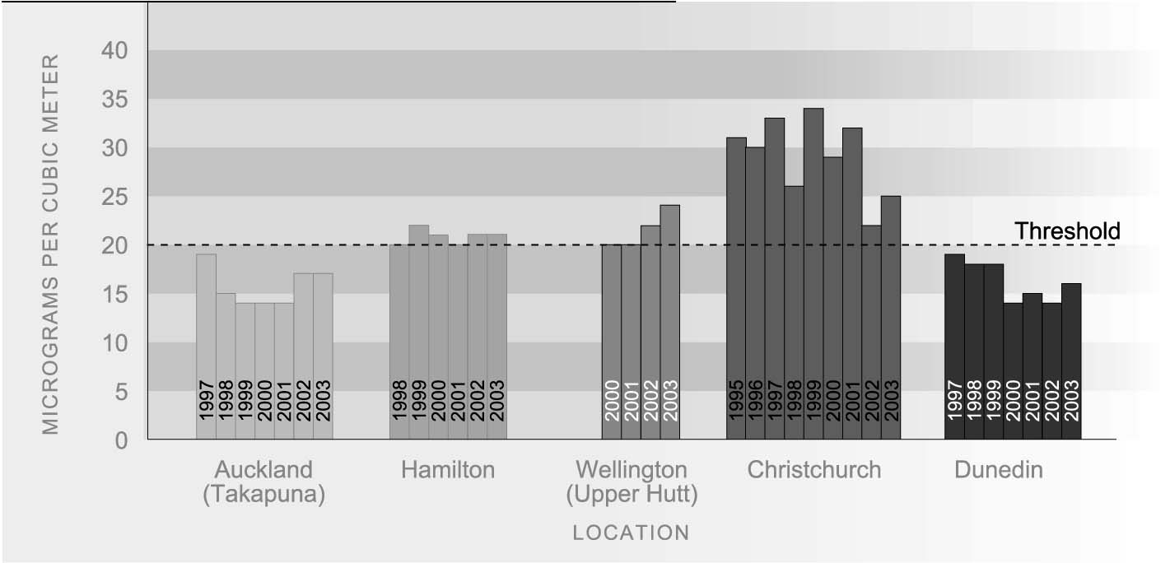
Source: Ministry for the Environment (2002)
Note: Data for Wellington is unavailable before 2000, for Dunedin before 1997, and for Hamilton before 1998

INTERNATIONAL Ambient air quality is entirely location-specific and it is not possible to compare
COMPARISON countries. For example, it is possible to compare annual PM10 in Auckland with annual PM10 in Los Angeles, but an OECD median cannot be calculated. As a broad generalisation, however, the air quality in New Zealand’s urban areas is comparable with or better than a number of OECD countries. New Zealand emits below the average OECD level for carbon dioxide on a per capita basis.⁷⁴

Drinking water quality
DEFINITION
The percentage of the surveyed population that receive their water from community water supplies, whose drinking water complies with the Drinking Water Standards of New Zealand 1995 relating to E. coli and Cryptosporidium. About 85 percent of the New Zealand population drink water from community supplies.

RELEVANCE Maintaining good drinking water quality is critical for human health and quality of life outcomes. The health risk to consumers from water-borne disease in drinking water supplies comes from two main types of microbiological organisms: bacteria (such as faecal coliforms, and E. coli), and parasites (such as Giardia, and Cryptosporidium). Improvements in this indicator ensure that less of the population is at risk of water-borne disease and other contaminants.
________________________________________________
CURRENT LEVEL The majority of New Zealanders are supplied with community drinking water that is AND TRENDS free of micro-organisms. The proportion of New Zealanders whose drinking water, measured at the tap, complies with the 1995 drinking water standards regarding E. coli increased from 69 percent in 1994 to 80 percent in 2002. Overall the level of E. coli compliance has fluctuated over the second half of the 1990s from between 80 and 86 percent. Most water supplies serving large population areas are fully compliant with the 1995 standards. The main reason for non-compliance is inadequate monitoring rather than the actual contamination of drinking water. Inadequate monitoring is the reason behind the slight decrease in E. coli compliance between 2001 and 2002.
Compliance with the 1995 drinking water standards for Cryptosporidium is measured at the water treatment plant rather than at the tap. Data is not available for Cryptosporidium compliance before 1996. Since 1996, the compliance rate has increased slightly from a value of 77 percent in 1996 to 81 percent in 2002. Between these years there was some measured fluctuation in levels of compliance with a low of 75 percent in 1997 and 1998.
While the proportion of consumers with fully compliant drinking water supplies has remained fairly flat since 1996, this reflects the replacement of the 1984 standards with the more stringent standards adopted in 1996 rather than any decline in water treatment over this time.
Figure EN2.1 Proportion of the surveyed population served with water that meets drinking water standards, 1994-2002
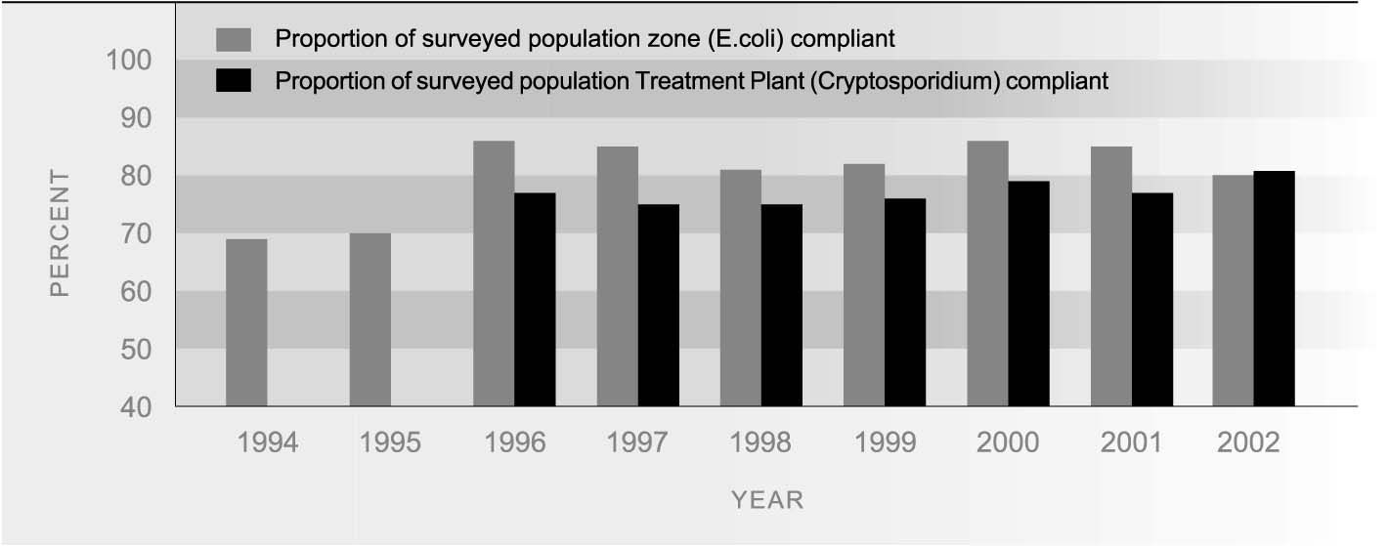
Source: Ministry of Health (2002b)

REGIONAL Groundwater sources supply drinking water for about 40 percent of the New Zealand
DIFFERENECES population, while about 60 percent of people are supplied from surface (catchment) water. Most water in catchment headwaters is of good quality, but problems with the quality of some groundwater sources have been identified.
There is considerable regional variation in the population served with drinking water that is fully compliant. In 2002, only 13 percent of the population in Otago and 21 percent of the population in Southland were served with drinking water that fully complied with the 1995 drinking water standards. Waikato and Northland also had particularly low compliance rates, varying between 32 percent and 38 percent of the population covered. Compliance in Auckland, Tauranga and Wellington, however, was close to 100 percent. The vast majority of non-compliance is due to inadequate monitoring, rather than actual contamination. This is the main reason for low levels of compliance in Northland, Waikato and Otago in 2002.
Where drinking water quality is affected, the agricultural sector is seen as the most important source of water quality problems.⁷⁵

INTERNATIONAL Overall, the quality of New Zealand water is high by international standards. New
COMPARISON Zealand’s water supplies are free of many of the diseases that result in sickness and death in other countries. However, the incidence of infection from Giardia in water supplies is 85 per 100,000 people, which is considered high compared to the reported rates for other western countries.⁷⁶

