DESIRED OUTCOMES
All people enjoy physical safety and feel secure. People are free from victimisation, abuse, violence and avoidable injury.
Safety
INTRODUCTION
Safety is fundamental to wellbeing: at their most extreme, violence and avoidable injuries threaten life itself. In other cases, they reduce quality of life for the victim and other people in a multitude of ways.
Both safety and security are important. Safety is freedom from physical or emotional harm, while security is freedom from the threat or fear of harm or danger. The desired outcomes recognise that threats come in many forms, ranging from deliberate violence to accidental injury.
Violence and injury corrode quality of life in many ways. Physical injury causes pain and incapacity, reducing victims’ enjoyment of life and ability to do things that are important to them.
Property crime, such as burglary, also affects people’s wellbeing. In addition to the direct losses associated with crime of this sort, evidence suggests the threat of burglary is a more significant worry for many people than the threat of violence.⁷⁷
Psychological effects are often as important as the physical ones. Victims of violence or injury often retain emotional scars long after their physical wounds have healed. They may suffer from depression or face other mental health issues.
Crime affects not only individuals but also society as a whole. The victim’s family and friends are likely to suffer grief and anger. They may have to care for someone who is temporarily or permanently incapacitated and may suffer from loss of livelihood. Crime and the fear of crime may also reduce social cohesion within communities.
Crime may restrict people’s choices about how to live their lives. For example, they may avoid certain areas or avoid going out because of a fear of crime.
Costs to society as a whole range from the costs of hospital care and law enforcement to the loss of the victim’s input to their work and community.
Children who grow up surrounded by violence may themselves become violent adults, perpetuating a negative cycle.

INDICATORS Four indicators are used in this chapter. They are: child abuse and neglect, criminal victimisation, safety perceptions, and road casualties. The first three indicators combine to provide a picture of the level and impact of violence in the community. Together, the indicators directly address the question of how free New Zealanders may be from victimisation, abuse, violence and avoidable injury.
Child abuse and neglect, the first indicator, are major social problems. They cause physical and psychological harm which are often long-lasting. Child abuse figures are relevant to current levels of wellbeing and point to future social problems as well.⁷⁸ This indicator uses the proportion of children assessed as abused following notification to the Department of Child, Youth and Family Services, which is likely to underestimate the true level of violence against children. This under-reporting makes it difficult to interpret trends over time and also difficult to draw conclusions from trends; an increase in the rate of reported child abuse may in fact be positive if it reflects higher levels of awareness and reporting of abuse, rather than higher levels of abuse itself.
Measuring criminal victimisation is difficult, as many crimes are not reported to the Police. This is particularly true of burglary, domestic violence, and child abuse. The second indicator uses survey results to give a more comprehensive picture of the level of criminal victimisation in society, including the level of violence.
The third indicator is perceptions of safety. Feeling unsafe harms quality of life by producing anxiety and reducing people’s options in life. However, there is some evidence that fear is often not linked to the actual risk of becoming a crime victim – for example, people may feel unsafe and have their quality of life reduced even when the actual likelihood of their being victimised is relatively small.
People should also be able to live in a society where they are free from the risk of avoidable death or injury. The leading cause of avoidable injury and death is motor vehicle crashes. In economic terms, the social cost of motor vehicle crashes has been estimated at $3.1 billion annually.⁷⁹ The final indicator is road casualties.
Workplace accidents are another form of avoidable injury. They are discussed in the chapter on Paid Work.
Child abuse and neglect
DEFINITION
The number of children assessed as abused (physically, emotionally, sexually) or neglected following a notification to the Department of Child, Youth and Family Services (CYFS), as a proportion (per 1,000) of all children under 17 years of age.

RELEVANCE Abuse or violence damages a child’s physical and psychological health, with the consequences often experienced well into adolescence and adulthood.

CURRENT LEVEL In the year to June 2003, there were 31,781 care and protection notifications to the
AND TRENDS Department of Child, Youth and Family Services (CYFS). On a population basis, this represented 31.8 notifications per 1,000 children aged 0-16 years. Annual fluctuations in these figures do not necessarily reflect changes in the prevalence of child abuse. They may be influenced by the level of resources made available, and by changes in administration and reporting patterns.⁸⁰ More than one notification can be made for individual children.
In the year to June 2003, 7,361 children were assessed as abused or neglected by CYFS. This was a substantiated child abuse rate of 7.4 children for every 1,000 children 0-16 years of age, similar to the (revised) rate of 7.2 percent in 2002.⁸¹
Figure SS1.1 Substantiated child abuse and neglect rate, by age group, 1997-2003
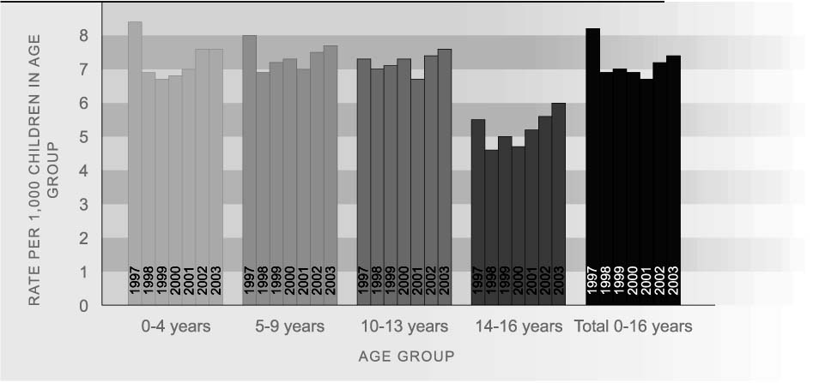
Source: Ministry of Social Development, SWIS (1997-2000), CYRAS (2001-2003)
Note: The rate is based on individual children who were assessed as abused (physically, emotionally, sexually) or neglected. 2002 rates have been revised

AGE AND SEX There is little difference by sex in rates of abuse among children under 10 years old but
DIFFERENCES at age 14-16 females are much more likely to be abused than males. In 2003, the rate of substantiated child abuse among 14–16-year-old females was 8.0 per 1,000, over twice the rate for males (3.9 per 1,000). These age and sex differences have been consistent over the last six years.
Table SS1.1 Substantiated cases of child abuse or neglect, by age and sex, years ended 30 June 2002 and 2003
Age group | Rate per 1,000 children
 | 2002 |  |  | 2003
 | Male | Female | Total | Male | Female | Total
0-4 years | 7.5 | 7.3 | 7.6 | 7.2 | 7.5 | 7.6
5-9 years | 7.3 | 7.6 | 7.5 | 7.4 | 7.9 | 7.7
10-13 years | 6.4 | 8.3 | 7.4 | 6.6 | 8.4 | 7.6
14-16 years | 3.7 | 7.4 | 5.6 | 3.9 | 8.0 | 6.0
Total | 6.5 | 7.7 | 7.2 | 6.5 | 8.0 | 7.4
Source: Ministry of Social Development, CYRAS. Revised data for 2002

ETHNIC DIFFERENCES Mäori children are more likely than non-Mäori children to be assessed as abused or neglected. In 2003, the rate per 1,000 was 11.9 for Mäori and 5.9 for non-Mäori. While the corresponding rates are not available for Pacific children, they are not over-represented among children assessed as abused, accounting for 11 percent of such children in 2003, about the same representation as they have in the child population.
Table SS1.2 Substantiated cases of child abuse or neglect, Mäori and non-Mäori ethnicity and sex, years ended 30 June, 1998-2003
 | Rate per 1,000 children AGES 0-16
 | Mäori |  |  | Non-Mäori
Year to 30 June | Male | Female | Total | Male | Female | Total
1998 | 11.8 | 13.9 | 13.0 | 4.6 | 5.5 | 5.1
1999 | 12.3 | 14.3 | 13.4 | 4.5 | 5.5 | 5.0
2000 | 11.1 | 13.2 | 12.3 | 4.7 | 5.6 | 5.3
2001 | 9.4 | 10.9 | 10.2 | 4.9 | 6.1 | 5.6
2002 | 9.7 | 11.4 | 11.8 | 5.5 | 6.5 | 5.7
2003 | 10.8 | 12.5 | 11.9 | 5.1 | 6.5 | 5.9
Source: Ministry of Social Development, CYRAS
Note: 2001 and 2002 rates have been revised

INTERNATIONAL A UNICEF report on child maltreatment deaths in 27 OECD countries, averaged over a
COMPARISON five-year period during the 1990s, placed New Zealand twenty-fourth out of 27 countries, with a rate of 1.2 deaths per 100,000 children under the age of 15 years.⁸² This was high compared to an OECD median of 0.6 deaths per 100,000.
Only Mexico and the United States (both 2.2 per 100,000) had higher child maltreatment death rates than New Zealand. Outcomes for other countries include Australia and Canada (both 0.7 per 100,000, 18th equal), and the United Kingdom (0.4 per 100,000, 6th equal). These findings should be treated with caution because the very small numbers involved produce highly volatile rates. In addition, although the data comes from the same World Health Organization database and uses the same international classification of death by cause, there may be differences between countries, and within countries over time, in the classification of death by intention.
Criminal victimisation
DEFINITION
The proportion of the population aged 15 and over who have been the victims of one or more incidents of criminal offending as measured by the 2001 National Survey of Crime Victims.

RELEVANCE The criminal victimisation rate provides a broad measure of personal safety and wellbeing. Surveys of criminal victimisation generally provide a more comprehensive picture of victimisation than police data, as not all offending is reported or recorded.

CURRENT LEVEL Survey data shows that 30 percent of New Zealand adults aged 15 and over
AND TRENDS experienced victimisation during 2000. This is similar to the level in 1995 (31 percent).
A breakdown by the type of offence shows that 9 percent of the adult population reported they had been the victim of violent offending in 2000, the same level as in 1995. Eleven percent reported they had been subject to an individual property offence, such as theft or wilful damage, up from 8 percent in 1995. The proportion of people who were the victim of a household property offence was 19 percent in 1995 and 17 percent in 2000.
A small number of individuals accounted for the vast majority of violent victimisations. Less than 2 percent of the adult population were victims of violence five or more times, but they experienced 55 percent of the violent victimisations. Violent victimisations comprised slightly less than half of the total volume of victimisations disclosed by the 2001 survey.
Figure SS2.1 Criminal victimisation prevalence rate by type of victimisation, 1995, 2000
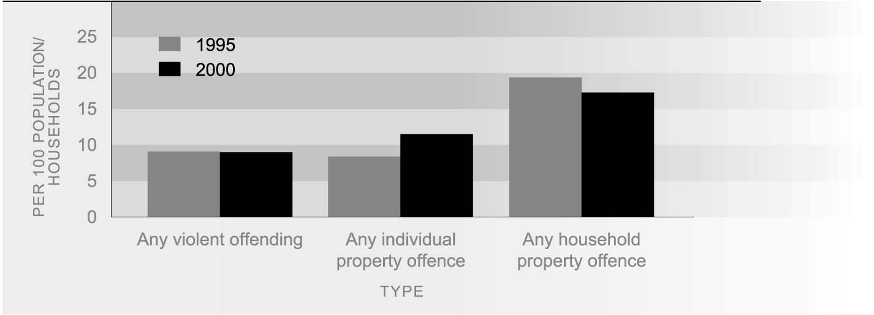
Source: Morris et al (2003), Tables 2.6, 2.8 and revised 1995 figures

AGE DIFFERENCES Young adults are more likely than older adults to be a victim of crime. In the 2001 survey, 46 percent of the 15–24 year age group had experienced victimisation compared with 33 percent of those aged 25–39, 28 percent of the 40–59 year age group and 13 percent of those aged 60 and over. Youth were more than twice as likely to be a victim of violent crime as the 25–39 year age group, the next closest group. Younger adults were also more likely than older people to experience an individual property offence, though the difference by age was less pronounced than for violent offences.
Table SS2.1 Criminal victimisation rate by major offence type and age, 2000
Offence type | Rate per 100 persons in each age group
 | 15-24 | 25-39 | 40-59 | 60+ | Total
Any violent offending  (including sexual assault) | 23.5 | 9.5 | 5.6 | 1.3 | 9.0
Any ‘individual’ property offence | 18.3 | 13.2 | 10.3 | 5.0 | 11.5
Any victimisation  (including household victimisation) | 45.9 | 32.9 | 28.2 | 12.7 | 29.5
Source: Morris et al (2003), Tables 2.6, 2.8, 2.13 and additional data

SEX DIFFERENCES The overall rate of victimisation did not vary by sex, with 30 percent of women and 29 percent of men reporting they had experienced victimisation in 2000. This is similar to 1995 when 31 percent of women and 32 percent of men experienced victimisation. While men and women were equally as likely to report being the victim of violence, more men than women disclosed violence by someone not well known to them (12 percent compared with 8 percent).
Survey information on partner violence shows that more than one in four women (26 percent) and just under one-fifth of men (18 percent) had been abused or threatened with violence by a partner at some time in their adult life. Changes in methodology between the 2001 and 1996 surveys on criminal victimisation mean it is not possible to compare changes in partner victimisation over time.⁸³
Women’s lifetime experience of sexual interference or assault was considerably higher than men’s (19 percent compared with 5 percent).

ETHNIC DIFFERENCES In 2000, Mäori were considerably more likely to be a victim of crime (41 percent) than Pacific people (28 percent) and Europeans (29 percent). The difference was greatest for violent victimisation, with one-fifth of Mäori experiencing offending of this type, compared to 11 percent of Pacific people and 8 percent of Europeans. Mäori were also more likely to experience individual property offences, though the difference was less marked than for violent offending. Pacific peoples were the least likely of any group to experience offending of this type. The proportion of Mäori women who had been abused or threatened with violence by a partner at some time during their adult life was very much higher (49 percent) than for European women (24 percent) and Pacific women (23 percent).
Table SS2.2 Criminal victimisation rate by major offence type and ethnicity, 2000

Offence type | Rate per 100 persons aged 15+
 | European | Mäori | Pacific | Other
Any violent offending  (including sexual assault) | 8.4 | 19.5 | 11.3 | 2.6
Any ‘individual’ property offence | 11.5 | 14.7 | 8.2 | 11.9
Any victimisation  (including household victimisation) | 28.9 | 40.9 | 28.3 | 26.4
Source: Morris et al (2003), Table 2.14

Perceptions of safety
DEFINITION
The proportion of people who reported that they felt unsafe walking alone in their neighbourhood at night. People who said they did not walk alone at night were asked how they thought they would feel.

RATIONALE Feeling safe is fundamental to wellbeing. Anxiety and worries about victimisation detract from wellbeing in themselves, and may cause people to alter their behaviour to avoid being victimised. This limits people’s options and can reduce their freedom. People’s subjective perceptions about safety are not always linked to the actual risk of becoming a crime victim.

CURRENT LEVEL In 2001, 29 percent of New Zealanders reported feeling unsafe walking alone in their neighbourhood at night. A fifth (20 percent) reported feeling only ‘a bit unsafe’, while 9 percent felt ‘very unsafe’.
Figure SS3.1 Proportion of the population who felt unsafe walking alone in their neighbourhood after dark, 2001
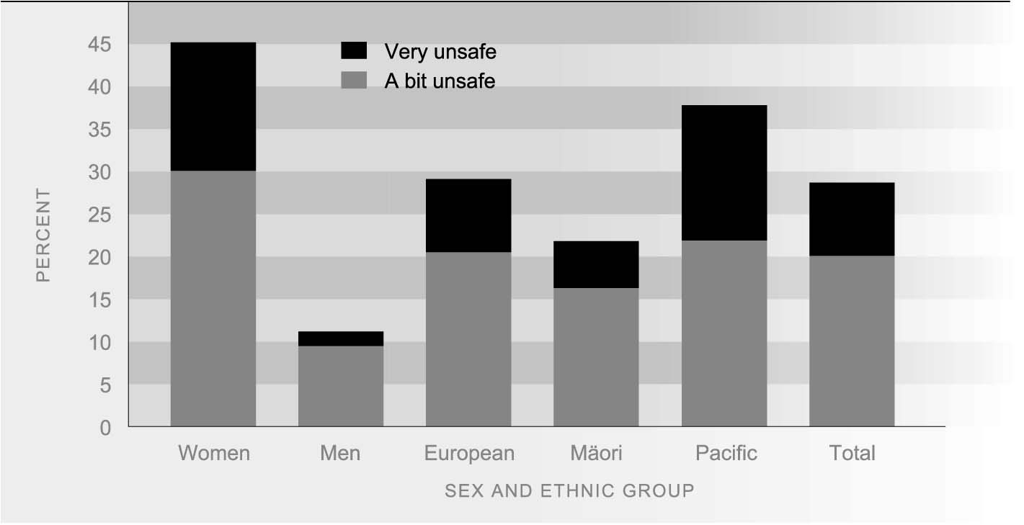
Source: Morris et al (2001)
People’s perceptions varied widely according to their behaviour. Of people who reported they did not walk alone at night, 30 percent reported feeling it would be a bit unsafe and 16 percent said they felt walking alone was very unsafe. People who reported that they walked alone at night were much less likely to feel unsafe. Only 10 percent felt a bit unsafe and 1 percent felt very unsafe.

SEX AND AGE Women were considerably more likely than men to report feeling unsafe about walking alone after dark (45 percent for females and 11 percent for males). Women were over three times more likely than men to report feeling a bit unsafe and over eight times as likely to report feeling very unsafe.
Table SS3.1 Proportion of adults aged 15 and over who felt unsafe walking alone in their neighbourhood after dark by sex, 2001
 | Age group |  |  |  |  | Sex
 | 15-16 | 17-24 | 25-39 | 40-59 | 60+ | Male | Female
A bit unsafe | 17.7 | 19.6 | 22 | 18 | 21.5 | 9.5 | 30.1
Very unsafe | 8.8 | 7.3 | 8 | 7.2 | 12.4 | 1.7 | 15.1
A bit unsafe or very unsafe | 26.5 | 26.9 | 30 | 25.2 | 33.9 | 11.1 | 45.2
Source: Morris et al (2003)
There is relatively little age difference in perceptions of safety. Just over a third (34 percent) of those aged 60 and older said they felt it would be unsafe to walk alone in their neighbourhood after dark. This compares with 27 percent of people aged between 15 and 24. At all ages, women felt less safe than men.

ETHNIC DIFFERENCES Pacific people were much more likely than other ethnic groups to report feeling unsafe about walking alone in their neighbourhood after dark. Over a third (38 percent) of Pacific people said they would feel unsafe, compared to 29 percent of the European and Other ethnic groups. The difference is greatest with regard to the proportion of people who felt very unsafe. Mäori, by way of contrast, generally felt safer than other ethnic groups. Just over one-fifth (22 percent) of Mäori said they would feel unsafe walking alone after dark in their neighbourhood, while 6 percent stated they would feel very unsafe.
Women were more likely to report feeling unsafe walking alone in their neighbourhood after dark than males for all ethnic groups. Pacific men were more than twice as likely as European and Mäori men to report feeling unsafe. In contrast, a similar proportion of Pacific and European women reported they felt unsafe, while the proportion among Mäori women was much lower. Pacific women, however, were considerably more likely to report feeling ’very unsafe’ compared to other groups.
Table SS3.2 Proportion of adults aged 15 and over who felt unsafe walking alone in their neighbourhood after dark by ethnicity, 2001
 | European | Mäori | Pacific people | Other
A bit unsafe
Male | 9.1 | 7.9 | 16.5 | 12.3
Female | 31.2 | 24.2 | 27 | 33.5
Total | 20.5 | 16.3 | 21.9 | 22.8
Very unsafe
Male | 1.7 | 1.2 | 5.1 | 0.4
Female | 15.2 | 9.7 | 26 | 13.1
Total | 8.6 | 5.5 | 15.9 | 6.7
A bit unsafe or very unsafe
Male | 10.8 | 9.1 | 21.6 | 12.7
Female | 46.4 | 33.9 | 53 | 46.6
Total | 29.1 | 21.8 | 37.8 | 29.5
Source: Morris et al (2003)
Road casualties
DEFINITION
The number of people killed or injured in motor vehicle crashes as a proportion (per 100,000) of the total population.

RELEVANCE Road deaths are a major cause of premature death, especially among young adults. Deaths, injuries and disability resulting from motor vehicle crashes inflict considerable pain and suffering on individuals, families and communities, as well as on other road users, emergency service providers, health workers and others.

CURRENT LEVEL In 2003, 461 people died as a result of motor vehicle crashes, a rate of 11.5 deaths per
AND TRENDS 100,000 population.⁸⁴ A further 14,361 people were injured, a rate of 358.2 injuries per 100,000 population. Deaths and injuries from motor vehicle crashes have declined substantially since 1986, when the rates were 23.1 and 569.6 per 100,000 respectively. The number of people killed in motor vehicle crashes was 40 percent lower in 2003 than it was in 1986. Although there was a rise in the number of people injured in the last three years, there were 24 percent fewer injured in 2003 than in 1986.
There is no conclusive evidence on what has driven the reduction in road casualties since 1986, but better roads, better vehicles, as well as legislation, enforcement and education aimed at reducing road casualties may have contributed to an improvement in drivers’ attitudes and behaviour.
Figure SS4.1 Road traffic injury and death rates, 1986--2003
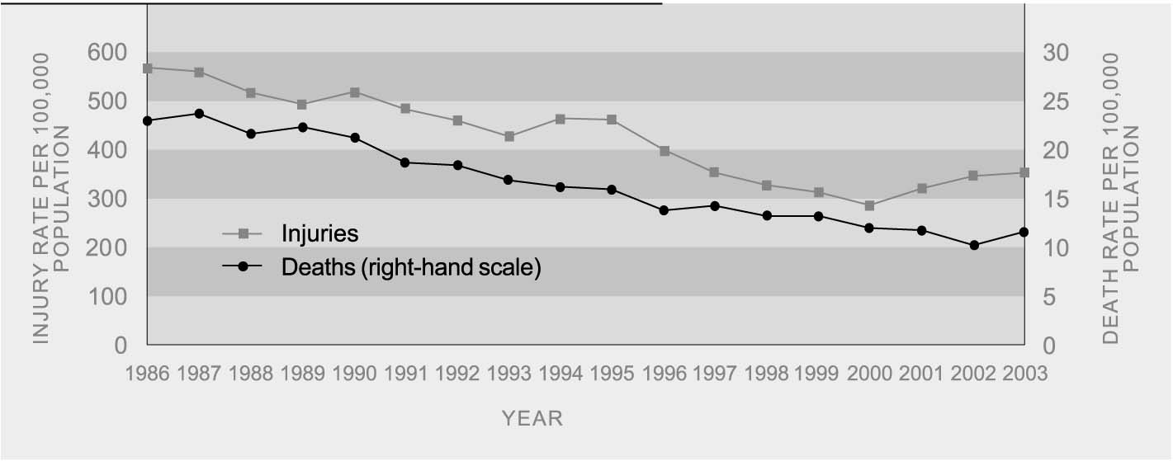
Source: Land Transport Safety Authority
Note: 2003 data is provisional

AGE AND SEX Young people aged 15-24 years are far more likely than any other age group to be
DIFFERENCES injured in a motor vehicle crash, with a rate more than double that of the population as a whole (785 per 100,000 in 2003). The risk of dying is relatively low in middle age, then increases sharply at older ages, partly because of increasing fragility among the very old.
Males are much more likely than females to be injured or killed in motor vehicle crashes. In 2002, the injury rate was 401.8 per 100,000 for males and 310.7 per 100,000 for females; the death rate was 15.8 per 100,000 for males and 7.3 per 100,000 for females.
Table SS4.1 Road casualty rates by age and sex, 2003
 |  | Rate per 100,000 population in each group
 |  | Reported injury rate |  |  |  | Death rate
Age | Males |  | Females | Total | Males |  | Females | Total
Under 15 | 146.4 |  | 125.7 | 137.1 | 3.5 |  | 2.6 | 3.1
15-24 | 895.2 |  | 666.5 | 785.0 | 30.4 |  | 14.2 | 22.4
25-34 | 535.2 |  | 385.0 | 458.8 | 25.9 |  | 6.4 | 15.8
35-44 | 394.5 |  | 281.7 | 337.5 | 16.0 |  | 6.3 | 11.0
45-54 | 297.7 |  | 252.7 | 275.5 | 10.8 |  | 6.4 | 8.6
55-64 | 261.4 |  | 220.0 | 240.7 | 12.0 |  | 5.1 | 8.5
65-74 | 226.5 |  | 204.5 | 216.6 | 15.4 |  | 8.3 | 11.7
75+ | 247.9 |  | 196.3 | 217.1 | 19.5 |  | 14.2 | 16.3
Total | 401.8 |  | 310.7 | 358.2 | 15.8 |  | 7.3 | 11.5
Source: Land Transport Safety Authority (provisional 2003 data); Statistics New Zealand, 2001-based estimated resident population as at 30 June 2003

ETHNIC DIFFERENCES Mäori are much more likely than other ethnic groups to die in motor accidents, though their age-standardised death rate declined from 26 per 100,000 in 1996 to 19 per 100,000 in 1999. In comparison, the death rate for European/Other ethnic groups was 12 per 100,000 in 1999 and for Pacific peoples, 8 per 100,000.
Table SS4.2 Motor vehicle death rates by ethnicity, 1996-1999
 |  | Age-standardised rate per 100,000
Year | Mäori |  | Pacific people | European and Other | Total
1996 | 26 |  | 14 | 12 | 14
1997 | 25 |  | 10 | 12 | 14
1998 | 21 |  | 12 | 12 | 13
1999 | 19 |  | 8 | 12 | 13
Source: New Zealand Health Information Service, cited in Ministry of Health 2000, Table 1; unpublished data for 1998, 1999 from NZHIS
Mäori and Pacific peoples are less likely to drive than Europeans, but they are at greater risk of injury and death from motor vehicle crashes. A 1998 survey showed that, per distance driven, the risk of being hospitalised as a result of a crash was more than three times as high for Mäori drivers, and only slightly less than three times as high for Pacific drivers compared to Europeans.⁸⁵

INTERNATIONAL In 2002 New Zealand was ranked 14th among 28 OECD countries with a road death
COMPARISON rate of 10.3 per 100,000 people.⁸⁶ This was similar to the OECD median of 10.8 deaths per 100,000. Turkey had the best outcome in the OECD in 2002 with a road death rate of 5.6 per 100,000. The New Zealand road death rate was better than that of the United States at 14.9 per 100,000 but worse than Canada at 8.9, Australia at 8.8 and the United Kingdom at 6.1 per 100,000.

