DESIRED OUTCOMES
People enjoy constructive relationships with others in their families, whänau, communities, iwi and workplaces. Families support and nurture those in need of care. New Zealand is an inclusive society where people are able to access information and support.
Social Connectedness
INTRODUCTION
Social connectedness refers to the relationships people have with others.
Social connectedness is integral to wellbeing. People are defined by their social roles, whether as partners, parents, children, friends, caregivers, team-mates, staff or employers, or myriad other roles. Relationships give people support, happiness, contentment and a sense they belong and have a role to play in society.⁸⁷ They mean people can call on help during hard times.
Social connectedness also refers to people joining to achieve shared goals which benefit each other and society as a whole – ranging from working together as part of business and paid employment to contributing to their communities through voluntary groups.
One of the most important aspects of social connectedness is the relationship people have with a spouse or partner. Studies have consistently found that having a partner contributes to a person’s reported level of wellbeing.⁸⁸
Several studies have demonstrated links between social connectedness and the performance of the economy as well as positive outcomes for individual health and wellbeing.⁸⁹
Social connectedness is fostered when family relationships are positive, and when people have the skills and opportunities to make friends and to interact constructively with others. Good health, employment, and feeling safe and secure all increase people’s chances of developing positive relationships.
There can be many barriers to social connectedness. The tendency to make connections outside the family varies between cultures and communities, and factors such as language differences, high levels of inequality, and tensions between ethnic groups can create barriers between people.
INDICATORS Five indicators are used to measure New Zealand's levels of social connectedness. Together, the five indicators used here measure opportunities for and actual levels of connection between people, both within people’s immediate social groups and with the wider community. The indicators are: access to the internet, regular contact with family/friends, trust in others, proportion of the population experiencing loneliness, and contact between young people and their parents.
Access to the internet is significant because it allows people to keep in touch without seeing each other face to face. This means social connectedness can be maintained even when people are in different cities or even different countries. It also means new social networks can be opened up between people who may never have met, crossing geographical boundaries.
For the vast majority of people, social networks centre on family and friends. The second indicator measures the proportion of people who take part in family activities and have family or friends over for a meal at least once a month.
Trust in others, the third indicator, measures the extent to which people expect others to act fairly towards them. High levels of trust enhance wellbeing by facilitating co-operative behaviour among people who otherwise do not know each other. Trust also enhances people’s ability to develop positive relationships with others.
Levels of loneliness are measured in the fourth indicator. Feelings of loneliness can not only be detrimental to people’s emotional health, but their physical health also, resulting in adverse health problems including stress, anxiety or depression.
The final indicator, the proportion of young people who report getting enough time each week with their parents, is a measure of the extent to which people in need of care and nurturing receive that support.
Telephone and internet access in
the home
DEFINITION
The proportion of the population with telephone and internet access in the home, as measured by the 2000 Living Standards Surveys.

RELEVANCE Being able to communicate and interact easily in the absence of frequent face-to-face contact helps maintain social connectedness. Access to telephones and access to communication via the internet, especially emails, are particularly relevant as social indicators because access to mail services is almost universal and fax use is principally by businesses. The internet also makes it easier to access a significant and growing repository of information and knowledge.

CURRENT LEVEL Access to a telephone is almost universal in New Zealand at 97 percent overall. Internet access is also relatively high at 41 percent, considering the relatively recent introduction of this communication technology.
Table SC1.1 Proportion of population with telephone and internet access by population characteristics, 2000
 | Telephone % | Internet access %
Population estimates
Total population | 97.3 | 40.6
Dependent children | 96.4 | 44.3
Age groupings
Adults aged under 65 | 97.3 | 44.2
Adults aged over 65 | 99.2 | 11.8
Family ethnicity
Mäori economic family | 92.3 | 28.3
Pacific economic family | 88.1 | 16.4
European economic family | 99.2 | 44.3
Other economic family | 96.9 | 50.7
Families with dependent children
One parent with dependent children | 88.9 | 25.3
Two parents with dependent children | 98.3 | 49.6
All families with dependent children | 96.8 | 45.6
Family employment/income status
People under 65, main income earner in full-  time employment | 98.8 | 49.0
People under 65, main income earner not in  full-time employment | 91.6 | 29.2
Adults over 65, with employment or other income  (above New Zealand Superannuation) | 99.5 | 18.2
Adults over 65, with little or no other income  (above New Zealand Superannuation) | 98.8 | 5.4
Source: Ministry of Social Development (2003b)
ETHNIC DIFFERENCES People living in Pacific economic families (those with any Pacific member) have the lowest telephone and internet access in the home (88 percent and 16 percent, respectively), followed by people living in Mäori economic families (92 percent and 28 percent). The highest level of internet access in the home was among people living in other non-European economic families (51 percent).

AGE GROUP AND Adults over 65 years are more likely than average to have a telephone, but much less
EMPLOYMENT likely to have internet access in their home (12 percent compared to 44 percent among
OR INCOME adults under 65). Older people with no income other than New Zealand Superannuation
DIFFERENCES have the worst level of internet access in the home (5 percent).
Among adults under 65, telephone and internet access in the home is lower than average where the main earner in the family is not in full-time employment, the difference being more striking in the case of internet access (29 percent compared to 49 percent).

DIFFERENCES BY Overall, families with dependent children are more likely than average to have internet\
FAMILY TYPE access in the home. However, sole-parent families are about half as likely as two-parent families to have internet access (25 percent compared to 50 percent) and considerably less likely than two-parent families to have a telephone (89 percent compared to 98 percent).

INTERNATIONAL New Zealand compares relatively favourably with other countries in relation to access
COMPARISON to the internet. In 2000, 14 out of every 100 New Zealanders were internet subscribers, compared with an OECD median of 11. New Zealand ranked ninth out of 26 OECD countries.⁹⁰
Participation in family/whänau activities and regular contact with family/friends
DEFINITION
The proportion of the population who participated in family/whänau activities and the proportion of the population who had family or friends over for a meal at least once a month, as measured by the 2000 Living Standards Surveys. ‘Family/whänau’ activities were not specified in the surveys; respondents interpreted them in their own ways.

RELEVANCE An important reflection of social connectedness is found in the extent to which people are in regular contact with family and friends, and the extent to which they participate in family (whänau) activities.

CURRENT LEVEL A high proportion of the population say they take part in family/whänau activities (86.8 percent) and more than two-thirds (70.5 percent) report having had family or friends over for a meal at least once a month.
Table SC2.1 Proportion of population doing family activities and having family/friends over for a meal, by population characteristics
 | Participation in family activities % | Have family/friends over for a meal %
Population estimates
Total population | 86.8 | 70.5
Adults aged under 65 | 86.5 | 72.0
Age groupings
Adults aged over 65 | 80.4 | 60.5
Family ethnicity
Mäori economic family | 90.9 | 68.9
Pacific economic family | 86.1 | 79.6
European economic family | 87.6 | 70.0
Other economic family | 71.8 | 70.3
Families with dependent children
One parent with dependent children | 87.4 | 65.4
Two parents with dependent children | 90.0 | 72.6
All families with dependent children | 89.6 | 71.4
Family employment/income status
People under 65, main income earner in full-  time employment | 89.0 | 73.4
People under 65, main income earner not in  full-time employment | 83.4 | 66.9
Adults over 65, with employment or other income  (above New Zealand Superannuation) | 85.5 | 69.3
Adults over 65, with little or no other income  (above New Zealand Superannuation) | 75.4 | 51.8
Source: Ministry of Social Development (2003b)
ETHNIC DIFFERENCES According to the surveys, people living in Mäori economic families are the most likely to take part in family or whänau activities (91 percent), while Pacific and European people have average levels of participation (86 and 88 percent, respectively). Those living in Other economic families are much less likely than average to take part in such activities (72 percent), perhaps reflecting the fact this group may include many new migrants whose families live overseas. Sharing meals in the home is more common among Pacific peoples (80 percent) than among people of other ethnic groups (70 percent).

AGE GROUP AND Adults over 65 years are less likely to engage in family activities (80 percent) and
EMPLOYMENT considerably less likely to have people over for a meal (61 percent), particularly those
OR INCOME with no income other than New Zealand Superannuation (52 percent).
DIFFERENCES
Among adults under 65, participation in family activities and sharing meals is somewhat lower than average where the main earner in the family is not in full-time employment (83 percent and 67 percent).

DIFFERENCES Not surprisingly, families with dependent children are more likely than average to
BY FAMILY TYPE participate in family or whänau activities, and there is little difference between sole-parent and two-parent families on this measure of social connectedness. However, sole-parent families are less likely than two-parent families to have friends or family over for a meal (65 percent compared to 73 percent).
Trust in others
DEFINITION
The proportion of the population aged 15 and over reporting that people can ‘almost always’ or ‘usually’ be trusted as reported in the Social Wellbeing Survey 2004.

RELEVANCE Trust in others is an important indicator of how people feel about members of their community. High levels of trust facilitate co-operative behaviour among people and contribute to people’s ability to develop positive relationships with others.

CURRENT LEVEL Results from the Social Wellbeing Survey 2004 show that over one-half (57 percent) of New Zealanders believe that people can be trusted, with 6 percent reporting that ‘people can almost always be trusted’ and 51 percent reporting that ‘people can usually be trusted’.
Figure SC3.1 Levels of trust in other people, 2004
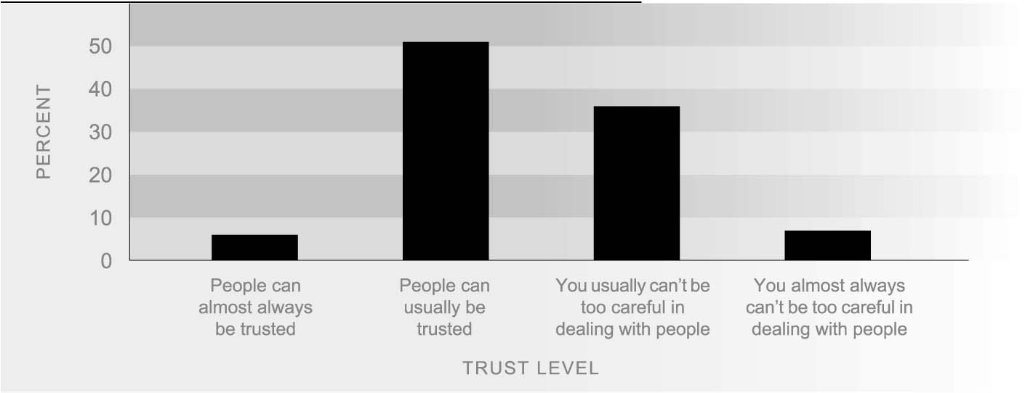
Source: Ministry of Social Development (2004)

SEX DIFFERENCES Males (60 percent) are more likely than females (54 percent) to report that people can be trusted. Both sexes have the same proportion of supporters (6 percent) for the statement ‘people can almost always be trusted’, but a higher proportion of men (54 percent) than women (48 percent) indicated that ‘people can usually be trusted’.
There are only minor age differences concerning trust in others. Across all age groups over 50 percent of New Zealanders report that people can ‘usually’ or ‘almost always’ be trusted.

ETHNIC DIFFERENCES Päkehä/Europeans showed the highest overall level of trust in others with 59 percent responding that people could ‘almost always’ or ‘usually’ be trusted. Mäori and Pacific people are more cautious, with only 49 percent of Mäori and 42 percent of Pacific people reporting that people could be trusted. Fifty-three percent of people in other ethnic groups (including Asians) indicated that they thought that people could ‘almost always’ or ‘usually’ be trusted.
Figure SC3.2 Proportion of respondents reporting that people can ‘almost always’ or ‘usually’ be trusted, by ethnic group, 2004
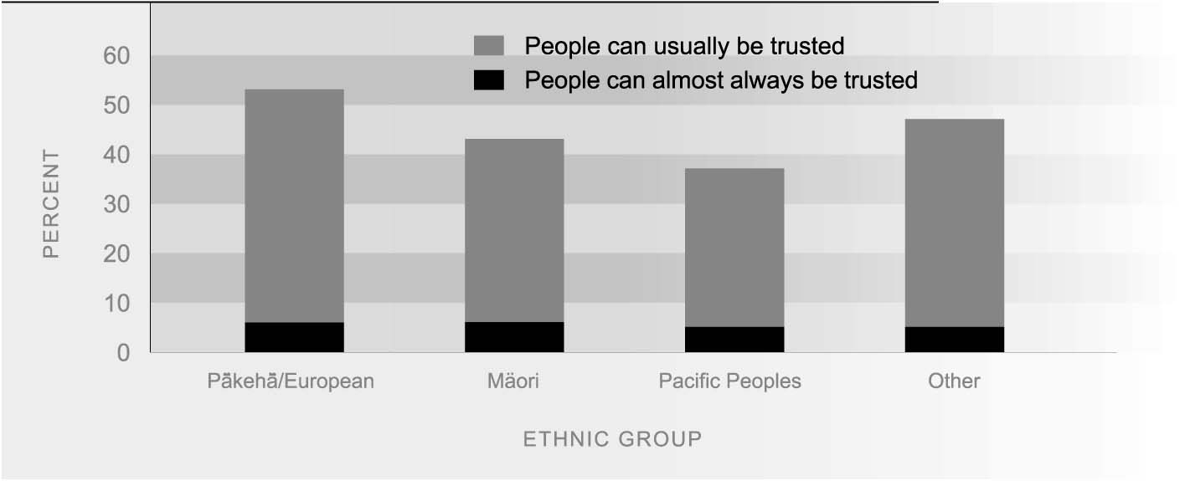
Source: Ministry of Social Development (2004)

PERSONAL INCOME Across all income levels a majority of New Zealanders indicated that people could
DIFFERENCES ‘almost always’ or ‘usually’ be trusted. New Zealanders with personal incomes between $40,001-60,000 reported the highest overall levels of trust. Those with incomes $20,000 or less reported lower levels of trust overall, with only 52 percent indicating that they thought people could be trusted ‘almost always’ or ‘usually’.
Figure SC3.3 Proportion of respondents reporting that people can ‘almost always’ or ‘usually’ be trusted, by person income, 2004
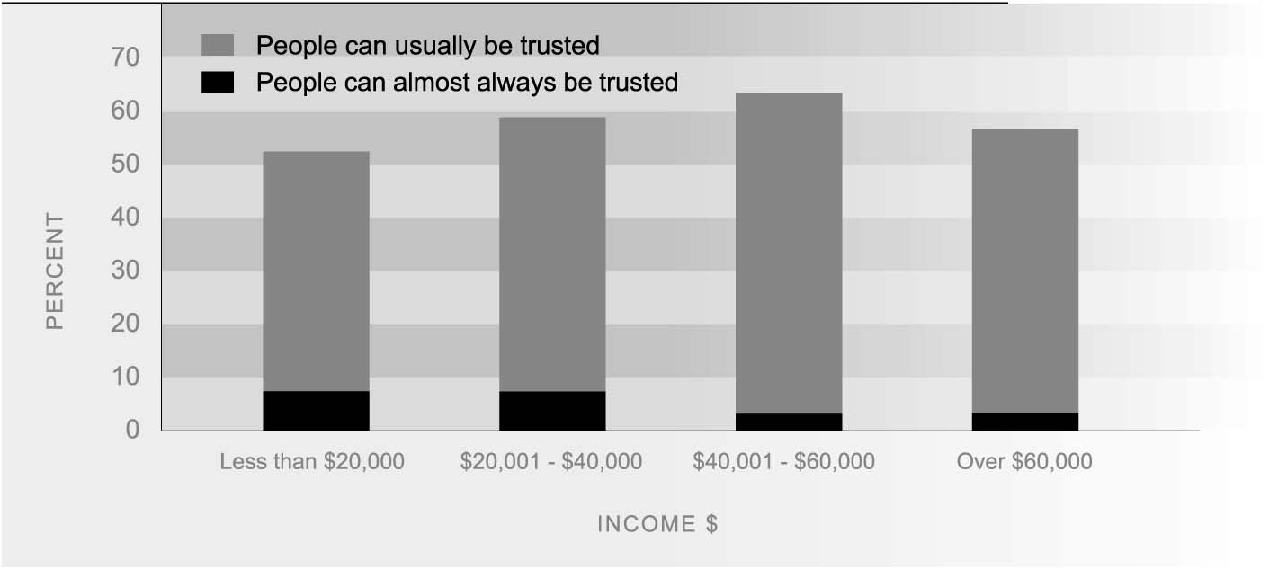
Source: Ministry of Social Development (2004)

INTERNATIONAL In 1998, 49 percent of New Zealanders said that most people can be trusted. This was
COMPARISON high compared to an OECD median of 38 percent in 1995/1996. New Zealand ranked sixth out of 26 OECD countries. Norway had the best outcome in the OECD, with 65 percent of Norwegians stating that most people can be trusted. Outcomes for other countries include Canada (sixth, 52 percent), Australia (13th, 40 percent), the United States (14th, 36 percent), and the United Kingdom (18th, 31 percent).
Loneliness
DEFINITION
The proportion of people aged 15 and over who reported feeling lonely sometimes, often, or always during the previous 12 months, as reported in the Social Wellbeing Survey 2004.

RELEVANCE Social contact is of fundamental importance to people: humans are social creatures. Self-assessed loneliness is a proxy indicator of whether people are happy with the amount and quality of social contact that they get. As well as being an undesirable state in itself, loneliness may also contribute to poor outcomes in other areas including adverse health problems such as stress, anxiety or depression.

CURRENT LEVEL In the Social Wellbeing Survey 2004, 26 percent of New Zealanders reported having felt lonely over the last twelve months. Twenty-two percent said they felt lonely ‘sometimes’ while a small group of people reported more frequent loneliness. Three percent said they were lonely ‘most of the time’ and 1 percent said that they ‘always’ feel lonely. Unemployed people and people without a partner were more likely than New Zealanders as a whole to report feeling lonely (41 percent and 37 percent respectively).
Figure SC4.1 Proportion of the population reporting loneliness, 2004
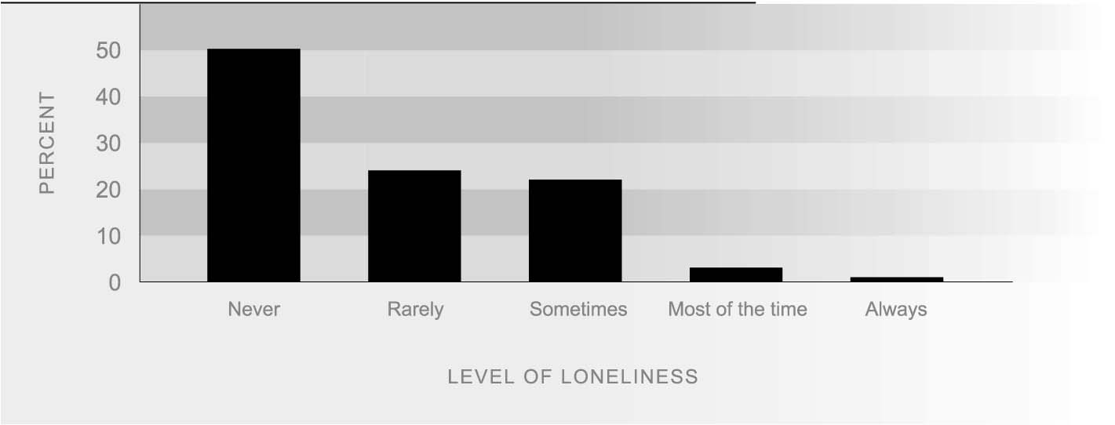
Source: Ministry of Social Development (2004)

SEX DIFFERENCES Overall, females (28 percent) were more likely to report having felt lonely in the last twelve months than males (24 percent). Twenty-six percent of females said they felt lonely ‘rarely’, compared to 22 percent of males, and 23 percent of females said they were ‘sometimes’ lonely, compared to 20 percent of males.

AGE DIFFERENCES Loneliness is most prevalent amongst those aged 15-24. Thirty-seven percent of people in this age group experienced feelings of loneliness ‘sometimes’, ‘often’, or ‘always’ compared to an average of 26 percent across all age groups. The proportion of people reporting feelings of loneliness tends to decrease as age increases. Only 26 percent of those aged 25-44, 22 percent of 45-64 year olds, and 23 percent of those aged over 65 reported feeling lonely ‘sometimes’, ‘often’, or ‘always’. However, even in older age groups there is a small proportion of people who report significant loneliness.
Figure SC4.2 Proportion of people experiencing loneliness always, often or some of the time, by age, 2004
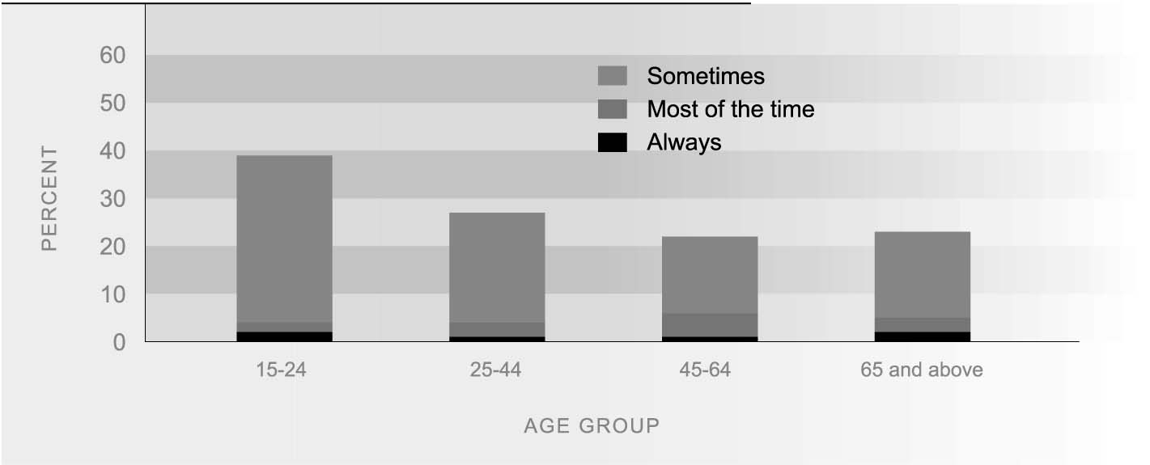
Source: Ministry of Social Development (2004)

ETHNIC DIFFERENCES About one quarter of Mäori, Päkehä/European and Pacific peoples stated that they are lonely ‘sometimes’, ‘often’, or ‘always’ and there is little difference between these groups in overall levels of loneliness. Between 21-25 percent experience loneliness ‘rarely’, 19 to 20 percent are ‘sometimes’ lonely, and 5 percent of all three groups are lonely either ‘most of the time’ or ‘always’. In contrast, 36 percent of people in ‘other’ ethnic groups (including Asians) felt lonely in the past twelve months.

PERSONAL INCOME People with personal incomes of $20,000 or less reported higher rates of loneliness
DIFFERENCES than people with higher incomes: 36 percent said they felt lonely ‘sometimes’, ‘often’, or ‘always’ in the past 12 months, compared to 24 percent of those earning $20,000 to $40,000 and 17 percent of those with incomes between $40,000 and $60,000. Only 14 percent of those whose incomes were over $60,000 indicated that they felt lonely. Of those on less than $20,000, 6 percent report being lonely ‘most of the time’ compared to 3 percent or less for those with incomes over $20,000.
Figure SC4.3 Proportion of people experiencing loneliness always, often or some of the time, by income, 2004
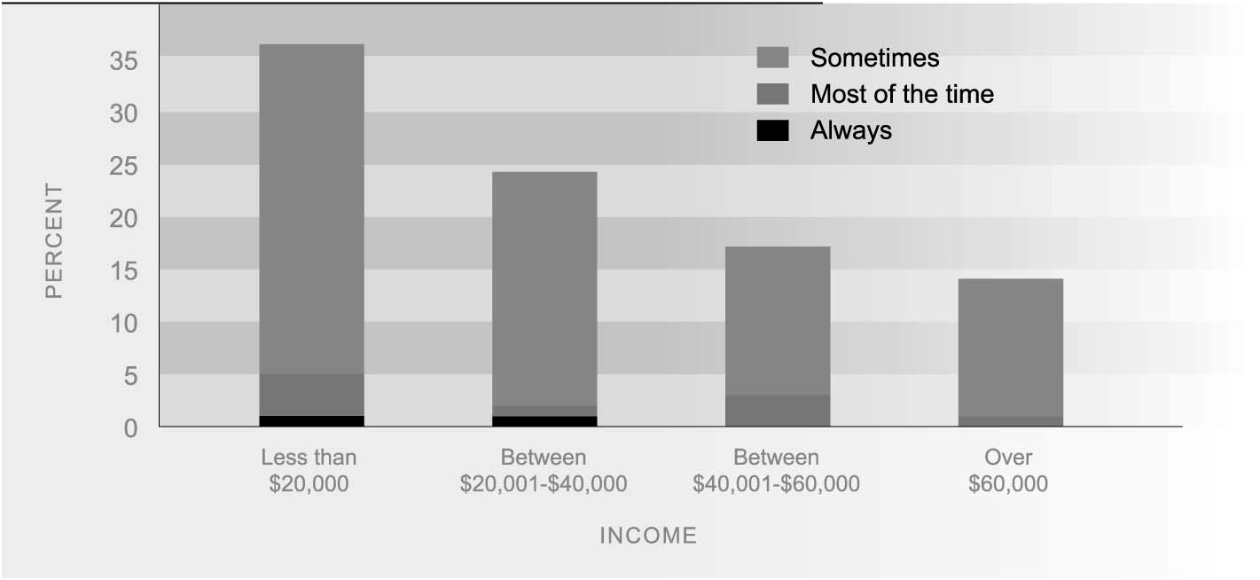
Source: Ministry of Social Development (2004)
Contact between young people
and their parents
DEFINITION
The proportion of secondary school students aged 12-18 years who reported that most weeks they were able to spend enough time with Mum and/or Dad (or someone who acts as Mum and/or Dad).

RELEVANCE Healthy relationships are built through both the quantity and quality of time spent together. Young people having enough time with their parents is a proxy indicator of the extent to which those in need of care and nurturing receive appropriate support.

CURRENT LEVEL In 2001, 63 percent of male students and 61 percent of female students reported that most weeks they were able to spend enough time with at least one parent.
Figure SC5.1 Students reporting they spent enough time with their parent(s), 2001
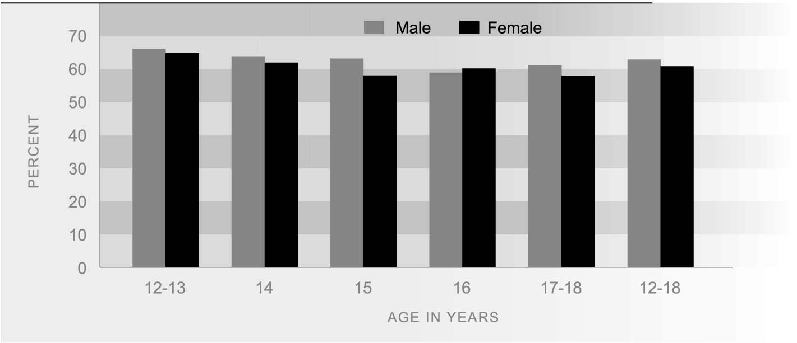
Source: Adolescent Health Research Group, (2003a)
AGE AND SEX There were no significant differences by sex in the proportion of students reporting that
DIFFERENCES they spent enough time with at least one parent. Girls at 15 years of age reported less often than younger boys and girls (12-13 years) that most weeks they were able to spend enough time with Mum or Dad.

ETHNIC DIFFERENCES Fifty-five percent of Mäori students and 65 percent of European students reported that most weeks they were able to spend enough time with Mum and/or Dad. The difference was statistically significant after adjusting for age, sex and socio-economic differences between the two ethnic groups. Pacific students (60 percent), Asian students (65 percent) and students of other ethnic groups (60 percent) showed no statistically significant difference from New Zealand European students after adjusting for age, sex and socio-economic differences.

